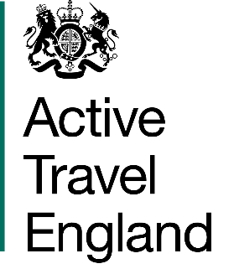

West Offices (City of York Council)
Station Rise
York
YO1 6GA

10 August 2026

Sent by email

Floating Bus Stops Disability Advisory Group

Apply to join the Disability Advisory Group on Floating Bus Stops
Applications to join the Disability Advisory Group close at midnight, Wednesday 9th September

Please email your answers to the questions below to contact@activetravelengland.gov.uk. Give your email the subject line “DAG application”.

You can put your answers to the questions below in the body of the email, or attach this document to the email.

- Why would you like to join the Disability Advisory Group on Floating Bus Stops? (suggested max 200 words).

- What experience will you bring to the group? (suggested max 200 words. You can include day-to-day lived experience, your own independent learning, any volunteering experience and any professional experience).

- Your first name and surname

- Your email address

- Any other contact information you would like us to have

- Are you a d/Deaf or Disabled person? (yes/no)

- What disability/disabilities or impairments do you have?

- Are you a carer? (yes/no)

- Do you work or volunteer for a disability access charity / other organisation?
  - I work for a disability access organisation (yes/no)
  - I volunteer for a disability access charity / other organisation? (yes/no)

- If you work or volunteer for any organisations working in disability access, please tell us:
  - Names of the organisation(s)
  - Your position(s) in the organisation(s)

- How do you make local trips? (answer all questions yes/no)
  - Walking/wheeling
  - Cycling or using faster mobility aids like class 3 (8mph) powerchairs or mobility scooters
  - Using buses
  - Using other public transport (like trams)
  - Driving your own car/van
  - Being driven in your own car/van
  - Taxi or private hire vehicles

- Can you attend online meetings? (yes/no)

- Access needs:
  - Do you have any access needs for online meetings (yes/no)
  - If you have any access needs for online meetings, please tell us what these are.
We will contact you by midnight on Wednesday 23rd September about your application.

Thank you for applying.

You do not have to give us any other contact information. Please tell us how you would like us to use any extra contact information. Other contact information you might want to give us could be: - A phone or textphone number, if you find this more accessible than emails. - An assistant or supporter’s email address.
We need to know this so that we can make sure we recruit group members who have lots of different experiences. A very short answer is fine, such as “I am autistic / visually impaired / Deaf”. If you want, you could give a description like “I use a walking frame” or “I need help to learn new routes”.

