We think Disabled people should be allowed to make similar trips at similar speeds to non-disabled people
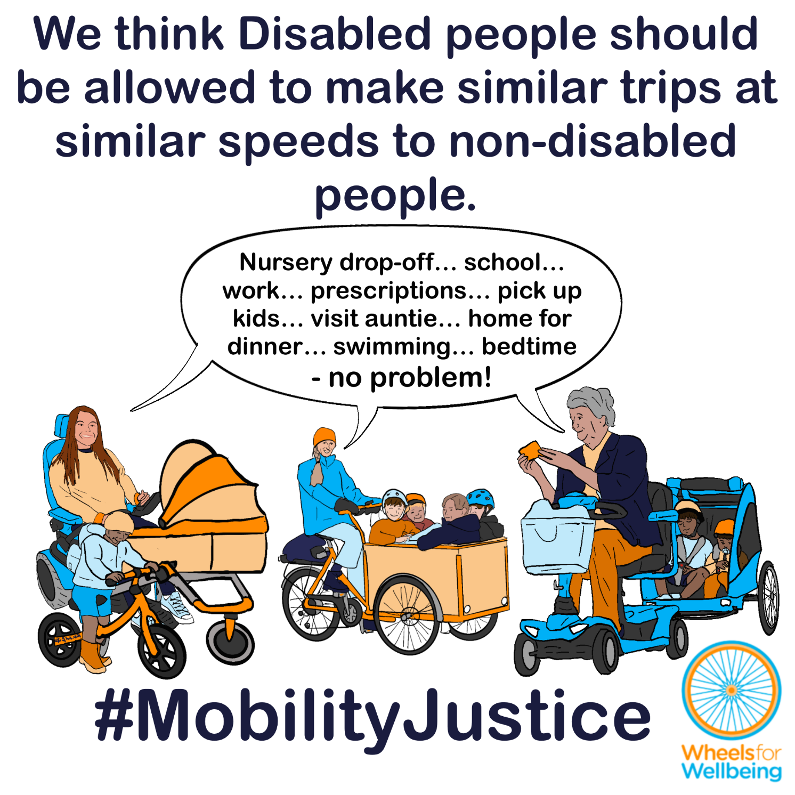

Why can’t Disabled people already make trips at similar speeds to non-disabled people?
In the UK at present, laws about “invalid carriages” largely determine what mobility aids Disabled people can use.
The law says that “invalid carriages” may only be used at a maximum powered speed of 4mph on all pedestrian spaces. These laws say that for all manual and powered wheelchairs, mobility scooters and other powered mobility aids, “footways” includes all footways (pavements), footpaths, bridleways and restricted byways. Cycle tracks are included as footways too. All together, that means people using wheelchairs and mobility scooters can only be powered at up to 4mph on traffic-free routes which people using cycles can use at any speed, and where e-cycles and trial scheme e-scooters can be powered at up to 15.5mph.
Class 3 “invalid carriages” can have a maximum powered speed up to 8mph – but speeds above 4mph are only permitted on roads. Government guidance says “invalid carriages” may not be used on cycle lanes or bus lanes on roads – even though people can cycle in cycle lanes and bus lanes, and even though cycle lanes and bus lanes will generally be much safer spaces to be in than the adjacent road carriageway that “invalid carriage” users have the right to go on!
Mobility scooters, powerchairs, innovative aids and power attachments can already be safety certified for maximum powered speeds up to 20kph, (12.4mph) under existing British Standards. Devices with this certification still can’t legally be used at above 4mph/8mph in public spaces in the UK.
Disabled children under 14 are only allowed devices that go up to 4mph – which prevents many Disabled children from taking part in activities and making journeys such as travelling to school independently or with their friends and family.

Having aids that go above walking speeds opens up options for work, education and more:
Many Disabled people can’t drive, and often can’t practically use other modes including taxis or public transport for many trips.
Disabled people who are able to use cycles and e-cycles can go above walking speed – but can’t legally use our devices on pavements at all, even for a final few metres to reach or leave our own homes.
Steph told us how using an e-cycle which can travel above walking speed can enable her to attend medical appointments without having to take too much time off work:
“I’m waiting on some medical thing where you have to go in about three or four times a week. The local hospital would take me probably a round trip of three to four hours if I did it by public transport, but I can get that down to perhaps two hours if I do it cycling, including the treatment. So what we worked out was being able to cycle it reduces the amount of time I have to have off work.”

Being able to combine and switch mobility aids for longer and shorter distance use is important for many people:
“I want to be able to drive a cabin car mobility scooter pulling a trailer with my powerchair on under a tarp. The cabin cars go further than I can do on my powerchair & are protected from the weather. But when I get somewhere like the supermarket or museum etc I wouldn't be able to go in in the cabin car, so I'd need my powerchair. If this setup was allowed I could actually go more places for days out/do more.
Also 8mph on a busy road is unsafe 12-15mph would actually be safer.”

What legal changes do we need?
A small number of legal changes would make big differences to mobility options for a lot of people. You may notice that this legal changes section is the same or similar in some of the other case studies in this series!
We want new mobility aid laws to be fit for purpose, fair and future-proofed.
- Mobility devices should have maximum permitted powered speeds aligned with e-cycles (or micromobility like e-scooters). That’s presently 15.5mph.
- Disabled people should have the right to use our chosen mobility devices (within specified dimensions and function categories) at pedestrian speeds everywhere pedestrians have the right to go.
- Disabled people should have the right to use our chosen mobility devices at cycling or cycling-equivalent speeds in all cycling-permitted spaces.
- All of the above points must still be subject to existing regulations which prohibit dangerous and antisocial behaviour by all public space users. These regulations apply equally to mobility aid users.
This isn’t radical – we want the rules for people using mobility aids to be the same as existing rules for people walking, running, using cycles or e-cycles!
- The Equality Act (2010) requires the government to make all reasonable adjustments to regulations that are needed to provide Disabled people with mobility equality – and says these adjustments must be made before any Disabled people experience discrimination.
- The Mental Capacity Act (2005) says that everyone must be assumed to have the capacity to make reasonable decisions. That means it’s not reasonable to apply blanket low maximum speeds and use restrictions to mobility aids meant for Disabled people that don’t apply to comparable devices like cycles, e-cycles and e-scooters that are mostly intended for use by non-disabled people.
- Some Disabled people already use a full range of e-assist cycles and trial scheme e-scooters at up to 15.5mph powered speeds in all cycle-permitted spaces.
- Some Disabled people already use fully powered mobility aids that are certified under existing British Standards for wheelchairs and mobility scooters for safe use up to 12.4mph.
- Disabled people already use our judgement to select appropriate speeds for different spaces, just as other pedestrians do. For example, we typically slow to well below the current 4mph maximum allowed when in busy and constrained spaces such as narrow pavements, shopping centres and transport hubs. We already recognise that safe speeds in these places are likely to be no more than 1-2mph, and that stopping for the safety of ourselves and others will often be necessary.

What you can do
We want Disabled people to have the same journey-making choices as non-disabled people. For this to happen, we need the law to change. The Department for Transport is running a consultation into changing mobility aid laws. The consultation deadline is 22nd April 2026.
You can help make changes to improve mobility options for all Disabled people:
- Read our explainers and recommendations. We are concerned about some of the consultation wording and a lack of information on current laws in the consultation document. Without our extra information, case studies and links to other sources, we’re worried people could accidentally give answers that will cause problems for themselves or others.
- Once you’ve read and considered our explainers and recommendations, please respond to the Department for Transport’s consultation.
The information in this sheet directly links to consultation questions 20, 21 and 22, and indirectly to a range of other questions, including 10-13.
We are releasing free resources about all areas of mobility aid regulations to cover all aspects of the consultation as quickly as we can. Resources include written information, case studies, graphics, social media and webinars.
Follow all our information updates and find out more about how changes to the law can improve mobility for Disabled people @WheelsForWellbeing on Bluesky, LinkedIn, Instagram and Facebook.
Contact us with comments, questions and suggestions at info@wheelsforwellbeing.org.
Join our free peer-support campaigning forum for Disabled people and allies.
Sign up for our newsletter (bottom of page)
Please donate to support our work if you can:
Wheels for Wellbeing is a small Disabled People’s Organisation – a charity run by and for Disabled people. We depend on donations for our campaigning work: very few grants are available for campaigning.
Any donation you can make helps us keep working to achieve mobility justice for all.
#MobilityJustice #EveryJourneyEveryone

See mobility device information and sources spreadsheet for details: https://wheelsforwellbeing.org.uk/wp-content/uploads/2026/02/My-Mobility-device-information-and-sources-v06.xlsx
BS EN 12184:2022 Electrically powered wheelchair, scooters and their chargers. Requirements and test methods https://knowledge.bsigroup.com/products/electrically-powered-wheelchairs-scooters-and-their-chargers-requirements-and-test-methods
See “Disabled children should be allowed powered aids that let them run, cycle and explore with their friends” https://wheelsforwellbeing.org.uk/disabled-children-powered-aids/
See Steph’s ICE Trike blog: https://wheelsforwellbeing.org.uk/case-study-stephs-ice-trike-and-the-cycle-to-work-scheme/
For more details see the Every Journey Everyone campaign page, including this Preliminary Considerations document: https://wheelsforwellbeing.org.uk/considerations-dft-mobility-devices-consultation/
“Not more than one person may be carried on a road on a bicycle not propelled by mechanical power unless it is constructed or adapted for the carriage of more than one person.” (Road Traffic Act 1988 s24(1)) https://www.legislation.gov.uk/ukpga/1988/52/section/24.
The same rules for passengers apply to e-assist pedal cycles as to unpowered cycles, see: The Electrically Assisted Pedal Cycles (Amendment) Regulations (2015) https://www.legislation.gov.uk/uksi/2015/24/made and The Electrically Assisted Pedal Cycles Regulations (1983) https://www.legislation.gov.uk/uksi/1983/1168/made
Wheels for Wellbeing Quick Guide to the Equality Act 2010 https://wheelsforwellbeing.org.uk/wheels-for-wellbeing-quick-guide-to-the-equality-act-2010/
Mental Capacity Act 2005 https://www.legislation.gov.uk/ukpga/2005/9/contents

