Wheels for Wellbeing Guide to Mobility Aids
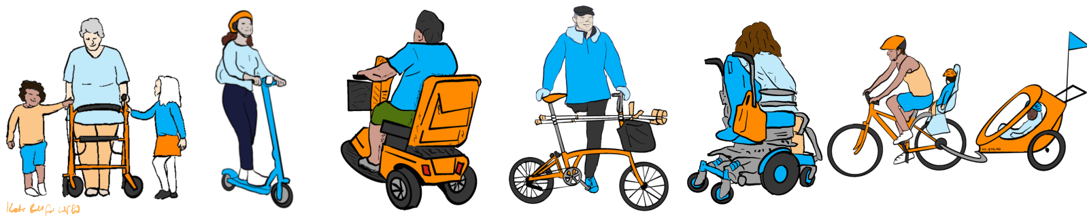

Introduction:
These guide sheets are intended to help people work towards creating a more accessible public realm: Without clear definitions, it’s hard to communicate. Our aim is to enable all Disabled people to use the mobility aids which suit us to make all the journeys we want and need to.
In this guide, we look at all kinds of mobility aids, the existing regulations around their manufacture and use, and discuss what we think should happen to improve access to mobility aids.
Key points highlighting current regulations are shown in blue, like this:
Current regulations key points are in blue
Key points highlighting our position on what rules and regulations should be, or should allow, are shown in orange, like this:
Our position statements are in orange
This guide is paired with our guide to paths, pavements and roads.

Disclaimer:
We are not lawyers: This document is not legal advice – it is guidance intended to help campaigners and others interested in active travel and accessibility. Wheels for Wellbeing cannot be held liable for any loss or other negative outcomes resulting from use of any of the information in this document.
If you find any mistakes or ambiguity in this document, or have any other questions or comments, please contact us.

Wheels for Wellbeing position on mobility aids
Wheels for Wellbeing are campaigning for clear, future-proofed legislation which will allow for innovations in mobility aid provision.
A current important area of innovation is powered wheelchair attachments. We want to see powered wheelchair attachments and other devices which can be used as mobility aids regulated along with e-scooters, e-cycles and other micro-mobility, to ensure that product quality, safety and innovation benefit Disabled people as well as non-Disabled people.
We believe that mobility aid legislation should be changed to facilitate the real mobility needs of Disabled people – including the need for devices which can carry more than one person, which can balance themselves when stationary, and which can be used in all weathers without risk of breakdown.
Regulation needs to account for use exemptions to enable Disabled people to use our mobility aids everywhere we need to, and enable VAT exemptions for all mobility aids.
Regulation needs to consider and mitigate potential complications around imported devices from countries with different definitions of “walking speed”: For fair access to these devices in the relatively small UK market, it is essential that Disabled people’s access to devices manufactured in other countries is not cut off by excessively strict regulation within the UK.
Simple changes in regulation could be incredibly powerful in providing Disabled people with improved access to a wider range of more reliable and cheaper powered mobility options.

Defining mobility aids
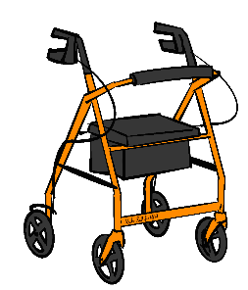
Mobility aids are defined in various different ways. For example:
- In the Equality Act 2010 s164A(6), regarding duties of taxi and private hire vehicle drivers, a mobility aid is defined as “any item the passenger uses to assist with their mobility but does not include – (a) a wheelchair, or (b) an assistance dog”. Carriage of people using wheelchairs (and additional mobility aids) is covered separately in s165 and assistance dogs in s168 and s170.
Taxis and private hire vehicles are required to carry assistance dogs unless the driver has an exemption certificate.
Taxis and private hire vehicles are required to carry wheelchairs and all other mobility aids unless it is unsafe for them to do so.
- The NHS provides information on mobility aids including walking sticks, walking frames, wheelchairs and mobility scooters.
- The World Health Organisation (WHO) groups mobility aids such as wheelchairs and white canes as assistive technology, a broad category ranging from prosthetic limbs to glasses and speech recognition software. The WHO priority assistive products list includes a large range of mobility-related aids, from prostheses and orthoses to canes, frames, wheelchairs and tricycles.
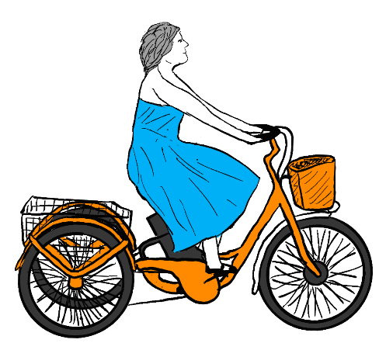
We propose that:
A mobility aid is any item which a Disabled person uses to help them move at pedestrian speeds.
This includes items used while the Disabled person is weight bearing, such as crutches, rollators, canes, assistance dogs or another person, as well as self-propelled, assistant-propelled and mechanically propelled devices which carry the user’s weight. It includes multi-stage journeys using devices such as class 3 “invalid carriages” and cycles which can go faster than pedestrian speeds, but which a Disabled person uses to assist them in walking/wheeling at pedestrian speeds in pedestrian spaces.
For example, a Disabled person may travel from their house on carriageway or on a cycle track at 8mph using a mobility scooter or powerchair, and potentially even faster using a cycle, then slow down to move through a shopping centre.

Mechanically propelled vehicles and motor vehicles
“Mechanically propelled” is a term used in a range of UK highways, vehicles and rights of way legislation. It means a vehicle that is driven by a motor or engine.
Most mechanically propelled vehicles are classed as motor vehicles, no matter how small they are. This is why it’s not legal to ride private e-scooters, hoverboards and other similar devices on roads or pavements: They are classed as unregistered motor vehicles. E-assist pedal cycles, class 2 and 3 “invalid carriages” and a few machines controlled by a person walking (such as self-propelled lawnmowers) are mechanically propelled but not classed as motor vehicles:
- Class 1 “invalid carriages” are machines, but are not mechanically propelled and so are not motor vehicles.
- Pedal cycles are not mechanically propelled. They are considered carriages in law. They are have a right to use carriageways, bridleways, cycle tracks and restricted byways, but not footpaths or footways.
- E-assist pedal cycles are (or are able to be) mechanically propelled, but are “to be treated as not being a motor vehicle” under the Road Traffic Act 1988 s189. This allows e-assist pedal cycles to be treated exactly the same as unpowered pedal cycles for using rights of way.
- Class 2 and class 3 “invalid carriages” are mechanically propelled, but users have a right to use footways (pavements) and are to be treated “as not being a motor vehicle” under the Chronically Sick and Disabled Persons Act 1970 s20.
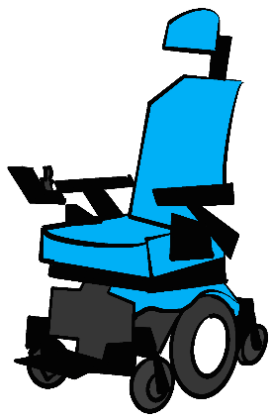

“Invalid Carriages”
“Invalid carriages” are categories of mobility aids in UK law. They are defined in the Chronically Sick and Disabled Persons Act 1970, section 20, and in the Use of Invalid Carriages on Highways Regulations 1988.
“Invalid carriages” in classes 1, 2 and 3 are not motor vehicles in law. This means they can be used on footways (pavements), footpaths, bridleways, restricted byways and many cycle tracks.
We believe that the “invalid carriages” legislation as it stands is outdated and restricts the development and provision of high-quality mobility aids.
The term “invalid” is offensive to many Disabled people.
We believe that regulation of “invalid carriages” and some related product standards unintentionally act to reduce innovation in and quality of mobility aids while increasing their price. The regulations are preventing Disabled people from having access to high-quality mobility aids which would enable us to make the journeys we want and need to make, “in the manner and at the time of [our] choice, and at affordable cost”, as required by the UN Convention on the Rights of Persons with Disabilities article 20.

All “invalid carriages”
- May only be used by “a person suffering from some physical defect or physical disability”, or by someone testing, demonstrating or transporting the “invalid carriage”;
- May only carry one person;
“Invalid carriages” carry a person’s weight: Mobility aids such as crutches, sticks, canes, walking frames, rollators and other comparable aids are not regulated as “invalid carriages”. Their use is not restricted to Disabled people only.

Class 1 “invalid carriage”
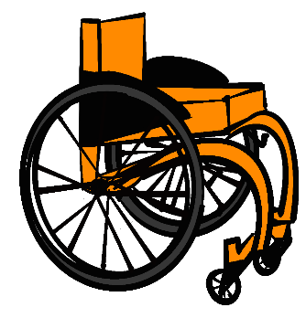
- Are unpowered – “not mechanically propelled”: Class 1 “invalid carriages” are mostly manual wheelchairs, but the category may include other unpowered devices such as handcycles which are specifically designed for and, in law, may only be used by, Disabled people. E-assist cycles designed for and used exclusively by Disabled people are EAPCs, not class 1 “invalid carriages”.
- May be used on footways, footpaths, bridleways and restricted byways. The Chronically Sick and Disabled Persons Act 1970 s20 gives people using class 1 “invalid carriages” the right to use the same public spaces as all other pedestrians.
- Are not mentioned in the Highway Code or other guidance on use of wheelchairs and mobility scooters, which only talk about powered mobility aids.

Class 2 “invalid carriage”
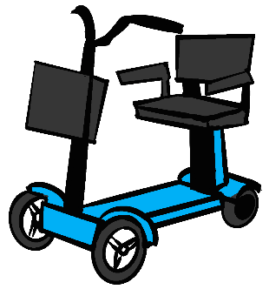
- Class 2 “invalid carriages” are powered mobility aids – generally powerchairs and mobility scooters with a maximum speed of 4mph.
- Must have suitable lights if used to ride along roads after dark, maximum unladen weight 113.4kg (in Wales only, 200kg with necessary user equipment) and must meet safety regulations.
- There is no maximum motor size for class 2 “invalid carriages”. However, they cannot freewheel while in use (see BS EN12184 – behind paywall), meaning the motor will act as a brake to stop them going above 4mph even on steep downhill slopes. This makes class 2 “invalid carriages” different from both pedal cycles and class 1 “invalid carriages”, which can freewheel fast down hills.
- May be used on footways, footpaths, cycle tracks, bridleways and restricted byways, but government guidance says class 2 “invalid carriages” may not be used in cycle lanes or bus lanes. The Chronically Sick and Disabled Persons Act 1970 s20 gives people using class 2 “invalid carriages” the right to use the same public spaces as all other pedestrians.
- Powered wheelchairs, whether class 2 or class 3, are regulated differently from mobility scooters for public transport access.
Wheels for Wellbeing are campaigning to change legislation to permit all powerchair, mobility scooter and other mobility aid users to use cycle lanes and bus lanes.
- We understand that class 2 “invalid carriages” can be used on carriageways – reminder – we are not lawyers, the disclaimer at the start of this document applies:
  - The Use of Invalid Carriages on Highways regulations 1988 section 9 simply says a class 2 invalid carriage has to have the correct lights when used on carriageway.
  - Highway Code rule 42 for “invalid carriage” users is comparable to rule 1 for pedestrians – footways “should” be used if provided. “Should” is advisory guidance, not a legal requirement: “Class 2 users should always use the pavement when it is available. When there is no pavement, you should use caution when on the road. Class 2 users should, where possible, travel in the direction of the traffic.”
Government guidance on using mobility scooters and powerchairs states that only class 3 “invalid carriages” may be used on road. This contradicts the Use of Invalid Carriages on Highways Regulations and Highway Code rule 42.
We consider it likely that this government guidance is incorrect.

Class 3 “invalid carriage”
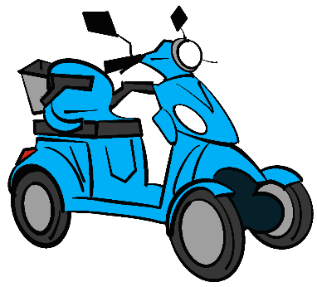
- Class 3 “invalid carriages” are larger mobility scooters and powerchairs. They have a maximum speed of 8mph and a maximum unladen weight of 150kg, or 200kg with necessary equipment (possibly except Northern Ireland - see class 2 for 200kg necessary equipment link relating to Wales).
- Class 3 “invalid carriages” have the same public spaces access rights and most of the same regulatory requirements as class 2 “invalid carriages”, plus, they:
  - Must have a switch to restrict speed to 4mph for use on footways and footpaths;
  - Must not be used by anyone younger than 14;
  - Must have a speed indicator, lights, a horn and a rear-view mirror,
  - Must be no more than 0.85m wide;
  - Must be registered with the DVLA – but you do not need a driving licence or insurance to use them.
- The Chronically Sick and Disabled Persons Act 1970 s20 gives people using class 3 “invalid carriages” the right to use the same public spaces as all other pedestrians, except where used at above 4mph and on public transport, where PSVAR and RVAR apply. Mobility scooter users have more restriction on their access rights than powerchair users, whatever the class of their aid. This is a particular problem for public transport accessibility.

Unclassed “invalid carriages”
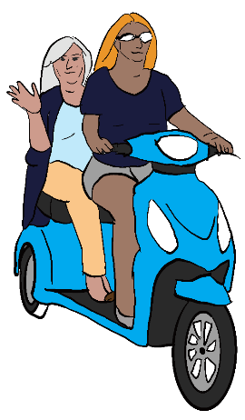
Any “invalid carriage” that doesn’t meet all the requirements of class 1, 2 or 3 is not in a class.
“Not in class” “invalid carriages” are motor vehicles. They must be registered with the DVLA in an appropriate motor vehicle class. The driver must have a suitable driving licence and insurance. We understand there are still historic “invalid carriages” regulations in place which allow for “invalid carriages” up to 254kg unladen weight, with 20mph speed limits. People using vehicles which meet these “invalid carriages” requirements would still need an appropriate driving licence, insurance and vehicle registration.

Medical devices regulations and innovative powered mobility aids
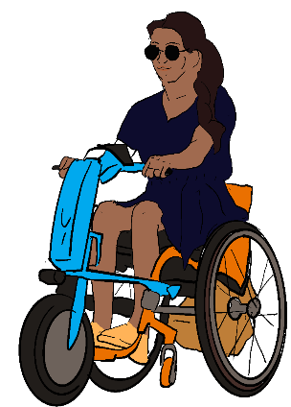
The rules and regulations which apply to well-known mobility aids like wheelchairs and mobility scooters are confusing enough: It’s hardly surprising that the rules for less well-known aids are even more confusing and confused!
Our understanding is that:
- Many innovative powered mobility aids available in the UK are regulated as class 1 medical devices.
- The regulatory body in the UK is the MHRA.
- Class 1 medical devices have been tested by the manufacturer using relevant product safety standards for function and safety, and given a UKCA or CE mark. This means they are allowed to be sold in the UK as medical devices. Class 1 medical devices are not always (or even usually) mobility aids: All sorts of medical equipment including thermometers and syringes can be class 1 medical devices.
- Most class 1 medical devices are “self-declared” – they are tested by the manufacturer, not an external body.
- Medical devices can be assistive technology used to “support and assist individuals with disabilities, restricted mobility or other impairments” which a manufacturer has stated have a medical purpose.
- “Class 1” in medical devices regulations has a completely different meaning from “class 1” in “invalid carriages” regulations: The same mobility scooter could be a class 1 medical device and a class 3 “invalid carriage”.
Class 1 medical devices are regulated by the MHRA for safety. A class 1 medical device with a UKCA or CE mark has been tested and declared as safe for its intended use. The MHRA does not regulate where mobility aids can be used.
Class 1, 2, 3 and unclassed “invalid carriages” are categories of mobility aid defined in UK highways laws. They must be made or adapted specifically for use by Disabled people, and are only permitted to be used by Disabled people. “Invalid carriages” regulations say where different kinds of unpowered and powered wheelchairs and mobility scooters can be used in the UK.

Pedal cycles

Unpowered cycles
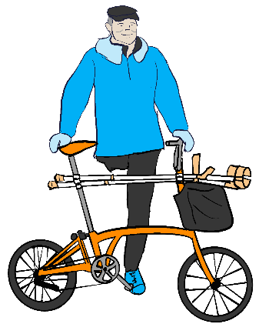
Pedal cycles include “bicycles, tricycles, velocipedes and other similar machines”. This is an incredibly broad category!
For more on the huge range of cycle types available, see our articles on choosing cycle types created in collaboration with Bikeability.
Pedal cycles are important mobility aids for many Disabled people, and provide essential transport, exercise, leisure and outdoor opportunities for many more.
Pedal cycle users:
- Can be any age;
- May carry passengers if their cycle is designed or adapted to do so;
- Can choose whether or not they want to wear any personal protective equipment such as helmets or high visibility equipment;
- Must have suitable brakes, and suitable front and rear lights and pedal reflectors if riding at night;
- Do not need speedometers, insurance, licences or any registration. Speed limits do not apply to cyclists, but they do have to ride in a way that is not dangerous, “with due care and attention” and “reasonable consideration for other persons using the road”;
- Must not ride if unable to do so safely due to drink or drugs;
- May ride on roads (carriageways), cycle tracks and cycle lanes, restricted byways and bridleways;
- Must give way to pedestrians on crossings and should give way to pedestrians on shared spaces under the Highway Code rules H1-H3.
- May not ride on footways or footpaths (though Boateng guidance recommends police exercise discretion towards people cycling considerately on footways where the cyclist believes the carriageway to be unsafe for them to use).
Wheels for Wellbeing campaign for Disabled people using cycles as mobility aids to be allowed to cycle at pedestrian speeds on all footways, footpaths and in all pedestrianised spaces.
Rules 59 to 82 of the Highway Code apply to cyclists, as do all later sections except the motorways section.
The Pedal Bicycles (Safety) regulations 2010 are safety regulations which people selling bicycles have to follow.
Public Spaces Protection Orders (PSPOs) are sometimes being used by local authorities to prevent people from cycling in parts of towns and cities.

E-assist pedal cycles (EAPCs)
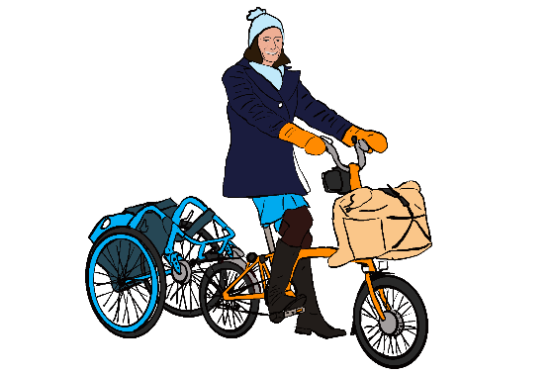
EAPCs are important mobility aids for a large proportion of Disabled cyclists.
As long as they meet all the regulatory requirements under the Electrically Assisted Pedal Cycles Regulations 1983, Electrically Assisted Pedal Cycles (Amendment) Regulations 2015 and Regulation (EU) No 168/2013 of the European Parliament and of the Council (retained EU laws):
The rules for using EAPCs are the same as for unpowered cycles, except that EAPCs may only be controlled by people aged over 14.
Passengers carried on EAPCs may be younger than 14.
People riding EAPCs must follow all the same rules as people riding unpowered cycles.
EAPCs are (or are able to be) mechanically propelled, but are not classed as motor vehicles.
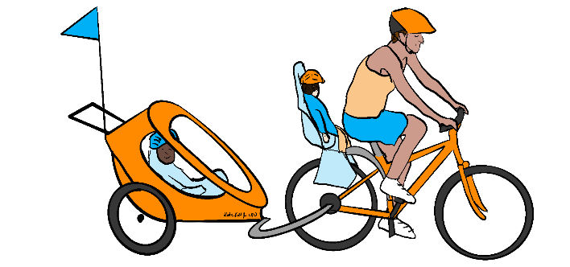
E-assist pedal cycles or EAPCs:
- Include the full range of cycle types – bicycles, tricycles, quad cycles, handcycles, upright and recumbent cycles, cargo cycles, tandems and more.;
- Must have working pedals which can move the cycle forwards;
- Can have a motor with power rated at up to 250W;
- May have a throttle which works up to 6kph/3.73mph;
- May not have the motor working when moving at above 25kph/15.5mph – must have a cut-out which stops the motor at 15.5mph;
- Can be pedalled faster than 15.5mph – and will probably freewheel down hills faster than 15.5mph, too, unless brakes are used!
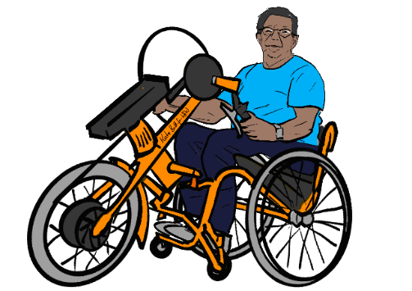
If a cycle has motor power working when moving at above 15.5mph, or has a motor with more than 250W power, it is a motorcycle, not a pedal cycle or EAPC.
- Motorcycle riders must have a licence, insurance and a suitable helmet.
- Motorcycles must always have a rear number plate.
- Motorcycles with or without number plates may only be ridden on carriageways and byways open to all traffic, or private land. They may not be ridden on bridleways, restricted byways, footways, footpaths, cycle lanes or cycle tracks.

E-scooters and micro-mobility
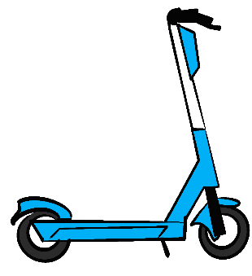
Regulated under the Road Traffic Act 1988 (see s185 (c)) as motor vehicles, except those included in government trials which align regulations fairly closely to the requirements for EAPCs, with a few key differences:
- Riders using trial scheme scooters must have a driving licence – meaning e-scooters cannot be ridden by anyone under 16;
- E-scooters have maximum speed 15.5mph and maximum continuous motor power output 500W;
- E-scooter riders are not allowed to carry passengers;
- E-scooter design is constrained by regulations, so they currently can have only two wheels, one in front of the other, and cannot have a seat;
- Only scooters included in trial schemes are currently legally allowed to be used (except on private land). They may be ridden on carriageways and cycle lanes, but usually not other routes including cycle tracks. They may not be used on footways or footpaths.

Motor vehicles - mopeds and motorcycles
E-assist cycles with motors rated at above 250W and speed cut-outs on the motor above 15.5mph are regularly called “bikes”, but in law are motor vehicles.
To be used legally, motorcycles must be:
- Registered with the DVLA, with an MOT and any VED required paid, insured, with a number plate;
- Ridden only on carriageways and byways open to all traffic (and private land). Some low-powered motorcycles may not be ridden on motorways. No motorcycles may be ridden on footways, footpaths, cycle lanes, cycle tracks, bridleways or restricted byways;
- Ridden by a person wearing suitable protective equipment, including a helmet, and who has a suitable licence. The minimum age for gaining a motorcycle is between 16 and 24, depending upon the licence type and route.
Highway Code rules 83-88 and all following sections apply to motorcycles.
