We think parents who use wheelchairs should have the right to use prams and pushchairs.
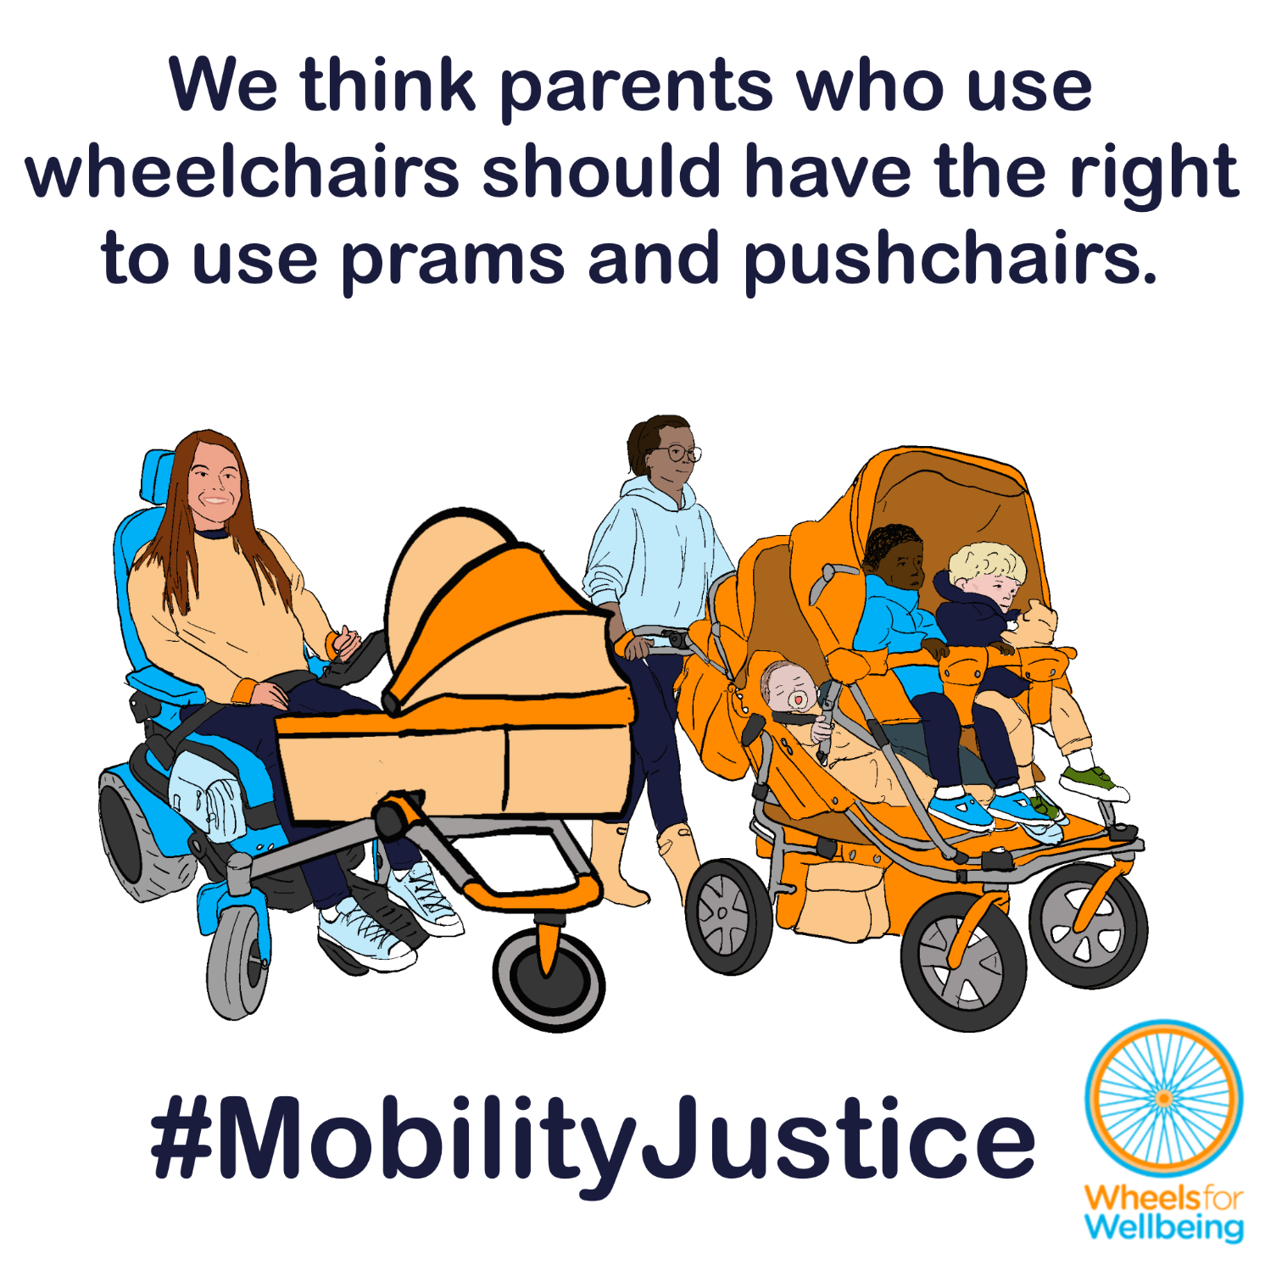

Why can’t Disabled people already use prams and pushchairs?
In the UK at present, laws about “invalid carriages” largely determine what mobility aids Disabled people can use. The law says that only one person can be legally carried on any “invalid carriage” in public spaces like pavements and roads. That means Disabled parents and carers aren’t allowed to attach anything that can carry babies or children to their mobility aid, even though parents and carers who walk, run and cycle can legally use a whole range of child-carrying devices, from prams and pushchairs, to cycle child seats and trailers.
C told us:
“When my twin children were toddlers, I’d need to take them out with me to the shops and other places. I put a connector on my wheelchair, and towed a cycle trailer behind with my children in it as I pushed my wheelchair up the pavement. Without such a method, it would have been impossible for me to leave the house while caring for my children. Neither I nor anyone I ever encountered knew I was breaking the law.”
Organisations including REMAP and Invictus Active have developed practical solutions that enable mobility aid users to transport babies and young children. The law means none of these devices can be used in public spaces, and none are available commercially.
One organisation reported that their wheelchair-compatible accessible pushchair is “the #1 top requested product” in their history.”
Current mobility aid rules are stopping Disabled parents and carers from taking their children on typical outings, from school runs to shopping, playgrounds to medical appointments and socialising in their local community – for no good reason at all.
Legalising mobility aids that are constructed or adapted to carry more than one person would open up safe, cost-effective mobility options for thousands of Disabled families each year, immeasurably improving the lives of many Disabled parents, carers and their children.

What legal changes do we need?
A small number of legal changes will make big differences to different accessible mobility options for a lot of different people. You may notice that this legal changes section is the same or similar in some of the other case studies in this series!
We want new mobility aid laws to be fit for purpose, fair and future-proofed.
- We think that more than one person should be able to use a mobility aid at a time, as long as the aid is constructed or adapted to carry more than one person.
- We think that mobility aids should be allowed to pull or push trailers for people or luggage, as long as these are safely attached.
- We think that mobility aids designed or adapted to be connected in “trains” to each other or alternative compatible devices (such as suitable cycles) should be allowed.
This isn’t radical - these suggested rules for people using powered mobility aids are exactly the same as existing rules for people walking, running, using cycles or e-cycles!
- People walking or running are allowed to pull or push luggage, shopping and other people using wheelchairs, pushchairs, trolleys and cases.
- Single, double, triple and even quad pushchairs and joggers are often used, by parents, carers, childminders and nurseries.
- Cycles and e-cycles which can transport multiple people including adults and children are legal in the UK.
- People cycling are allowed to carry cargo, tow trailers, attach child seats, and connect cycles together using towbars, tow ropes and other devices.

What you can do
We want Disabled people to have the same journey-making choices as non-disabled people. For this to happen, we need the law to change. The Department for Transport is running a 15-week consultation into changing mobility aid laws. The consultation deadline is 22nd April 2026.
You can help make changes to improve mobility options for all Disabled people:
- Read our explainers and recommendations. These should all be released by mid February 2026. We are concerned about some of the consultation wording and a lack of information on current laws in the consultation document. Without our extra information, case studies and links to other sources, we’re worried people could accidentally give answers that will cause problems for themselves or others.
- Once you’ve read and considered our explainers and recommendations, please respond to the Department for Transport’s consultation.
The information in this sheet directly links to consultation questions 20, 21, 22 and 23, and indirectly to a range of other questions, including 10-13.
We are releasing free resources about all areas of mobility aid regulations to cover all aspects of the consultation as quickly as we can. Resources include written information, case studies, graphics, social media and webinars.
Follow all our information updates and find out more about how changes to the law can improve mobility for Disabled people @WheelsForWellbeing on Bluesky, LinkedIn, Instagram and Facebook.
Contact us with comments, questions and suggestions at info@wheelsforwellbeing.org.
Join our free peer-support campaigning forum for Disabled people and allies.
Sign up for our newsletter (bottom of page)
Please donate to support our work if you can:
Wheels for Wellbeing is a small Disabled People’s Organisation – a charity run by and for Disabled people. We depend on donations for our campaigning work: very few grants are available for campaigning.
Any donation you can make helps us keep working to achieve mobility justice for all.
#MobilityJustice #EveryJourneyEveryone

See https://remap.org.uk/solutions/baby-pram-attachment-for-wheelchair/
See https://www.invictusactive.com/solutions/wheelchair-pram-attachment/
“Invalid carriages” are presently not permitted to have trailers attached in any circumstances. (Road Vehicles (Construction and Use) regulations 1986 s83) https://www.legislation.gov.uk/uksi/1986/1078
“Not more than one person may be carried on a road on a bicycle not propelled by mechanical power unless it is constructed or adapted for the carriage of more than one person.” (Road Traffic Act 1988 s24(1)) https://www.legislation.gov.uk/ukpga/1988/52/section/24.
The same rules for passengers apply to e-assist pedal cycles as to unpowered cycles, see: The Electrically Assisted Pedal Cycles (Amendment) Regulations (2015) https://www.legislation.gov.uk/uksi/2015/24/made and The Electrically Assisted Pedal Cycles Regulations (1983) https://www.legislation.gov.uk/uksi/1983/1168/made
In the UK, cycles are “carriages”, not “road vehicles” or “motor vehicles”, meaning many motor vehicle rules do not apply to cycles (Local Government Act 1888 s 85) https://www.legislation.gov.uk/ukpga/Vict/51-52/41 . Construction and use regulations for cycles do not mention trailers – see: The Pedal Cycles ((Construction and Use) Regulations 1983 and The Pedal Cycles (Construction and Use) (Amendment) Regulations 2015 https://www.legislation.gov.uk/uksi/2015/474/made

