Experiential Inclusive Cycling:
One-Day In-Person Training

Cycling policy and infrastructure standards have changed radically in recent years with inclusive and accessible schemes now the expected norm. However, many of those working in active travel have little knowledge or experience of what accessible and inclusive cycling for Disabled people actually entails. This course will address these gaps and ensure that all those working in the field are fully equipped and confident in meeting current accessibility and inclusivity standards.

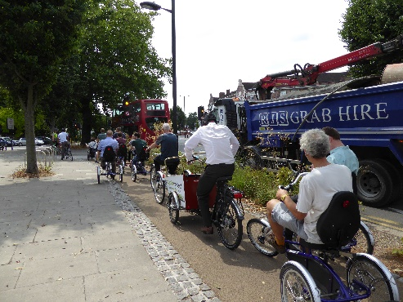
At the end of the course participants will understand their obligations under: The Equality Act, LTN1/20 and Gear Change. They will have in-depth knowledge of:
- The experiences of a Disabled cyclists using a range of cycles
- Inclusive cycle design and barriers to cycling
- Inclusive behaviour change/active travel schemes

The course is interactive and experiential and uses a range of learning methods including:
- Classroom delivery from WfW Campaigns and Policy team
- Face-to-face discussions/observations of sessions with Disabled cyclists
- Cycling experience using non-standard cycles led by WfW operations team in the velodrome and local area
Course participants navigating cycle infrastructure using a range of non-standard cycles.

Previous trainees have described the course as follows:
“This course was the highlight of our induction fortnight!” Healthy Streets Officer.

“We had a brilliant day with WfW last week. A great investment to help our engineers and designers view inclusive cycling through a common lens. What we need is consistency across the network and I think this session will be fundamental in helping to deliver high quality designs that meet everyone’s needs.” Local authority cycling manager.

“I’d known of Wheels for Wellbeing’s work for years but it’s only when attending your course that the penny really dropped about practicing equality in active travel. I do my job so much better now!”
Local authority active travel manager.

Logistics
The course takes place over one day (c.6 hours, 10:00-16:00) at Herne Hill Velodrome, South London, usually on a Monday or Thursday with a maximum of 12 participants per course. It is suitable for anyone working in the active travel field including: elected representatives with responsibility for transport or planning, planners, engineers, architects, transport policy officers, cycle providers, behaviour change/healthy streets officers, campaigners and students in a range of disciplines. For further details and pricing and to discuss options in other geographical areas of the UK, please contact: kay@wheelsforwellbeing.org.uk or isabelle@wheelsforwellbeing.org.uk

