Accessible CycLE-Parking:
Interactive training module delivered online or in person.
This course will equip participants to design cycle parking infrastructure which meets the needs of Disabled cyclists who use standard and non-standard cycles and complies with their obligations under the 2010 Equality Act and the government’s most recent cycle infrastructure guidance, LTN1/20.

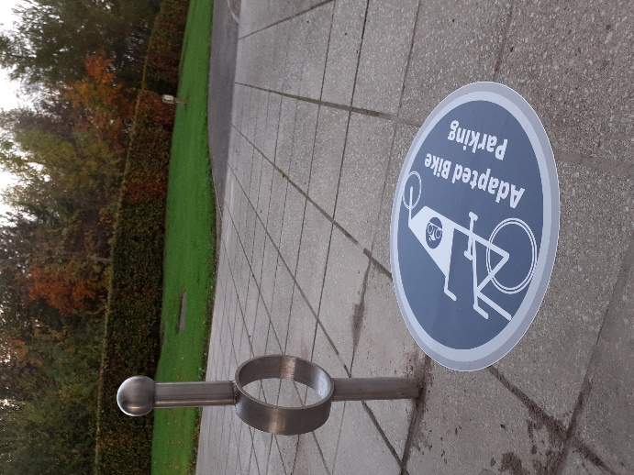
The course includes a brief overview of disability in the UK and the social model of disability, followed by an in-depth analysis of Disabled cyclists: how often they cycle and the types of journeys they make, the kinds of cycles they use, the barriers and enablers to cycling, and cycles as mobility aids. The course then provides a brief overview of approaches to design and disability before presenting a comprehensive guide to accessible cycle parking design. The course is interactive and problem-solving based.
Design & image ©Kevin Hickman

All previous participants described the delivery and understanding as either “good” or “very good” and the training objectives as “very well met”. 100% of respondents would definitely recommend the training to colleagues and others.

Duration: 3 hours
Number of participants: 12 – 16

Further information: contact Kay Inckle kay@wheelsforwellbeing.org.uk

