The Guide to Inclusive Cycling
Our Recommendations

5th Edition

September 2025

What needs to happen
to make cycling inclusive for everyone
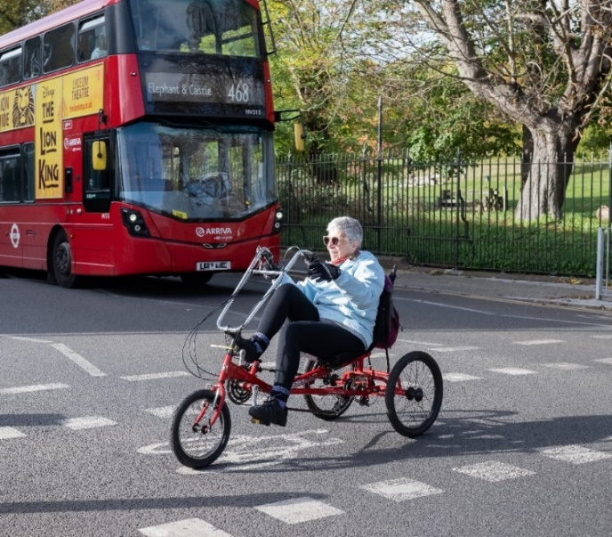

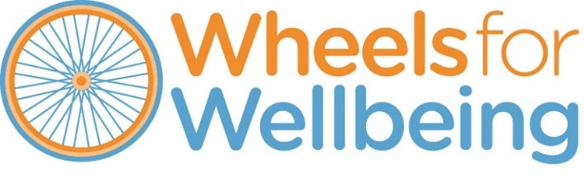

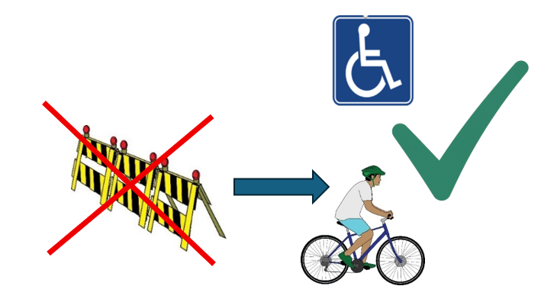

Who are Wheels for Wellbeing?
We are a UK charity founded in 2007.
We work to remove barriers so Disabled people can enjoy cycling.

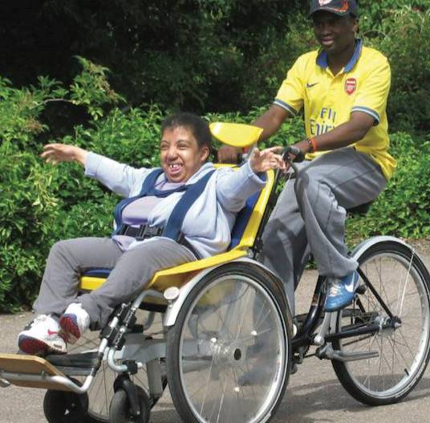
What we do
- We run inclusive cycling sessions for Disabled people of all ages and impairments.

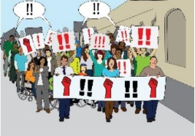
- We campaign for the needs and rights of Disabled cyclists and Disabled people who want to cycle or to use wheels to get around.

An impairment is a part of a person’s mind or body which is not the same as most people. For example, not hearing or only having 1 leg. Bad eyesight is a visual impairment.

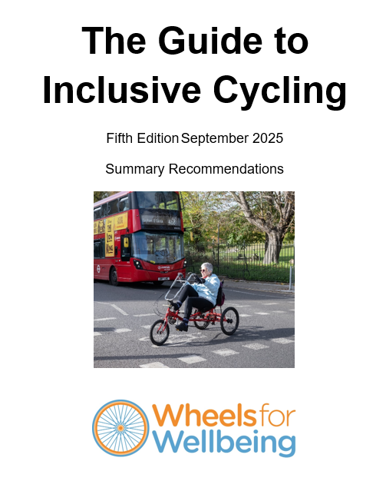
What is this document about?

In this Guide, we say how to make cycling and other active transport accessible for everyone.

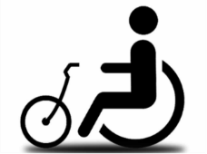
We say what changes we want to see to make this happen.

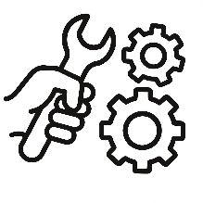
This includes changes to:
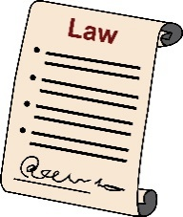
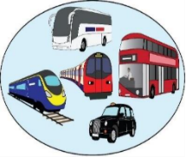
- the law

- the design of things like cycle lanes and public transport
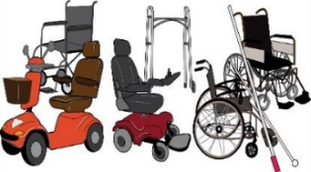
- the types of cycles and mobility aids that are available.

mobility aids are things like wheelchairs and mobility scooters. Things that help Disabled people move around.

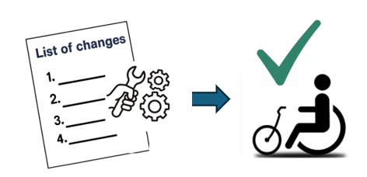
In this document, we have made a list of the most important changes we want to see to make cycling more accessible.

Keep reading to see what these changes are and how you can help us make them happen.

Notes:
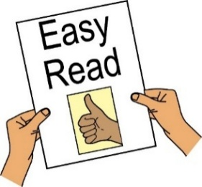
- This is the Easy Read version of our recommendations in the Guide.
- The full Guide is here on our website link (not easy read).
- This is the 5th edition (version) of the Guide.

An edition means a new document which has changes from the original. So, when we have new things to say, we make a new edition (new document).
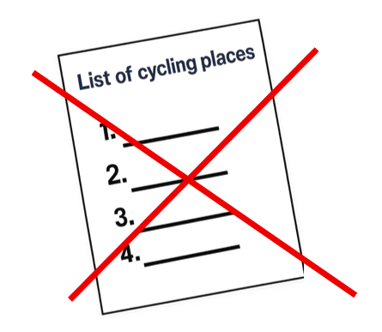

What this Guide does not do
The Guide does not give a list of where you can do inclusive cycling.

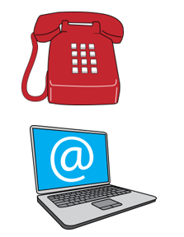
If you want to find out where you can do cycling near you, please contact our Inclusive Cycling Advisor, Katie:

call: 020 7346 8482
email: info@wheelsforwellbeing.org.uk

Welcome
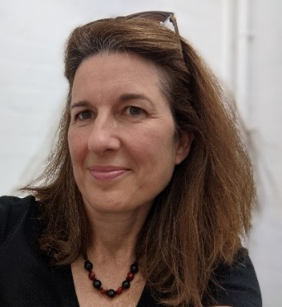

By Isabelle Clement
Director, Wheels for Wellbeing

MBE (Member of the British Empire)

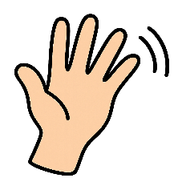

Welcome to our Guide to Inclusive Cycling!
This Guide is really useful for anyone who wants to see Disabled people take part in cycling without barriers.
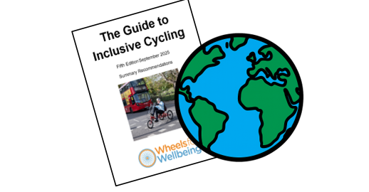
People use the Guide abroad as well as in the UK. We make sure it’s always up to date.
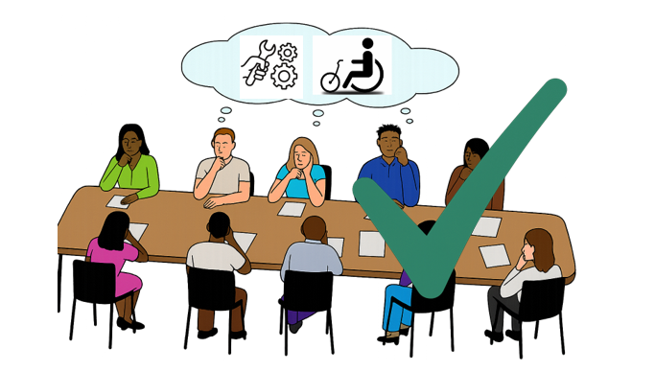
We keep learning and thinking and want to share our knowledge with everyone. Thanks to us and other Disabled people’s organisations, things are changing.

I want to thank the Rees Jeffreys Road Fund who gave us funds so we could write this new Guide.

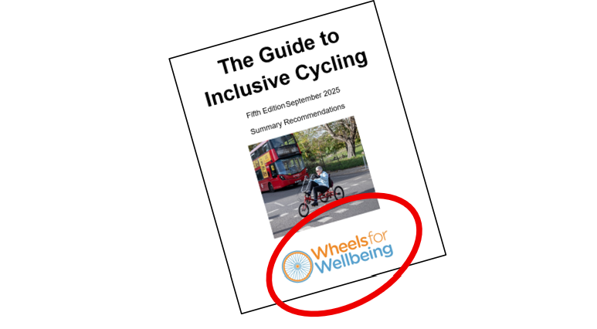
This Guide only has the views of Wheels for Wellbeing.

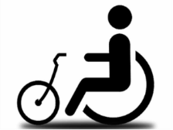

This Guide is for you if you’re interested in:

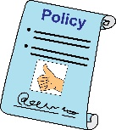
- transport equity and justice

- accessible active travel policy

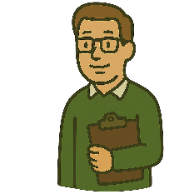
- campaigning for changes to local infrastructure or the law, or

- looking for expert help.

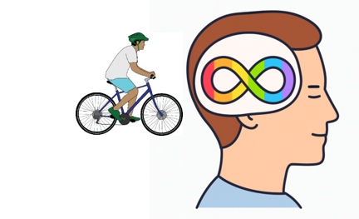
There is also a new chapter on cycling and neurodiversity.

Equity means everybody gets what they need rather than everyone getting the same. For example, some people need a cycle with 3 wheels. So if only cycles with 2 wheels are available, that is not fair.

Active travel means travel that involves movement or exercise. For example, walking/wheeling or cycling.

Infrastructure here means society’s travel systems, like roads, trains and cycle lanes.

Neurodiversity means someone thinks and learns differently from an “average” person. For example, this includes people with autism or people who have difficulty reading.

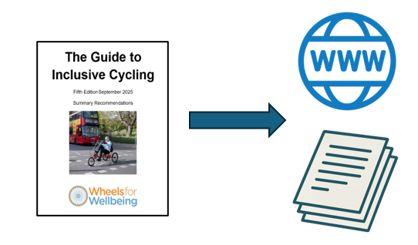
In the Guide, there are links to more information in our website.
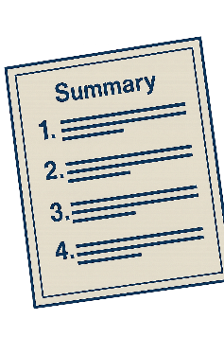
And there are links to other documents that we talk about.

This document is a summary of our main recommendations in the Guide.

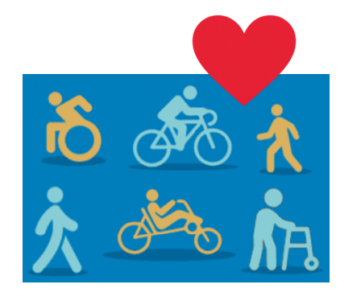
We want walking/wheeling and cycling to be accessible to everyone, for:
- whole journeys or just part of them
- transport and getting around
- leisure or
- health.

Walking/wheeling means moving at a walking pace, but this could be with wheels, like a wheelchair user. We use this term to be inclusive when talking about walking, to include people who use wheels to move.

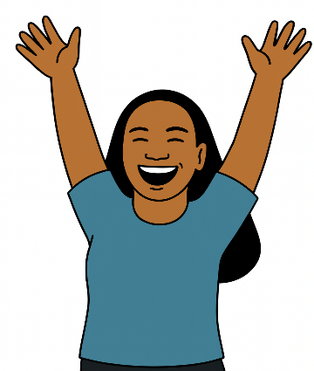

When we move more, it can change our lives. It can make us feel healthier and good about ourselves, no matter our age.
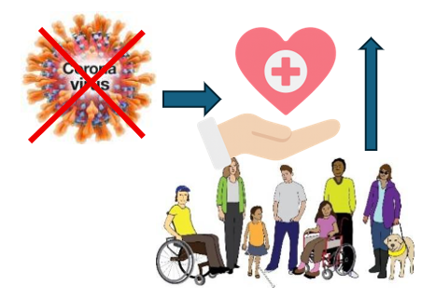
In general, non-Disabled people have better health and are more active than Disabled people.
After Covid, this difference is getting worse for Disabled people. We need to help do something about it.
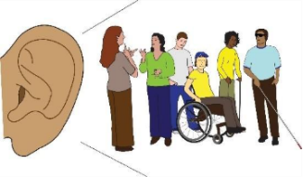

We want Disabled people’s voices to be heard clearly in this work.
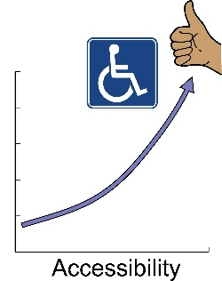

We can change how people understand and support accessible cycling and other active travel.

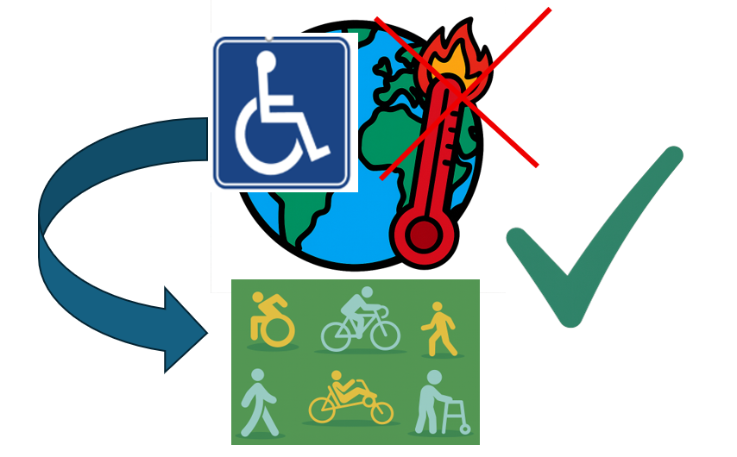
Finally, climate change is affecting everyone. We must include Disabled people in the move to cleaner, active and shared travel.
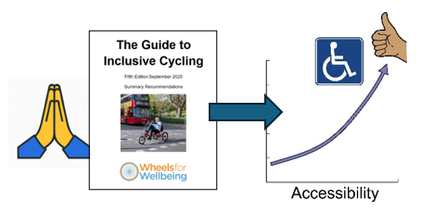
I hope you enjoy reading this document. We hope it helps you to help improve our walking/wheeling and cycling environment.
Please contact us with your thoughts. We want to talk about how we can together make active travel accessible to all as soon as we can!

What we need

to make cycling more inclusive

our recommendations

We need:

equity

mobility justice and

the Social Model of Disability
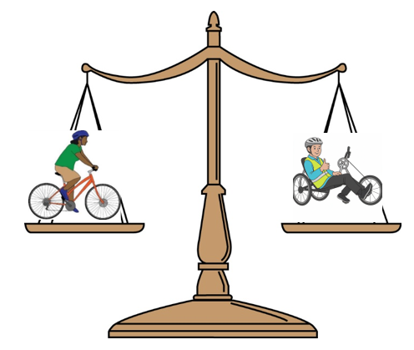
- Equity means everybody gets what they need instead of everyone getting the same.
For example, some people need a cycle with 3 wheels. So if only cycles with 2 wheels are available, that is not fair.

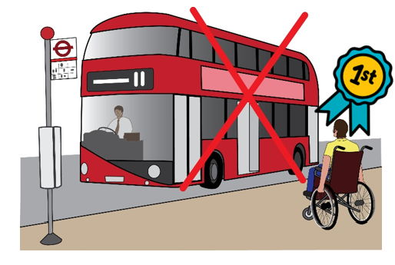
- Mobility justice means putting first the people who cannot make journeys because there is no accessible transport.
It means thinking about these people first when designing new transport systems.

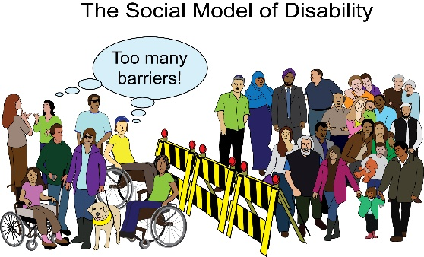
- The Social Model of Disability says people are only disabled because of the way society is organised. It looks at how society excludes Disabled people instead of looking at their disability.
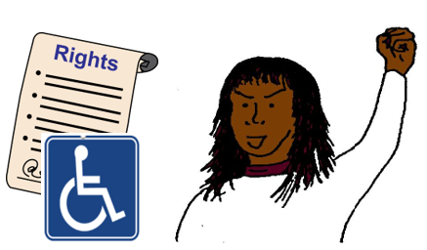
The Social Model is about rights for Disabled people.

mobility means moving around, getting around.

justice means being fair to everyone.

We need inclusive language and pictures
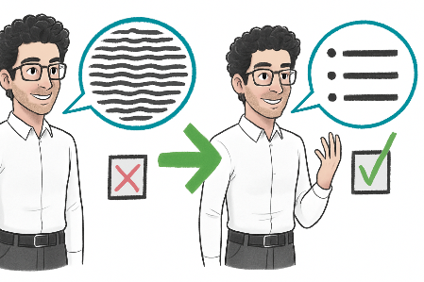
Everyone should use inclusive language and pictures to promote equal rights for Disabled people.

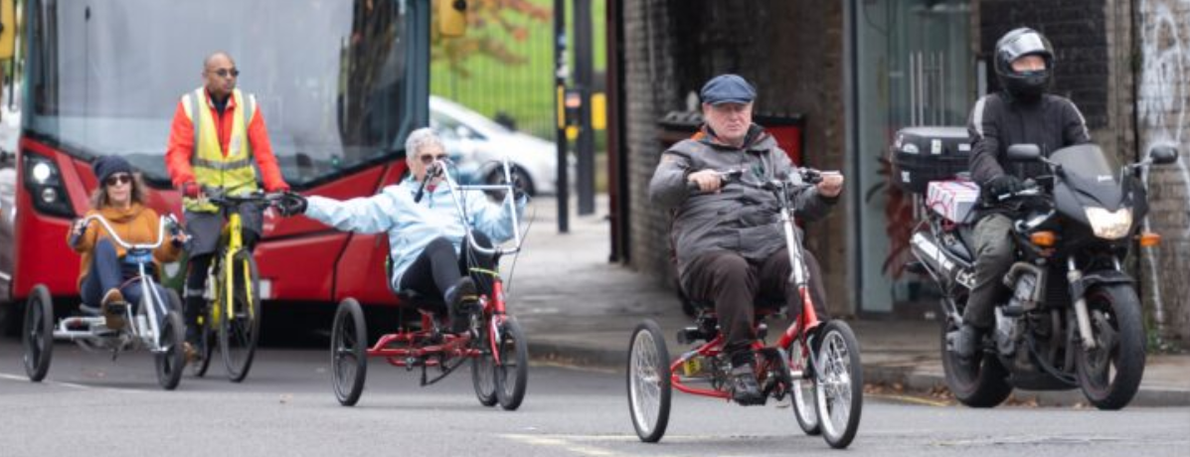
- You can use our photobank of pictures of Disabled cyclists here for free:
Click here for Photobank

- You can ask anyone who is writing about cycling or about Disabled people to use these pictures.

We need inclusive consultation and co-production
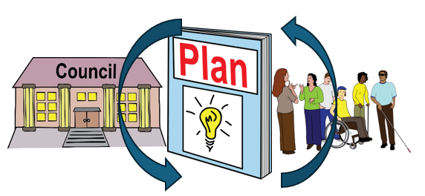
When authorities make rules and design accessible services, they must involve Disabled people from the start.

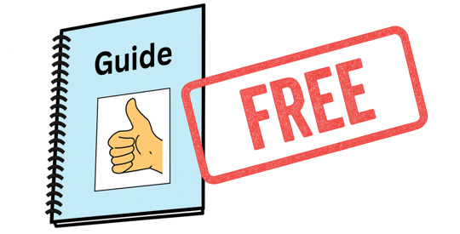
- We have a free guide on how to make consultations inclusive and accessible here:
Guide to accessible consultations link

Consultation means asking people about something. For example, councils will do a consultation to ask the public about how they should improve their services. They might send out a survey to ask the questions.

Co-production means working together equally, right from the start. Sharing power.

We need high quality information

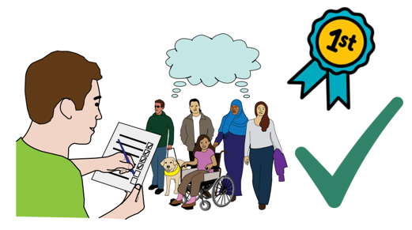
We need good research (studies) to get quality information about Disabled people and active travel.
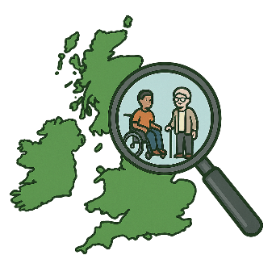

The information needs to be from across the UK and for any kind of disability.


- Get involved!
  - Sign up to our newsletter at the bottom of this webpage:
Wheels for Wellbeing newsletter sign up link


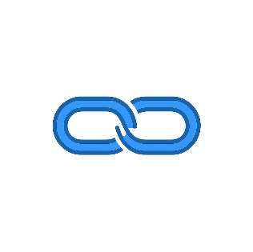
  - To take part in research, you can click the links below to sign up to:
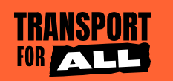
    - Transport for All



    - RiDC (Research Institute for Disabled Consumers)

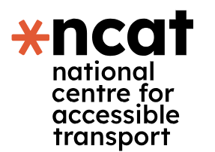

    - NCAT (National Centre for Accessible Transport)

We need support for law cases about discrimination against Disabled people when they travel

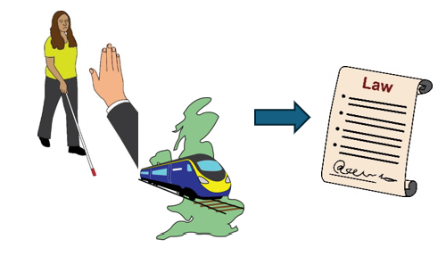
If transport companies do not treat Disabled people fairly and give them what they need to make a journey, it can be against the law.
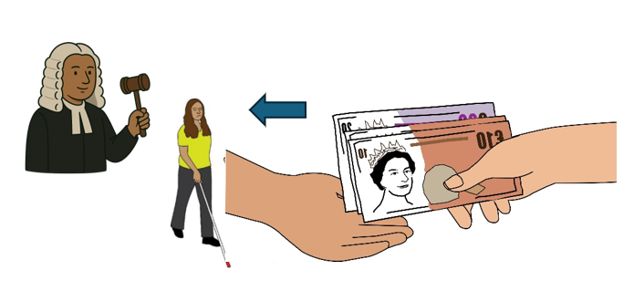
Disabled people can take these companies to court to try to make them make changes. Also, the court might make them pay money to the Disabled person.

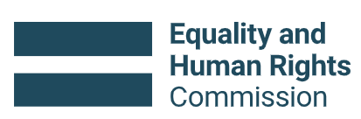
These kinds of law cases need more support, ideally by the Equalities and Human Rights Commission (EHRC).
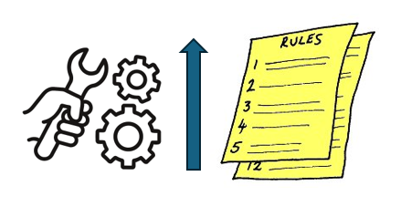
This is so that things can change in the future with better rules and systems.


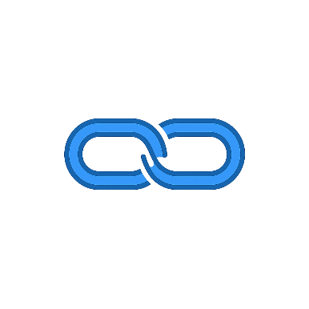
- You can see some of the recent EHRC law cases, including one about Disabled people and transport here in this link.

Discrimination means not treating someone fairly because of things like their disability, race or sex.

We need a national, accessible cycling advice service
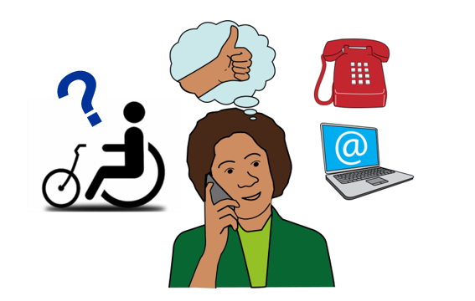
We need this service to give information about:
- cycle types
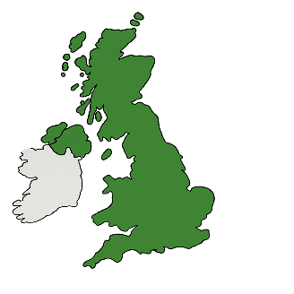
- cycle training and
- where to find cycles.

- We have an advice line that offers some of these services:
call: 020 7346 8482
email: info@wheelsforwellbeing.org.uk

We need very good design and maintenance of infrastructure
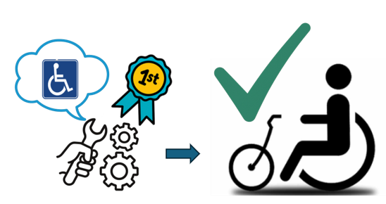
We need all roads, rails and public transport designed with Disabled people in mind from the start. This is essential for good accessibility.


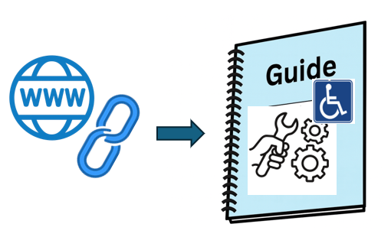
- On our website, we have lots of free advice about how to design things in the best way for Disabled people.
Click this link and scroll down to “WfW Good Practice Guides And Explainers”.
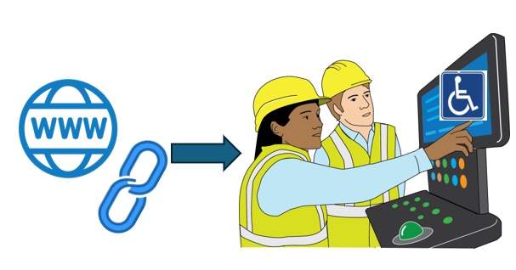
- You can send this link to anyone who might be working on active travel in your area.

Maintenance means keeping things in good working order. Making sure everything works well, doing repairs.

Infrastructure here means society’s travel systems, like roads, trains and cycle lanes.

We need to use good tests to check to see if things are fair for everyone.

We need to know how accessibility problems affect Disabled people.
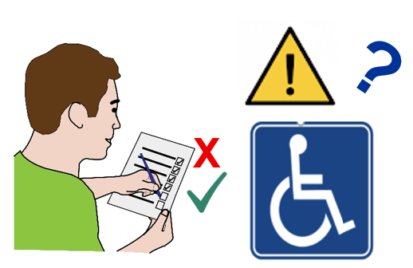
This is to help see accessibility problems and try to fix them or make them better.

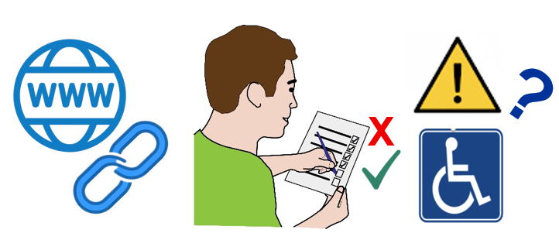
- Click this link on our website to find out more about these tests.

We need to look at lots of accessibility design information and support – in the UK and abroad
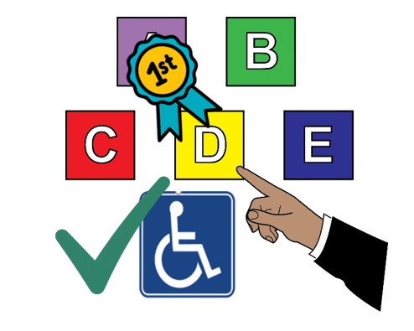
Different organisations suggest making things accessible in different ways. We should choose the way that helps the most Disabled people possible.
  - On this link on our website you can find lots of advice guides about best practice for accessibility.

Ask anyone working on active travel to use these guides.

We need changes in the law
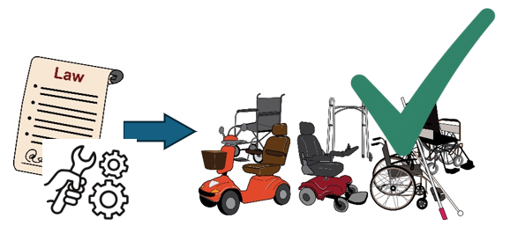
This is to make mobility aids and micromobility devices fully inclusive and accessible to all.
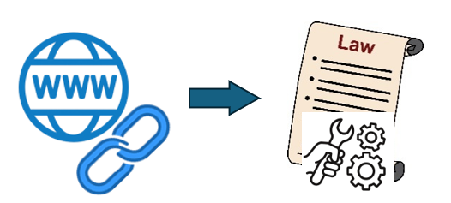
- You can read about the changes that we want to see in the law on our website page link here.

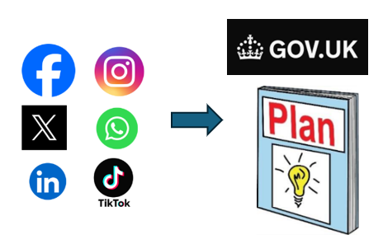
If you follow us on social media, you can find out when the government starts to consult (ask) about their plans and how to have your say.

Our social media name is: @wheelsforwellbeing.org.uk

mobility aids are things like wheelchairs and mobility scooters. Things that help Disabled people move around.

micromobility devices are things like electric scooters and electric cycles. They are usually electric and can be used by anyone.

We need funds to help Disabled people to cycle

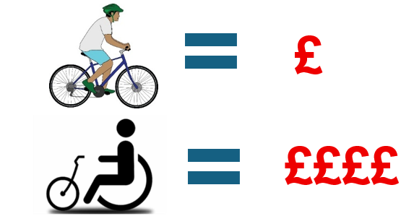
It costs more for Disabled people to cycle compared to non-disabled people. We need funds (money) to help with this.
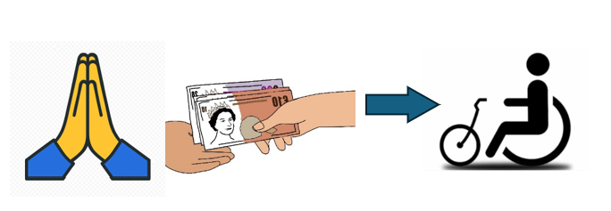
We also need funds for poorer Disabled people to get cycles at lower cost or for free.
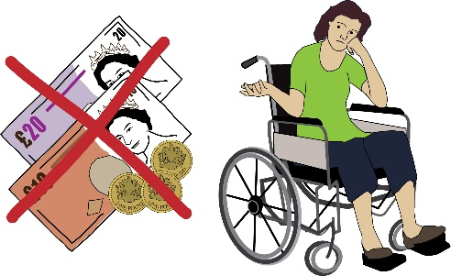
  - If you need funds for your own cycle, click this link on our website to see what’s available.

We need accessible cycle hire and share schemes

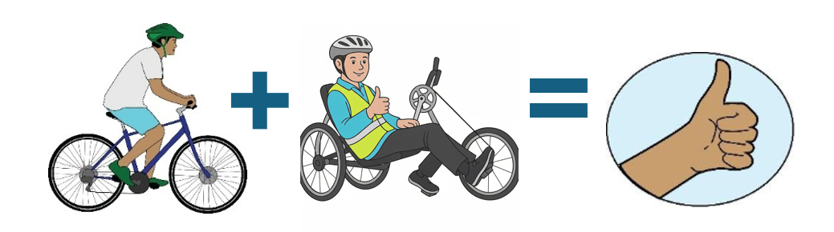
Accessible cycles need to be available as easily as standard bikes and e-bikes are.

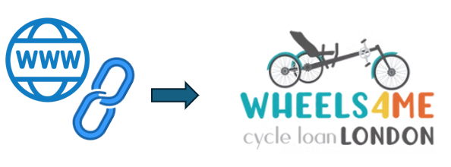
- Click here on our website to find out more about our inclusive cycle hire scheme in London.

We need a big change in public transport accessibility
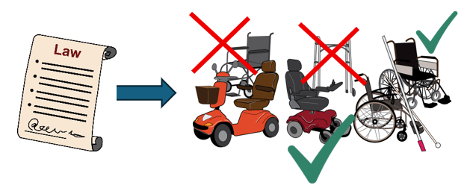

Now, the law does not recognise all mobility aids.

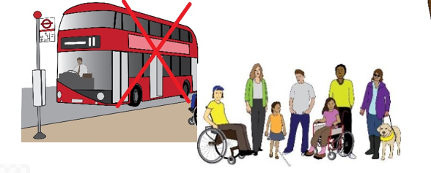
Also it is often difficult for many Disabled people to travel at the same time. This must change.

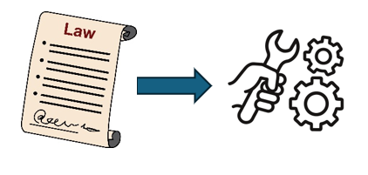
- Find out more about the law changes we want to see here on our website.

We need high quality training in disability equity and accessibility

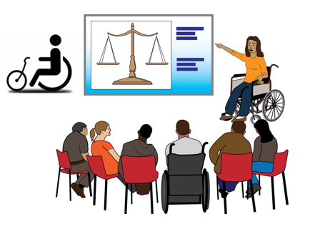
Everyone making decisions about transport and mobility must do this training. If they don’t, they won’t understand what Disabled people’s transport needs are.

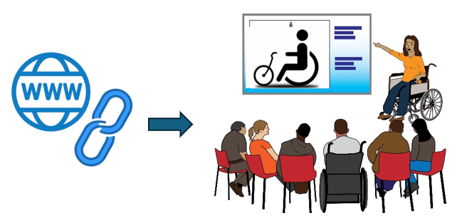
- Click this link to find out more about our training we offer. You can recommend our disability equity training to anyone working on accessible transport.

Equity means everybody gets what they need rather than everyone getting the same. For example, some people need a cycle with 3 wheels. So if only cycles with 2 wheels are available, that is not fair.

We need everyone to use the current accessibility guidance and standards
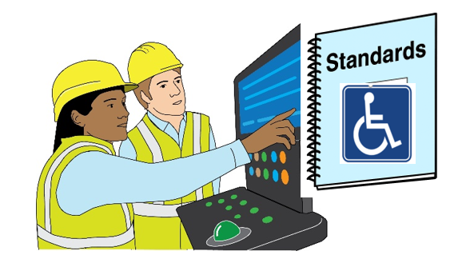
Anyone working on any public transport scheme should start with these standards. Then there should be reviews to keep improving.
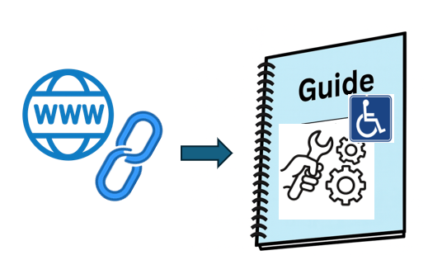
- Click here on our website to find our guides about accessible design.

We need co-production with local Disabled people. And we need experts to make sure accessibility is always good.
We need local Disabled people to be involved in design of transport schemes right from the start.

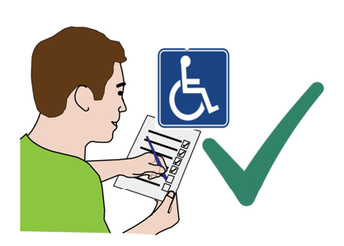
We also need experts to keep checking everything is going well.

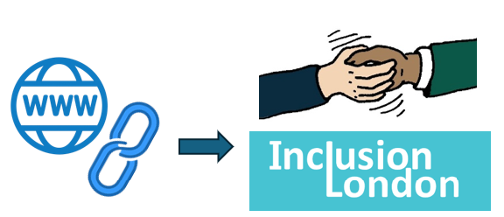
- Click here for information about co-production from Inclusion London.

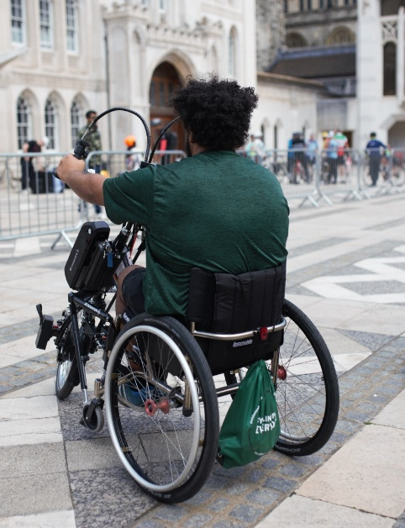
Wheels for Wellbeing
336 Brixton Rd
London
SW9 7AA

www.wheelsforwellbeing.org.uk

info@wheelsforwellbeing.org.uk

Tel: 020 7346 8482

Find us on BlueSky, Facebook, Instagram & LinkedIn @wheelsforwellbeing

Registered Charity number 1120905
Company number 06288610

© Wheels for Wellbeing
All rights reserved

