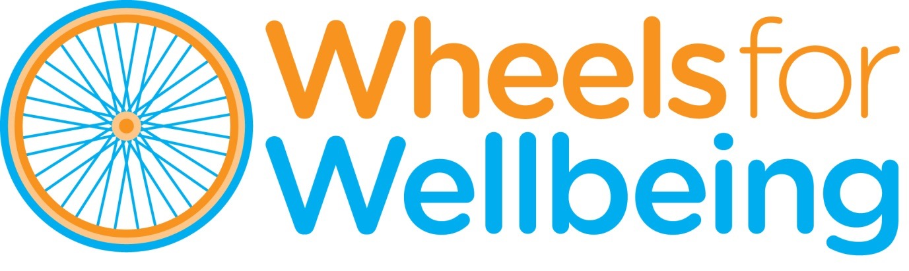

**Recruitment Pack**

**MARKETING & COMMUNICATIONS MANAGER**

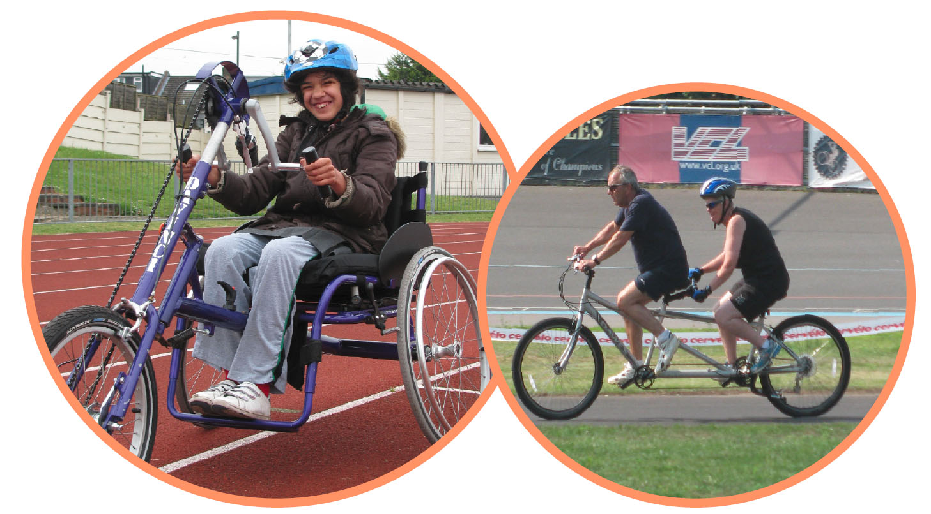

January 2025

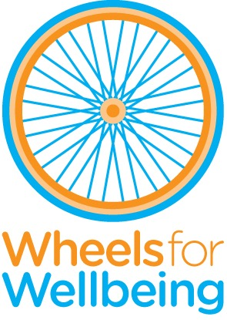

336 Brixton Road

London

SW9 7AA

Tel: 020 7346 8482

[info@wheelsforwellbeing.org.uk](mailto:info@wheelsforwellbeing.org.uk)

[www.wheelsforwellbeing.org.uk](http://www.wheelsforwellbeing.org.uk)

January 22, 2025

Dear Applicant,

Thank you for your interest in the post of **MARKETING AND COMMUNICATIONS MANAGER (20 to 25 hrs pw)** at Wheels for Wellbeing. This is a new post within our organisation, being created to support our Board of Trustees, our Director and the rest of the Senior Management Team as we implement our new strategic plan. We would love to hear from you if you:

* Have proven marketing and/or communications management experience, evidenced through the development of marcomms plans and the implementation of communications and marketing activities.
* Would like to use your communications and marketing skills to play a pivotal role in removing barriers to cycling for Disabled people
* Care deeply about mobility justice and equity

We are the right organisation for you if you’re looking:

* To be part of a culture that genuinely values the impact communications and marketing makes.
* To align your work with a deeper purpose. We’re committed to remove the barriers to cycling for Disabled people and other minoratised communities.
* To have significant input and involvement, owning and learning from the results of your work and from the wider team.
* To work in an experienced team that has a passion for developing talent.
* For a flexible work life balance that encourages you to make time for your own wellbeing.

Wheels for Wellbeing is an Equal Opportunity Employer and our employees are people with different strengths, experiences and backgrounds, who share a passion for improving people's lives. As you would expect from a Disabled-led organisation, Wheels for Wellbeing is proactive about supporting Disabled employees who need reasonable adjustments. Diversity not only includes disability, race and gender identity, but also age, sexual orientation, religion and many other parts of one’s identity. We are committed to creating a diverse and inclusive working environment - a place where individuality is embraced, everyone has the opportunity to thrive and inclusion is everyone's responsibility. We welcome and encourage individuals from diverse backgrounds to apply, and we will consider all applications fairly and consistently.

Our office is based within a community hub in South London, home to several Disability-led organisations and is accessible by wheelchair & other mobility aids; this post can be also be done remotely, with regular visits to our premises. We are planning to hold interviews in person at our office but will consider online interviews, if required for accessibility reasons.

Please note that this post involves some work with adults at risk and is not protected under the Rehabilitation of Offenders Act 1974. Applicants invited to interview will therefore be asked to disclose criminal convictions, no matter when they occurred. Information will be treated confidentially and only considered if relevant to the post.

To apply, please email your CV to info@wheelsforwellbeing.org.uk with a cover letter (no more than two pages, ensuring you address the points in the person specification). The **closing date for this role is Midday on Monday 17th February**. We will however consider applications as they reach us, so we encourage you to apply as soon as you are able to. Formal interviews are likely to be held **24th or 25th February 2025**.

Yours sincerely

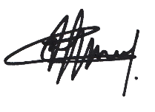

Isabelle Clement MBE, Director

Background

Wheels for Wellbeing is a disability and cycling organisation led by Disabled people. Formed from the belief that cycling is transformational for health, transport and social inclusion, Wheels for Wellbeing champions mobility justice and mobility equity. Established eighteen years ago, the charity seeks to radically change the world of active travel by removing barriers to cycling for Disabled people.

As well as operating cycling sessions for Disabled people at three venues in South London, Wheels for Wellbeing is driving improvements to cycling infrastructure and the team is actively changing cycling design standards in London, across the UK and in cities across the globe.

Our grassroots work takes place in leisure facilities, community centers, schools, hospitals and on streets in south London, using our large fleet of bikes, trikes, handcycles, recumbents, tandems and side-by-sides. Our participants are aged 2-102 and live with a range of impairments, health conditions, mental health issues and/or neurodiversity. They all experienced barriers to cycling prior to finding out about the cycling opportunities and advocacy we provide. We call this our **Wheels for Life** work-stream.

In 2012 a few of us became aware that very few people realised that Disabled people could cycle and that for many, our cycle was far more than a bike, i.e. an incredibly important mobility aid. This lack of understanding was resulting in Disabled people being denied key rights: the right to improve our health by travelling actively; to access green and blue spaces and our local communities, etc. We started communicating with cycle campaigners, transport planners and designers as well as decision makers about the lived experience of Disabled cyclists. We found a real appetite for what we had to say and our **Wheels for Change** work-stream was born, working to influence cycling policy, infrastructure guidance, etc. at local, national and UK level. Wheels is regarded as a thought-leader in this field.

Our expertise is now widely sought and so we have developed training and consultancy services. This area of our work is growing and one of our strategic aims is to grow it significantly (into **Wheels for Learning**) alongside our two other work-streams.

Our funding sources are varied: a combination of Trust & Foundations grants, self-generated income and individual & corporate donations. Communications is of course crucial for our ability to fundraise and this post will be key in supporting our long-term financial sustainability.

Our team is small, with big ambitions to grow our influence.

For more information, see [www.wheelsforwellbeing.org.uk](http://www.wheelsforwellbeing.org.uk/) & @WheelsForWellbeing on social media.

**Wheels for Wellbeing staff structure (January 2025):**

Posts in orange are currently vacant

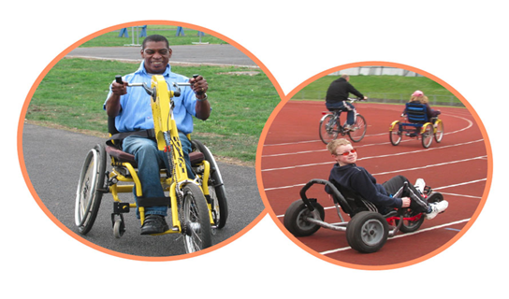

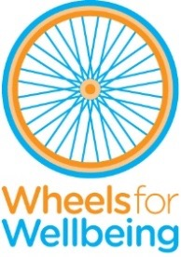

# MARKETING & COMMUNICATIONS MANAGER

**Responsible to:** Director/CEO

**Line management responsibilities:** N/A

**Hours:** 20 to 25 per week (flexible)

**Contract duration:** Two Years Fixed term (with ambition to make permanent)

**Salary: £18k to £27k (**£33k to £38kdepending on experience - pro-rata)

**Place of work:** Brixton, SW9 (or home based + occasional visits to the office/sessions)

**Job Purpose**

This role is new within Wheels for Wellbeing. As the organization’s role and influence expands and we implement our recent strategic vision, our Board, our Director and the rest of the Senior Management team require the support of an experienced Marketing and Communications professional.

Following a recent strategic review of our operations, a three-pillar approach is being adopted by the charity:

**Wheels for Life:** Continue to operate and promote inclusive cycling hubs at three venues in South London; develop an inclusive cycle hire service and signpost enquiries to recommended partners across London/the UK.

**Wheels for Change:** Campaigns & policy influencing work to bring about mobility justice for Disabled people, with a particular focus on active travel (walking/wheeling and cycling). Thought-leadership in this field.

**Wheels for Learning:** Establishing a UK-wide Training and Consultancy service will speed up the spread of our expert knowledge and will support our financial sustainability strategy. It will also provide volunteering and paid work opportunities for growing numbers of Disabled cyclists.

We are seeking an experienced and dynamic communications and marketing professional to build a marcomms strategy, engage our target audience and build on our reputation as the go-to organisation for inclusive cycling and to support our fundraising and income generating strategy. There is scope for creative thinking; from how we engage with users of our services to build advocacy, how we link mobility justice to the climate emergency and how we share our stories of success to increase our reach and impact.

**Probationary Period**

The appointment of every new employee is subject to a probation period of six months.

**Pension**

Wheels for Wellbeing provides 5% contribution towards your pension.

**Annual leave**

Annual leave entitlement is 20 days in addition to the 8 English Public Holidays (pro rata), plus a few days between Christmas and New Year when the building is closed.

**Job Description**

**Key Responsibilities**

* Develop a communications strategy aligned to the organisation’s communication priorities. Identify key messages and develop a clarity of message for the organisation to use. Create a unique positioning for the Wheels for Wellbeing brand, utilising insights from the latest strategic review and following an audit of existing digital and communication outputs.
* Fundraising: Attract, build and deepen relationships with individual and corporate fundraisers. Utilise events and activities to raise awareness of Wheels for Wellbeing and to attract challengers to raise funds for the charity. Use a funnel approach (within the marcomms strategy) to convert users and advocates into regular donors. In due course, build an approach to activate and engage legacy giving and philanthropists.
* Plan, design and create a content plan, both online and offline.  Share impact and stories of success to build engagement and advocacy across all target audiences.
* In partnership with the Wheels for Wellbeing team, build brand and tone of voice guidelines. Lead on the creation of brand collateral and ensure compliance with brand standards.
* Manage Wheels for Wellbeing digital channels and activity on a day-to-day basis, engaging with users and supporters (building a comms culture internally so all team members feel confident in utilising digital media). Identifying opportunities for further engagement.  Build on work already started, eg newsletters, regular blogging, user insights.
* Partner with the Campaigns team to develop opportunities with external stakeholders and influencers. Support the team to find and build relationships with influencers and advocates.
* Provide an analytical data-driven-perspective. Monitoring, reporting, and analysing engagement emails, posts and marcomms campaigns to drive continual results improvements and learning.
* Over the length of the contract, promote the importance of Wheels for Wellbeing’s role nationally in amplifying the voice of Disabled cyclists with organisations like Transport for All, Disability Rights UK. Position Wheels for Wellbeing as the campaigning voice of Disabled people in the climate emergency and as active lobbyists for transport equity.
* In due course, build and collaborate on an internal communications plan to facilitate two-way sharing of information with a focus on tangible stories.

**Activities**

**Wheels for Life**

* Build community locally to support local Disabled people to access cycling sessions. Drive attendance at cycling sessions by utilising SEO, online tools and offline communications platforms. Connect with Disabled cyclists anywhere, over the time of the contract building a community of advocacy and support.
* Support our Cycling Operations team to identify and link up with health and social care networks locally to promote the sessions.
* Promote the benefits of volunteering at Wheels for Wellbeing.
* Work collaboratively with the sessions team to build a marketing and communications plan that aligns with the fundraising and income generation strategy

**Wheels for Change**

* Collaborate with the campaigns team and share stories of success. Build the reputation of Wheels for Wellbeing as a leading disability organisation and disability advocacy movement.
* Share stories from our Disabled Cyclists Advocacy Network
* Identify partners for Wheels for Wellbeing to work with, linking with other disability organisations.
* Position Wheels for Wellbeing as an organisation that is led by Disabled people, and can therefore authentically help organisations understand active travel.

**Wheels for Learning**

* Increase the awareness of WfW as a provider of Training and Consultancy by utilising SEO, online tools and offline communications platforms. Connect with active travel and public transport professionals across the UK, attracting future customers.
* Build a community where learnings and influence can be shared.

**Other**

* Contribute to the ongoing development of Wheels for Wellbeing, team meetings and organisational priorities
* Be proactive in keeping up to date with developments affecting the role
* Abide by and promote organisational policies and practices, and charity’s values
* Support diversity and equality of opportunity in the workplace
* Occasionally, with notice, work evenings / weekends
* Work at least once a quarter in an appropriate role at a Wheels for Wellbeing session

The above list of job deliverables is not exclusive or exhaustive and the post holder will be required to undertake such tasks as may reasonably be expected within the scope and grading of the post.

**Person Specification**

|  |  |  |
| --- | --- | --- |
| **KNOWLEDGE AND EXPERIENCE** | **Essential** | **Desirable** |
| Minimum of 3 years communications/marketing experience. | ✓ |  |
| Proven communications experience, evidenced through the development of marcomms plans and the implementation of communications and marketing activities. | ✓ |  |
| Experience of providing training & support to operational teams | ✓ |  |
| Demonstrable experience of creating successful digital campaigns and utilising tools to do this - experience using Linked In, Mailchimp, Moz, hubspot (or similar) and Google Data Studio or similar. | ✓ |  |
| Knowledge of GDPR legislation |  | ✓ |
| Experience (paid or unpaid) of working with Disabled adults and children |  | ✓ |

|  |  |  |  |  |
| --- | --- | --- | --- | --- |
| **SKILLS** | **Essential** | | **Desirable** | |
| Excellent written communication skills with ability to write blogs/articles/reports | ✓ | |  | |
| Excellent teamwork skills, with proven ability to develop relationships with key stakeholders both internally and externally, both in person and online | ✓ | |  | |
| Able to gather and analyse data to influence activity, providing reporting metrics to the organisation. | | ✓ | |  |
| Skilled at managing multiple projects, with attention to detail and able to meet deadlines. | | ✓ | |  |
| Budget management experience. |  | | ✓ | |

|  |  |  |
| --- | --- | --- |
| **ATTITUDES AND BEHAVIOURS** | **Essential** | **Desirable** |
| Professional manner and friendly disposition. Commitment to excellent customer service & high levels of satisfaction | ✓ |  |
| A commitment to working to empower and further the rights of Disabled people and to working within the Social Model of Disability | ✓ |  |
| Respectful of others and with a total belief in the equal value of people, regardless of race, religion, culture, gender, age, disability or sexuality | ✓ |  |