Recruitment Pack

INCLUSIVE CYCLING ADVISOR

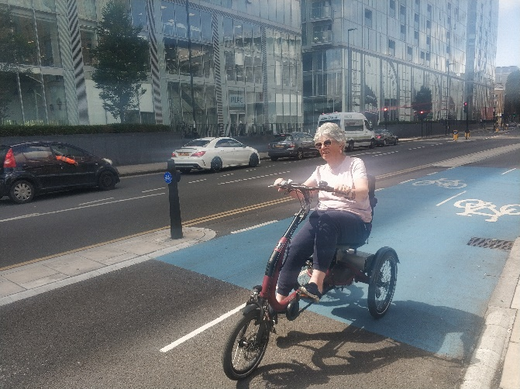

APRIL 2024

336 Brixton Road
London
SW9 7AA
Tel: 020 7346 8482
info@wheelsforwellbeing.org.uk
www.wheelsforwellbeing.org.uk

April 15, 2024
Dear Applicant,

Thank you for your interest in the post of INCLUSIVE CYCLING ADVISOR at Wheels for Wellbeing. This is a new post within our organisation, being created as part of the forthcoming launch of Wheels4Me London (a fully inclusive cycle loan scheme for the Capital). Wheels4Me London is a partnership project between Sustrans London, Peddle My Wheels and Wheels for Wellbeing, funded by the Motability Foundation. This post is full-time and currently funded until November 2026 (with an ambition to make it permanent). This post is an information and advice role and the post holder could be based anywhere in the England, but they will need to be able to travel to London when required.

We especially welcome applications for this role from Disabled people, but would like to hear from anyone who is:
- Passionate about Disabled people having access to cycling
- Has knowledge about and/or is willing to learn about all types of cycles for all types of riders
- Has excellent customer care skills (friendly, helpful, patient, a good listener)
- Feels energised when researching information to meet the needs of enquirers
- Is able to communicate with people from diverse backgrounds and impairment groups

We are an Equal Opportunity Employer and our team is made up of people with different strengths, experiences and backgrounds, who share a passion for improving people's lives. Diversity includes disability, race and gender identity, but also age, sexual orientation, religion and many other parts of one’s identity. All of our employees’ points of view are key to our success, and inclusion is everyone's responsibility.

Our office is based within a community hub in South London is accessible by wheelchair & other mobility aids. We plan to hold interviews in person at our office but will consider online interviews, if required for accessibility reasons.

Please note that this post involves some work with adults at risk and is not protected under the Rehabilitation of Offenders Act 1974. Applicants invited to interview will therefore be asked to disclose criminal convictions, no matter when they occurred. Information will be treated confidentially and only considered if relevant to the post. If appointed you will be required to undertake a DBS check.

To apply, please email your CV to me (isabelle@wheelsforwellbeing.org.uk) with a cover letter (no more than one page of A4, ensuring you address the points in the person specification (see page 7 of this pack). The closing date for this role is 12 noon on Friday 3rd May 2024. Interviews are likely to be held on Friday 10th May.

Yours sincerely

Isabelle

Isabelle Clement MBE, Director

Background

Wheels for Wellbeing is a disability and cycling organisation led by Disabled people. Established over fifteen years ago, the charity exists to radically change the world by removing barriers to cycling. Formed from the belief that cycling is transformational for health, transport and social inclusion, Wheels for Wellbeing champion mobility justice and mobility equity. There are two main strands to the organisation, the first is the cycling operations team, and the second is the campaigns and policy team (see staff structure below).

Since 2007 our cycling operations team have been working in leisure facilities, community centres, schools, hospitals, velodromes and on streets in south London, using our large fleet of bikes, trikes, handcycles, recumbents, tandems and side-by-sides. Our participants are aged 2-102 and live with a range of impairments, health conditions, mental health issues and/or neurodiversity. They all experienced barriers to cycling prior to finding out about the cycling opportunities we provide.

Since 2012 our campaigns and policy team have been working with cycle campaigners, transport planners, local and national governments and designers to influence cycling policy, infrastructure guidance, etc. at local, national and UK level. Wheels for Wellbeing is regarded as a thought leader in this field and our expertise is now widely sought and we have developed a range of training and consultancy services.

Reasons for the creation of this post:
Though we (and others) provide opportunities for Disabled to cycle at inclusive cycling sessions, the cost of purchasing your own e-trike, a recumbent or a handcycle remains extremely high and there are currently no opportunities to try one out, as part of any of the existing cycle hire/cycle share schemes currently in existence. Also, many Disabled people struggle to find impartial information about what options they may be able to consider when wanting to cycle. We ran a first inclusive cycling loan pilot project in 2021/22. The learning from this led to the exciting Wheels4Me London+ partnership, led by Sustrans London, and with the logistics support of Peddle My Wheels and funded by the Motability Foundation. The service is being launched this Spring/Summer and this post, based within Wheels for Wellbeing, will be central to its success.

For more information, see www.wheelsforwellbeing.org.uk & @Wheels4Well on social media.

Wheels for Wellbeing staff structure (April 2024):

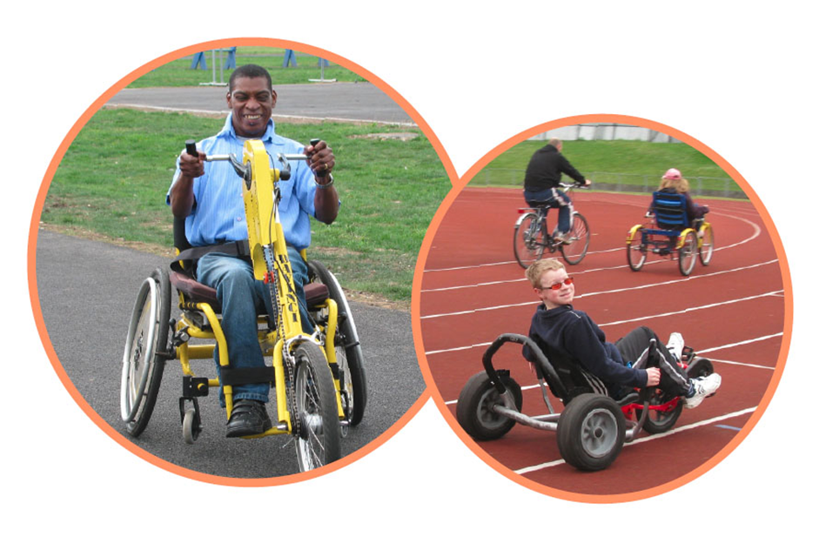

INCLUSIVE CYCLING ADVISOR

Responsible to: Cycling Operations Manager
Hours: Full-time (35 hours per week – Monday to Friday)
Duration: Thirty months Fixed term (with ambition to make permanent)
Salary: £26,500
Place of work: To be agreed (can be home-based; hybrid or office-based in SW9)

Job Purpose
Increasing numbers of Disabled people are becoming aware of the fact that CYCLING might be possible for them. However, information about how/where to access cycling, the variety of possible equipment, regulations around cycling a non-standard cycle, funding avenues, etc. can be difficult to find. As the Wheels4MeLondon loan scheme starts to be marketed in Spring/Summer 2024, we anticipate increasing numbers of enquiries to reach us, including from around the UK.

With the support of the rest of the Wheels for Wellbeing team, our Specialist Advisor will become very knowledgeable about all aspects of Inclusive Cycling and will support enquirers with information and advice about the most appropriate next steps with regards to their cycling ambitions. They will provide information and advice, based on where enquirers live, their level of experience with cycling, their goals (whether they wish to try out cycling, to borrow, hire or to purchase a cycle, etc.).

Where a caller wishes to attend one of our own cycling sessions, the Advisor will support them with using our booking system. Where a caller is ready to borrow a cycle through Wheels4MeLondon, the Specialist Advisor will support callers to request a loan via the Peddle My Wheels website. Peddle My Wheels staff will then deliver the cycle to them at the agreed place and time, provide cycle training where required, and collect the cycle at the end of the loan period. For other enquiries, the Advisor will signpost callers to relevant external organisations.

To be successful in this role you need excellent listening and communication, interpersonal and organisational skills. You will love acquiring knowledge (including through online research), storing information and sharing it. You need to be confident using record keeping systems, within our data protection & privacy policy and working with people from diverse backgrounds and with a range of accessibility needs.

Job Description

- Answering enquirers’ queries and providing information. This will include:
  - Being first point of contact for enquiries into Wheels for Wellbeing’s phone / email.
  - Actively listening to understand the detailed nature of the query and responding through the most appropriate and accessible mode of communication, whether contact is made by phone, email, instant messaging or other methods of communication.
  - Sourcing information from the rest of the Wheels for Wellbeing team and/or researching specific information for callers (where appropriate, redirecting the query to colleagues within the organisation or signposting them to other organisations).
  - Ensuring that new, useful information is stored/posted to our website for use by future enquirers.
  - Supporting people with queries about how to access Wheels for Wellbeing’s services, including support with our booking system
- Building accessible information resources (eg: website pages, briefings, FAQ page, etc.) about Inclusive cycling, such as:
  - Inclusive cycling opportunities providers in London and around the UK
  - Types & models of non-standard cycles and specialist adaptions retailers around the UK and overseas
  - Details of the Wheels4Me London’s scheme and other inclusive cycle hire/loan schemes around the UK.
  - Funding options for Disabled people wishing to purchase their own cycles
- Effective liaison with all Wheels4MeLondonPlus partners for successful cycle loan experience. This will include:
  - Regular communication with the Peddle My Wheels team to ensure most effective referral methods (to be developed with your input, as the scheme gets off the ground during Spring/Summer 2024)
  - Take part in project team meetings with all partners (Sustrans London; Peddle My Wheels and the rest of the WfW team).
  - Collect and store data such as numbers & types of enquiries, case studies, etc., as required for reporting to the funder.
  - Contribute to short articles, social media posts, etc. for the promotion of Wheels for Me London and Inclusive Cycling in general.
Other:
- Contribute to the ongoing development of Wheels for Wellbeing, team meetings and organisational priorities
- Be proactive in keeping up to date with developments affecting the role
- Abide by and promote organisational policies and practices, and charity’s values
- Support diversity and equality of opportunity in the workplace
- Occasionally, with notice, work evenings / weekends
- Work at least once a quarter in an appropriate role at a Wheels for Wellbeing session
The above list of job deliverables is not exclusive or exhaustive and the post holder will be required to undertake such tasks as may reasonably be expected within the scope and grading of the post.

Person Specification

KNOWLEDGE AND EXPERIENCE | Essential | Desirable
Experience of giving advice / customer care / information, whether in a paid or unpaid capacity
Knowledge of inclusive cycling equipment / adaptions / barriers to cycling for Disabled people etc. Further knowledge will be developed over time by spending time at inclusive cycling sessions & talking with Disabled cyclists
Lived experience of disability
Up to date knowledge of (or ability to learn about) Safeguarding; Health & Safety; Data Protection legislation

SKILLS: | Essential |  | Desirable
Some experience of cycling (on any kind of cycle)
Excellent listening skills
Ability to communicate effectively and clearly with a wide range of people, over the telephone and in writing as well as face to face
An organized individual who has excellent attention to detail, timekeeping and reliability
Ability to keep good records, and the ability to collect case studies (this can be in a variety of formats)
Enjoys working in partnership with others
Computer literate, with the ability to use MS Office, email systems and databases (for inputting information and extracting reports)

ATTITUDES AND BEHAVIOURS | Essential | Desirable
A commitment to working to empower and further the rights of disabled people and to working within the Social Model of Disability
A positive, energetic and enthusiastic outlook with a ‘can do’ approach
A professional manner and friendly disposition. Commitment to excellent customer service & high levels of satisfaction
An ability to relate positively to people of different cultures, backgrounds and experiences
Respectful of others and with a total belief in the equal value of people, regardless of race, religion, culture, gender, age, disability or sexuality

