Recruitment Pack

CENTRAL OPERATIONS MANAGER

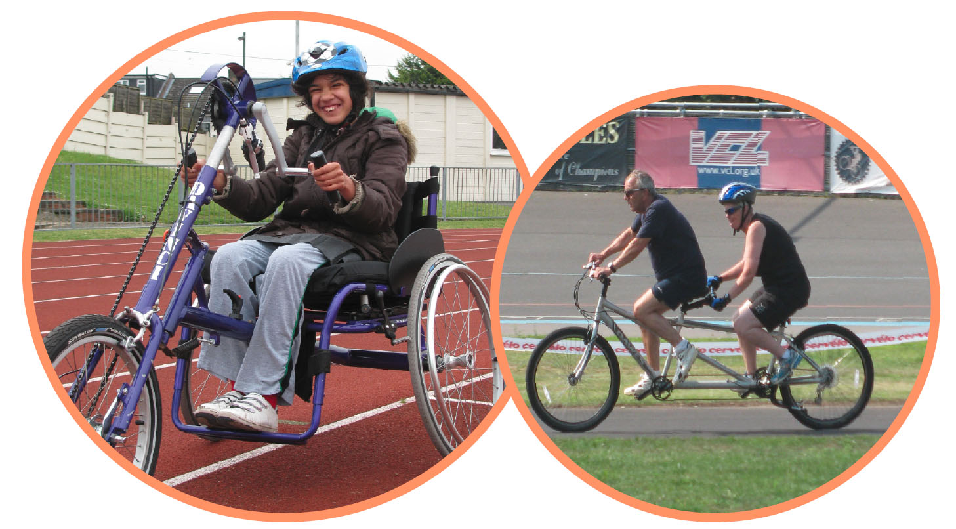

January 2024

336 Brixton Road
London
SW9 7AA
Tel: 020 7346 8482
info@wheelsforwellbeing.org.uk
www.wheelsforwellbeing.org.uk

January 8, 2024
Dear Applicant,

Thank you for your interest in the post of CENTRAL OPERATIONS MANAGER (25hrs pw) at Wheels for Wellbeing. This is a new post within our organisation, being created to support our Board of Trustees, our Director/CEO and the rest of the Senior Management Team as we finalise and implement our new strategic plan. We would love to hear from you if you:

- Have strong Human Resources and Finance knowledge and experience
- Enjoy reviewing and implementing operational policies and systems to increase efficiency and support good governance
- Have experience of supporting organisational change as part of a senior team

We are an Equal Opportunity Employer and our team is made up of people with different strengths, experiences and backgrounds, who share a passion for improving people's lives. Diversity not only includes disability, race and gender identity, but also age, sexual orientation, religion and many other parts of one’s identity. All of our employees’ points of view are key to our success, and inclusion is everyone's responsibility

Our office is based within a community hub in South London, home to several Disability-led organisations and is accessible by wheelchair & other mobility aids; Lambeth is a great borough to cycle to/around and the office has plentiful cycle parking. This post can be also be done remotely, with regular visits to our premises. We are planning to hold interviews in person at our office but will consider online interviews, if required for accessibility reasons.

Please note that this post involves some work with adults at risk and is not protected under the Rehabilitation of Offenders Act 1974. Applicants invited to interview will therefore be asked to disclose criminal convictions, no matter when they occurred. Information will be treated confidentially and only considered if relevant to the post.

To apply, please email your CV to me (isabelle@wheelsforwellbeing.org.uk) with a cover letter (no more than two pages, ensuring you address the points in the person specification). The closing date for this role is Thursday 1st February 2024. We will consider applications as they reach us, so we encourage you to apply as soon as you are able to. Interviews are likely to be held on Thursday 22nd or Friday 23rd February 2024.

Yours sincerely

Isabelle

Isabelle Clement MBE, Director/CEO

Background

Wheels for Wellbeing is a disability and cycling organisation led by disabled people. Established over fifteen years ago, the charity exists to radically change the world and remove barriers to cycling. Formed from the belief that cycling is transformational for health, transport and social inclusion, Wheels for Wellbeing champion mobility justice and mobility equity.

As well as operating cycling sessions for disabled people at three venues in South London, the team focus on removing barriers to cycling for disabled people more generally. Wheels for Wellbeing is driving improvements to cycling infrastructure and the team is actively changing cycling design standards across the UK and in cities across the globe.

Since 2007 our grassroots work has been taking place in leisure facilities, community centres, schools, hospitals and on streets in south London, using our large fleet of bikes, trikes, handcycles, recumbents, tandems and side-by-sides. Our participants are aged 2-102 and live with a range of impairments, health conditions, mental health issues and/or neurodiversity. They all experienced barriers to cycling prior to finding out about the cycling opportunities and advocacy we provide. We call this our Wheels for Life work-stream.

In 2012 a few of us became aware that very few people realised that Disabled people could cycle and that for many, our cycle was far more than a bike, i.e. an incredibly important mobility aid. This lack of understanding was resulting in Disabled people being denied key rights: the right to improve our health by travelling actively; to access green and blue spaces and our local communities, etc. We started communicating with cycle campaigners, transport planners and designers as well as decision makers about the lived experience of Disabled cyclists. We found a real appetite for what we had to say and our Wheels for Change work-stream was born, working to influence cycling policy, infrastructure guidance, etc. at local, national and UK level. Wheels for Wellbeing is regarded as a thought leader in this field.

Our expertise is now widely sought and so we have developed some training and consultancy services. This area of our work is growing and one of our strategic aims it to grow it significantly (into Wheels for Learning) alongside our two other work-streams.

Our funding sources are varied: a combination of Trust & Foundations grants, self-generated income and individual & corporate donations.

Based in London but also, since 2020 around the UK, the team is small, with big ambitions for growth. This role will be critical to turning our ambitions into reality.

For more information, see www.wheelsforwellbeing.org.uk & @Wheels4Well on social media.

Wheels for Wellbeing staff structure (January 2024):

Posts in orange are new posts and currently vacant
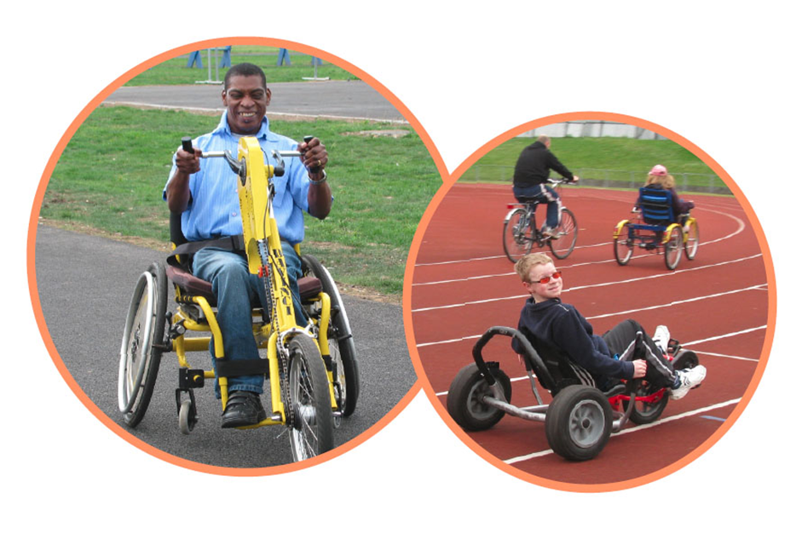

CENTRAL OPERATIONS MANAGER

Responsible to: Director/CEO
Line management responsibilities: Admin Apprentice or Trainee (post to be created)
Hours: 25 per week
Duration: Two Years Fixed term (with ambition to make permanent)
Salary: £33,000 - £38,000 depending on experience (pro-rata for 25 hrs pw)
Place of work: Office based (or Home based with regular visits to the office)

Job Purpose
This role is new within Wheels for Wellbeing. As the organization’s role and influence expands and we implement our recent strategic vision, our Board, our Director and the rest of the Senior Management team require the support of an experienced Operations Manager. This will also enable our Director to take more of a strategic and external facing role to become exclusively a CEO.

The successful candidate will ensure the effective running of Wheels for Wellbeing’s central operations - HR, Finance & IT/telephony (in liaison with our external specialist providers); keep all key policies updated; provide head-office support our two main existing departments (Wheels for Life and Wheels for Change) and lead on establishing new systems and structures for a new department (Wheels for Learning).

To be successful in this role you will have experience of working at senior management level, of providing leadership and of supporting organizational change; excellent communication, interpersonal and organisational skills, with the ability to work on your own initiative and exercise sound judgement.

Our success comes from the dedicated work of our skilled staff, many of whom are Disabled people. You will be valued for who you are in our supportive and friendly team.

Probationary Period
The appointment of every new employee is subject to a probation period of six months.

Pension
Wheels for Wellbeing provides 5% contribution towards your pension.

Annual leave
Annual leave entitlement is 20 days in addition to the 8 English Public Holidays (pro rata), plus a few days between Christmas and New Year, when the building is generally closed.

Job Description

Key deliverables:
Be responsible for all Central Operations to support the Director/CEO & all WfW services:
- Human Resources (with the support of our external HR consultants):
  - Coordinate new staff recruitment: support department managers with recruitment pack production, advertising etc.; new staff on-boarding (contracts; DBS checks where required, etc.)
  - Source/coordinate/monitor mandatory & other training, development opportunities and explore developing apprenticeships & traineeships within Wheels for Wellbeing
  - Communicate with staff about salary reviews, changes in terms & conditions etc.
  - Coordinate leaving processes incl. exit interviews
- Cross-organisational policies regularly reviewed and in line with current legislation & best practice (eg: Safeguarding; H&S; D&I & EOps; GDPR)
- Finance:
  - Keep track of funding streams for each project & liaise with fundraiser re: project budgets for bids, for monitoring etc.
  - Lead on budget preparation / management accounts preparation / Year End;
  - Liaise with each department re: creditor invoices needed & liaise with bookkeeper re: production of invoices / bank reconciliation / salaries journals etc. Coordinate systems for credit control across the organisation.
  - Liaise with our external payroll provider re: monthly wages + pensions administration, etc.
  - Support Cycling Operations Manager with Sessions Rota and zero hours contracted staff pay / leave etc. calculations.
  - File annual Gift Aid claims based on correct documentation
  - Schedule all online banking payments for 2nd authorization.
- Head-office services
  - Oversee telephony/Broadband/Printing/IT contracts & relationships with suppliers - including coordinating online Portal development, office management, insurance.
  - Ensure all callers have a good experience when interacting through any of our systems (online, on the telephone, via our booking system, our website etc.).
  - Ensure all staff (including off-site staff) have appropriate phone & IT equipment, as well as correct seating, etc., including supporting them and their managers over Access To Work applications.
  - In liaison with our Marketing and Communications Manager (new post, about to be created), ensure our website is correctly representing and supporting all areas of our work.
  - Be the main contact for all our suppliers.
- Ensure Monitoring & Evaluation frameworks are agreed for each funding stream / liaise with our external Fundraiser and produce required impact data
- Support the Director/CEO in the production of Board papers & coordination of online/in person meetings and events

Business Development:
- Support Director/CEO with finalising Business Plan & implementation plan, following our strategic review, coordinating input from all teams.
- Lead on setting up “Wheels for Learning” incl: project planning; setting up systems for work flow monitoring; recruiting & developing partners/consultants (all in coordination with Campaigns & Policy Manager).
- Support “Wheels for Change” and “Wheels for Life” Managers in all Projects / services development planning & implementation

Other:
- Contribute to the ongoing development of Wheels for Wellbeing, team meetings and organisational priorities
- Be proactive in keeping up to date with developments affecting the role
- Abide by and promote organisational policies and practices, and charity’s values
- Support diversity and equality of opportunity in the workplace
- Occasionally, with notice, work evenings / weekends
- Work at least once a quarter in an appropriate role at a Wheels for Wellbeing session
The above list of job deliverables is not exclusive or exhaustive and the post holder will be required to undertake such tasks as may reasonably be expected within the scope and grading of the post.

Person Specification

KNOWLEDGE AND EXPERIENCE | Essential | Desirable
Senior management experience working within an organisation that delivers front line services.
Experience of financial, risk, HR and performance management
Experience of working with a range of stakeholders and managing stakeholder relationships
Up to date knowledge of Safeguarding; Health & Safety; GDPR
Experience of line management, team development and change management.
Experience in a strategic role, including implementing organisational strategy and/or developing and overseeing monitoring and/or evaluation functions.
Lived experience of disability

SKILLS: | Essential | Desirable
Effective written and verbal communication skills at all levels
A high standard of numeracy and data interpretation skills.
Ability to manage financial oversight
An organized individual, with sound judgement. Demonstrable ability to use initiative, including when under pressure, to assume a high level of personal responsibility in dealing with issues and to facilitate constructive solutions to requests or problems
Enjoys working in partnership with other organisations for the joint delivery of services.
Proven ability to liaise competently with IT support suppliers over IT / Telephony & to work effectively in hybrid / remote working context
Excellent attention to detail, timekeeping and reliability

ATTITUDES AND BEHAVIOURS | Essential | Desirable
A commitment to working to empower and further the rights of disabled people and to working within the Social Model of Disability
A positive, energetic and enthusiastic outlook with a ‘can do’ approach
A professional manner and friendly disposition. Commitment to excellent customer service & high levels of satisfaction
An ability to relate positively to people of different cultures, backgrounds and experiences
Respectful of others and with a total belief in the equal value of people, regardless of race, religion, culture, gender, age, disability or sexuality

