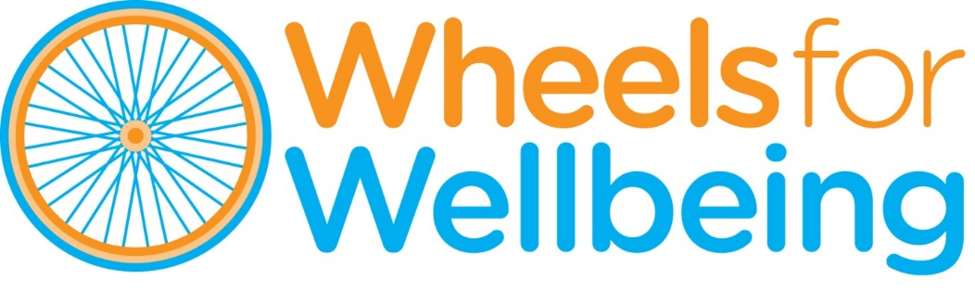

Recruitment Pack

Campaigns & Policy Officer

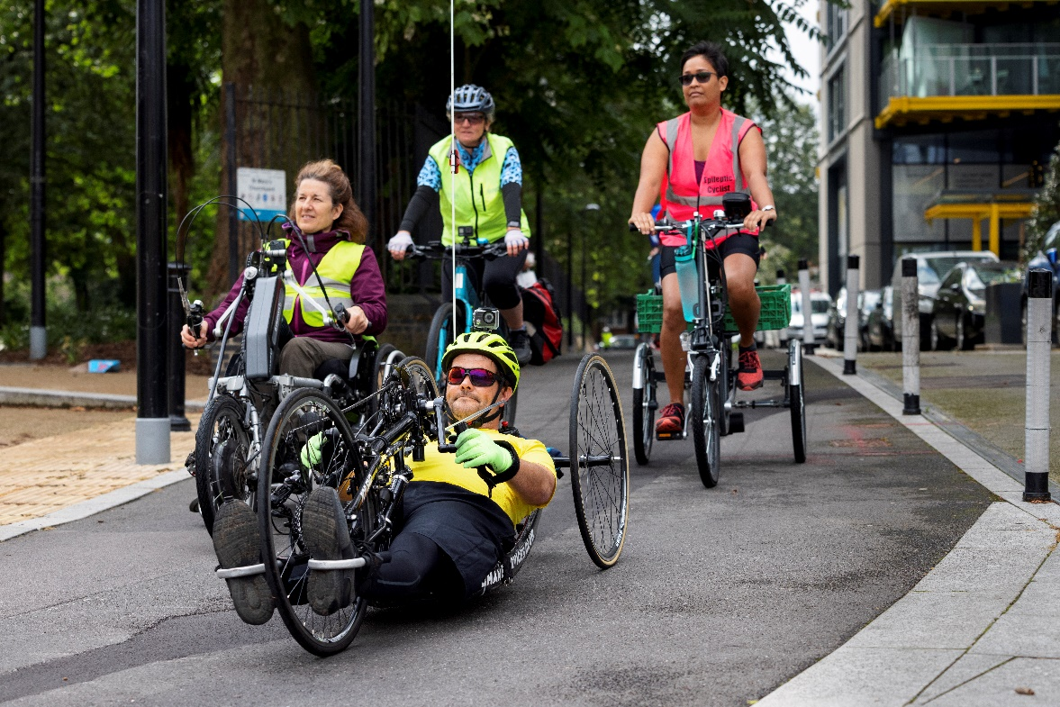

September 2022

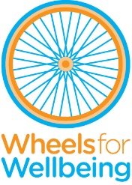

336 Brixton Road

London, SW9 7AA

Tel: 020 7346 8482

info@wheelsforwellbeing.org.uk

www.wheelsforwellbeing.org.uk

**26 August 2022**

Dear Applicant,

Thank you for your interest in our posts of **Campaigns & Policy Officer**s. We are replacing a recently departed officer (part-time, permanent post) and covering the other officer’s parental leave (part-time, 12 months) in our Campaigns and Policy team. These posts will help enhance our reach and impact, amplifying the voice of Disabled people to influence attitudes to and accessibility of cycling.

We would love to hear from you if you are:

* Passionate about Disability rights and active travel
* Have campaigning experience – especially in digital campaigning and/or lobbying
* Thrive in a team but can also work independently
* Are excited by working in an evolving area of rapid change

I attach some background information, the job description and person specification.  Please note that these posts involve some work with adults at risk and is not protected under the Rehabilitation of Offenders Act 1974. Applicants invited to interview will therefore be asked to disclose criminal convictions, no matter when they occurred. Information will be treated confidentially and only considered if relevant to the post.

Wheels for Wellbeing is strongly committed to employing a diverse workforce, including Disabled people. We promote opportunities for Disabled people in all aspects of our work. Our offices are based within an inclusive community hub, fully accessible by wheelchair and home to several Disability-led organisations. We offer flexible working practices, including hybrid and home-working conditions.

**To apply,** please email your CV to [info@wheelsforwellbeing.org.uk](mailto:info@wheelsforwellbeing.org.uk) with **a cover letter** (no more than two pages) outlining **why you would like to be considered for one of these posts, the skills and experience you bring, and how you’d ensure that a wide range of experiences inform Wheels for Wellbeing’s campaigns and policy work** (please address all the points in the Person Specification).

The closing date for this role is Monday **26/09/2022,** and we hope to carry out interviews on Friday **07/10/2022**. We want the recruitment process to be accessible to you, so please tell us if adjustments might be helpful.

If you’d like to discuss any aspect of the role or the application process, then please don’t hesitate to contact me. I look forward to hearing from you.

Yours faithfully

 Isabelle

Isabelle Clement MBE, Director

[isabelle@wheelsforwellbeing.org.uk](mailto:isabelle@wheelsforwellbeing.org.uk)

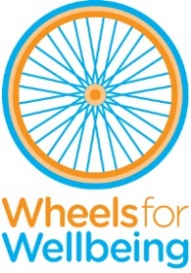

Background

[Wheels for Wellbeing](http://www.wheelsforwellbeing.org.uk) is a small charity with unique impact, run by and for Disabled people. Our campaigning voice is shaped by Disabled trustees, staff, participants and allies.

Since 2017 our grassroots work has taken place in leisure facilities, community centres, schools, hospitals and on streets in south London, using our large fleet of bikes, trikes, handcycles, recumbents, tandems and side-by-sides. Our participants are aged 2-102 and live with a range of impairments, health conditions, mental health issues and/or neurodiversity. They all have one thing in common: they had all experienced barriers to cycling prior to finding out about the cycling opportunities and advocacy we provide. We prove each day that anyone can cycle, with they have the right equipment, infrastructure, support and encouragement.

Our campaigns and policy work started being developed in 2012 from the realisation that very few people realised that, not only Disabled people CAN cycle, but that most don’t because of a multitude of practical, attitudinal, financial and other barriers to accessing one of the most accessible means of being physically active and socially included. We have become the voice of Disabled people who cycle and our expertise is sought widely. We are regularly referred to as thought-leaders and experts on inclusive active travel. It is our mission to challenge the barriers that prevent Disabled people from enjoying active and independent travel, by:

* Helping 1000+ Disabled people a year experience cycling from our three inclusive cycling hubs in South London.
* Chairing and administrating the Expert Panel on Inclusive Cycling. Facilitating and supporting DCAN, the Disabled Cycling Activists’ Network and Coordinating the ['Beyond the Bicycle' Coalition](https://www.beyondthebicycle.org.uk/), which aligns Disabled cyclists’ needs with those of allies who use larger or wider cycles: parents of small children; cargo bike delivery companies etc.
* Providing training, consultancy and advice regarding accessibility and inclusion to organisations such as Transport for London, Sustrans, Department for Transport, Transport Scotland, local authorities across the UK, developers and architects.
* Creating a movement and voice for Disabled people's rights to active travel.
* Changing attitudes to cycling, and attitudes to Disability.

We are keen to accelerate the growth, recognition and impact of our work at an urgent time for Disabled people and the planet. Giving everyone the choice of realistic, practical and affordable options to travel actively will be critical in tackling health and social inequalities, especially in the wake of the COVID-19 pandemic and helping cities to build back better with healthier, more inclusive and accessible environments, with better air quality and reduced car dependence.

Plans for the coming year include work to:

* Continue to build key campaigns including “My Cycle My Mobility Aid” through digital campaigning and lobbying work.
* Grow our ability to meet the demand for training and consultancy services from the public and private sector.
* Support the network of Disabled Cycling Activists (DCAN) who can influence more widely and build self-confidence and connections through the value of their own lived experience.
* Continue to create strategic partnerships and co-design projects with cycling campaign groups/active travel organisations/local and national Government.
* Build new alliances with other Disabled People’s Organisations (DPOs) to change the narrative and build consensus around how to best tackle barriers to active travel for Disabled people.
* Share Wheels for Wellbeing’s [Guide to Inclusive Cycling](https://wheelsforwellbeing.org.uk/campaigning/guide/) and [Report of National Survey](https://wheelsforwellbeing.org.uk/wp-content/uploads/2022/05/Disability-and-Cycling-Report-of-2021-national-survey-results.pdf) far and wide to influence inclusive streetscapes, reduce reliance on motor vehicles, improve air quality and disseminate essential information about Disabled cyclists.

Wheels for Wellbeing staff structure:

# 

# Two part-time Campaigns & Policy Officer posts

**Responsible to: Campaigns & Policy Manager**

**Line management responsibility for: N/A (though you will be supporting DCAN members)**

**Permanent post: 21 hours per week, based in Brixton, SW9 or working from home**

**12 months’ parental cover post: 21 hours per week, based in Brixton, SW9 or working from home**

(we will consider appointing one person combining the 2 contracts and working 35 hrs per week).

**Salary: £16,702pa for 21 hours (pro-rata of £27,837)**

This role’s purpose is:

* To ensure that the unprecedented investment in cycle infrastructure across the UK improves routes, facilities & conditions for Disabled cyclists – by providing expert advice to Department for Transport, Transport for London, local authorities and others.
* To support Disabled cyclists and raise wider awareness of their needs – by working with local, national and international partners (charities, businesses, government) to influence attitudes, policy and standards.
* To work on key campaigns which will transform the landscape for Disabled cyclists with a focus on lobbying and/or digital campaigning.

The post requires excellent communication, digital, research and writing skills, attention to detail as well as the ability to build relationships with and influence a wide range of stakeholders including politicians. The post holder will support individuals and groups to make their voices heard so Disabled cyclists have the confidence to lobby for inclusive cycling policy.

If you are passionate about ensuring that the voice of marginalised groups is heard by people in positions of power; if you thrive on balancing a variety of priorities and pride yourself on getting things done; if you’re as fired up by supporting local activism as you are about influencing politicians’ understanding of what matters to their constituents, this is the role for you.

**Job Description:**

**You will support Disabled people across the UK to develop their own voice in**

**the fight for walking, wheeling and cycling equality through:**

1. Regularly canvassing the views of Disabled cyclists through a variety of means (surveys; testimonials, etc.) and representing their views through reports/articles on our website, in written briefings/presentations, digital campaigning etc.
2. Support the ongoing development and growth of the DCAN peer support/campaigning network.
3. Support Wheels for Wellbeing’s current users and DCAN members to advocate and campaign for change in their local area and to make Disabled cyclists more visible and:
   1. Increase awareness that active travel environments are often inaccessible to Disabled people, limiting them to use motorised transport or isolating them; also that many Disabled people cycle and that cycling policy, infrastructure and trade should reflect their needs by, for example, supporting Disabled cyclists’ campaigns for local barrier-removal.
   2. Change the perception that Disabled people are anti-cycling and, on the contrary, build a strong pro-active travel lobby.
4. Facilitating and supporting the Expert Panel on Inclusive Cycling as it grows into a nationally recognised expert body in the field of inclusive cycling.

**You will increase the understanding of not only policy makers, but also journalists & other campaign groups of accessibility issues for Disabled cyclists by:**

1. Working within the rest of the Campaigns & Policy team to develop and deliver key campaigns such as My Cycle My Mobility Aid, and lead on digital campaigning.
2. Drafting policy documents/briefings on key issues of concern to our organisation.
3. Developing targeted relationships with policy makers and influencers including with key politicians at local, regional and national level.
4. Keeping abreast of National, regional and local government policy developments and consultations on cycling/transport/Disability/Equality, ensuring that the needs and experiences of Disabled cyclists are reflected and the voice of Disabled cyclists is heard in response.
5. Working within the rest of the Campaigns & Policy team, planning and delivering training and consultancy on aspects of Inclusive Cycling policy to a wide range of stakeholders (such as Local Authority Planners/Designers, community policing staff etc.).
6. Building strategic alliances with other Disabled People’s Organisations such as local, regional and/or national mobility and access groups, groups representing cargo-bike users, parent cyclists etc. (including [*The Beyond The Bicycle Coalition*](https://beyondbicycle.wordpress.com/), which our Director co-founded).

**You will participate positively to the running and development of Wheels for Wellbeing by:**

1. Being in charge of weekly press-scans, ensuring that the whole of WfW team are kept abreast of relevant developments/events relevant to our work.
2. At all times promoting and adhering to the organisation’s core values, including user-led working practices and the Social Model of Disability
3. Working collegiately and effectively as a key member of the Campaigns & Policy team
4. Contributing to team meetings and organisational priorities
5. Occasionally working evenings/weekends as necessary
6. Being proactive in keeping up to date with developments affecting the role
7. Carrying out other associated duties as may arise, developing or being assigned in line with the broad remit of the post
8. Abiding by and promoting organisational policies and practices, and the Charity’s values
9. Supporting diversity and equality of opportunity in the workplace
10. Promoting improvement and innovation in your working practices and across the organisation, and seeking to deliver all work to the highest quality

This job description is not exhaustive, but is provided to assist the post holder to know what her/his main duties are. It may be amended from time to time without change to the levels of responsibility appropriate to the grade of the post and in discussion with the post holder.

# Person Specification

1. **EXPERIENCE** (in a paid or unpaid capacity)

|  |  |  |
| --- | --- | --- |
|  | **Essential** | **Desirable** |
| **Experience in a customer advisory role or stakeholder development role** | √ |  |
| **Experience of report writing** | **√** |  |
| **Experience in key aspects of campaigning including lobbying and digital campaigning (in a paid or unpaid capacity)** | **√** |  |
| **Personal experience of disability AND/OR experience of working with Disabled/older people** | **√** |  |
| **Experience of facilitating the engagement of minoritised groups** |  | √ |
| **Project management experience** |  | **√** |
| **Experience of cycling (however occasional)** |  | √ |

1. **KNOWLEDGE & UNDERSTANDING**

|  |  |  |
| --- | --- | --- |
|  | **Essential** | **Desirable** |
| **Understanding of the social, physical and emotional benefits of active travel and of the multiple barriers to active travel experienced by Disabled people** | √ |  |
| **A commitment to working to empower and further the rights of Disabled people and to working within the Social Model of Disability** | √ |  |
| **An understanding of the wide range of specialist cycles and adaptations that exist on the market and/or that can be tailored to individuals' needs** |  | √ |
| **Knowledge of the current walking & cycling policy context nationally** |  | √ |

1. **SKILLS**

|  |  |  |
| --- | --- | --- |
|  | **Essential** | **Desirable** |
| **The ability to relate to Disabled as equals and to acknowledge them as the expert in how physical and societal barriers affect them** | **√** |  |
| **The ability to build and maintain relationships with a range of stakeholders** | √ |  |
| **The ability to influence others, develop persuasive arguments and promote equality** | **√** |  |
| **The ability to work and communicate clearly with people, one to one as well as in groups** | **√** |  |
| **The ability to confidently use social media (esp: Twitter /Facebook/ Instagram)**  **√** |  |  |
| **The ability work effectively as a team member, with good communication and collaborative working skills as well as the ability to take the lead and work independently on key areas (with support of line manager)** | √ |  |
| **Literacy skills sufficient to be able to produce high quality resources, briefings, reports and articles on local/national policy and practice issues.** | **√** |  |
| **The ability to work independently, to work to deadlines and to balance priorities** | **√** |  |
| **The ability to give presentations** | **√** |  |

1. **ATTITUDES & BEHAVIOURS**

|  |  |  |
| --- | --- | --- |
| **Friendly and approachable; always respectful of others** | **√** |  |
| **Pro-active and confident in taking on and exploring new issues and projects** | **√** |  |
| **At ease with making new contacts, meeting new people** | √ |  |
| **You understand how crucial it is to be able to discuss impairment related issues with people in ways which are always appropriate, neither intrusive nor belittling or patronising. We call this disability confidence. We will help you develop this but you must be committed to it.** | √ |  |