Recruitment Pack

SESSION MANAGER

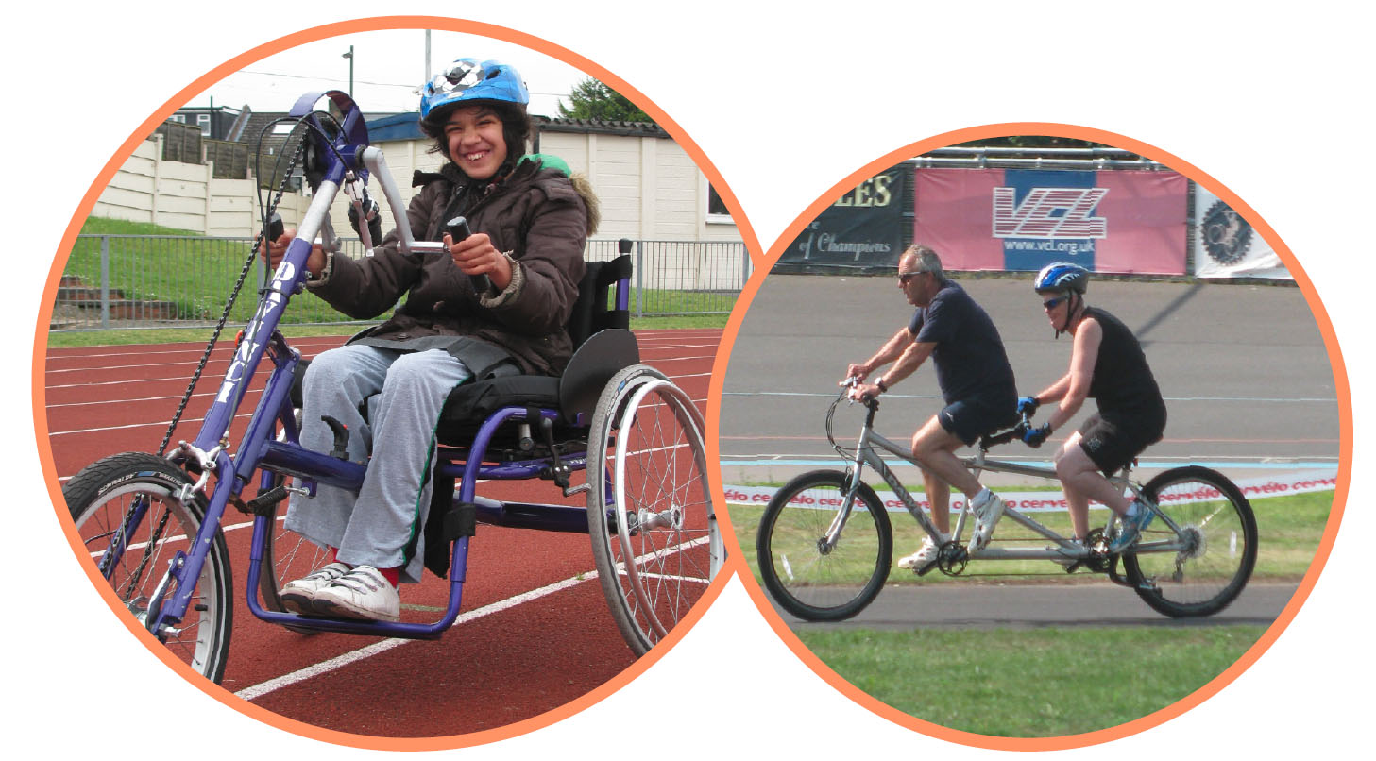

336 Brixton Road
London
SW9 7AA
Tel: 020 7346 8482
info@wheelsforwellbeing.org.uk
www.wheelsforwellbeing.org.uk

16 May 22
Dear Applicant,

Thank you for your interest in the post of Session Manager at Wheels for Wellbeing. We currently have two positions: one permanent position for our Herne Hill sessions and a temporary, sickness cover, at our Croydon sessions – this is anticipated to be for a minimum of 6 months. Feel free to apply for either one or both of these positions.

We would love to hear from you if you:
- Are passionate about inclusive cycling and promoting the benefits of cycling for Disabled people
- Can manage a team of dedicated cycling instructors and volunteers and many partnerships

I attach some background information, the job description and person specification. Please note that this post involves some work with children and with adults at risk and is not protected under the Rehabilitation of Offenders Act 1974. Applicants invited to interview will therefore be asked to disclose criminal convictions, no matter when they occurred. We will also request an enhanced DBS. Information will be treated confidentially and only considered if relevant to the post.

Wheels for Wellbeing promotes opportunities for Disabled people in all aspects of our work. Please tell us if there is anything else we can do to make sure the recruitment process is accessible to you. We are planning to hold interviews in person at our officeswhich are based within an inclusive community hub, fully accessible by wheelchair and home to several Disability-led organisations. Our sessions are all held at accessible venues.

To apply, please email your CV to info@wheelsforwellbeing.org.uk with a cover letter (no more than two pages) outlining why cycling needs to be inclusive and why you would like to be considered for this post and the skills and experience you bring (ensuring you address the points in the person specification).

The closing date for this role is 5pm on Monday 6th June. Applications received after this will not be considered. Interviews will take place on week commencing June 13th.

Yours sincerely,

Isabelle Clement

Isabelle Clement MBE, Director

Background
Wheels for Wellbeing is a small charity with unique impact, run by and for Disabled people. Our campaigning voice is shaped by Disabled trustees, staff, participants and allies.

Our grassroots work takes place in leisure facilities, community centres, schools, hospitals and on streets in south London, using our large fleet of bikes, trikes, handcycles, recumbents, tandems and side-by-sides. Our participants are aged 2-102 and live with a range of impairments, health conditions, mental health issues and/or neurodiversity. They all have one thing in common: they had all experienced barriers to cycling prior to finding out about the cycling opportunities and advocacy we provide.

We provide regular supported, off-street cycle sessions at Croydon Arena (Croydon), Herne Hill Velodrome (Southwark) and Ladywell Day Centre (Lewisham). Alongside these sessions, we run dedicated sessions for Disabled children and their families and private sessions for specific groups (both at our venues and in the community).

We prove daily that anyone can cycle, as long as they have the right equipment, infrastructure and support. Our expertise is sought widely, and we are regularly referred to as thought-leaders and experts on inclusive active travel. It is our mission to challenge the barriers that prevent Disabled people from enjoying active and independent travel, so are we also:
- Being a campaigning voice for Disabled people's rights to active travel.
- Changing attitudes to cycling, and attitudes to Disability.
- Providing training and advice regarding accessibility and inclusion to organisations such as TfL, Sustrans, Department for Transport, local authorities across the UK, developers and designers.
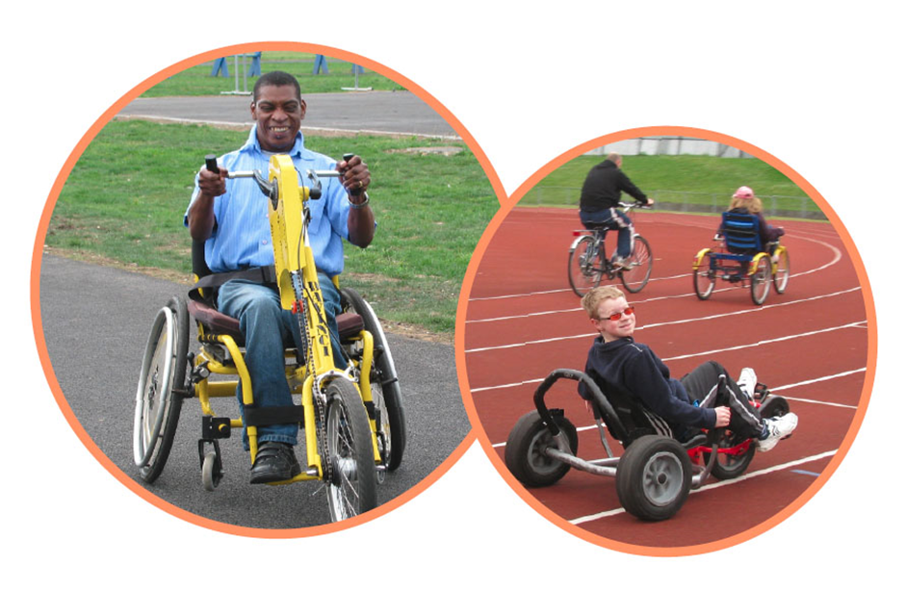

Wheels for Wellbeing staff structure (May 2022):

Session Manager/s – Herne Hill Velodrome and/or Croydon Arena

Responsible to: Operations Manager
Accountable for: Inclusive Cycling Instructors and Session Volunteers
Hours: 16 hours permanent (Herne Hill) + 16 hours temporary for sickness cover - anticipated to be for a minimum of 6 months (Croydon)
Salary: £29,000 pro rata (incl. London Weighting)
Number of posts available: 1 or 2 posts -job share/flexible working considered

Job Purpose
This post is crucial within Wheels for Wellbeing: whilst other Inclusive Cycling Instructors work sessionally, on a rota basis, you will be the one constant member of staff at the Herne Hill Velodrome or Croydon Arena (or both). You will be in overall charge of ensuring a safe and fun experience for our participants, whilst being part of the session delivery team. The post is principally based at two out of our three locations in South London but you will also work regularly from our offices in Brixton and will need to travel locally on occasions (attendance at weekend sessions will be required twice a month). The post holder will champion a team work ethos and ensure standards are consistent at all our sites.

Core hours will include working the following cycling sessions:
Croydon (Croydon Sport Arena):
Tuesday, 9.00-1:30
Wednesday, 9:00 – 1pm (from end July, tbc)
Herne Hill Velodrome
Monday 9.00-1:30
Thursday 9.30-2:30
Please note: it is also expected that the Session Manager(s) will cover two weekend sessions a month:
Saturday 9:00 – 1:00pm (One session per month)
Sundays 12.00-4:00 (One session per month)

Aside from the above core hours, remaining hours are flexible within office hours; Monday – Friday; 08:00 – 18:30 and will be used to lead some of our programmes of led rides, ad hoc additional sessions (eg: outreach events) as well as Instructors line management, partner liaison, team meetings, etc.

Principal Responsibilities
- To have responsibility for the smooth and safe running of Wheels for Wellbeing inclusive cycling sessions.
- To line manage our fantastic session staff - Inclusive Cycling Instructors (both qualified, trainees and volunteers) in line with the employee handbook and all internal Health and Safety, Safeguarding, Diversity policies and legislative requirements.
- To be responsible for the recruitment, training, supervision and performance management of our Cycle Instructors and volunteers with the support of our Operations Manager and Senior Administrator.
- Be the link between sessions and the rest of the organisation, ensuring high quality of data collection at sessions and safe cash handling

Probationary Period
The appointment of every new employee is subject to a probation period of six months. This may be extended if it is felt you have not achieved a satisfactory level of performance but have the potential to do so.

Pension
After three months, the post holder will be eligible to join Wheels for Wellbeing’s group stakeholder pension scheme (NEST), and Wheels for Wellbeing will make a 5% employer’s contribution.

Annual leave
Annual leave entitlement is 20 days in addition to the 8 English Public Holidays (pro-rata if part-time)

Job Description

- Service Delivery: You will oversee and manage Wheels for Wellbeing’s (WFW’s) flagship sessions and outreach sessions:
- Coordinate and manage Wheels for Wellbeing weekly cycling sessions, ensuring they are safe and fun in equal measures for our participants
- Ensure WFW sessions are responsive to the needs and views of service users
- Ensure that the safeguarding of children and young people and of adults at risk is top of the whole team’s mind throughout our activities.
- Work with the Senior Administrator to schedule staff and volunteers on our monthly rota
- Ensure operational policies and procedures are adhered to at cycling sessions. Contribute to their review, and updates as necessary
- Ensure high quality of participants and sessions records; ensure that the bookings process is adhered to; provide regular reports on usage
- In the event of an incident, manage the situation in line with WFW policies and procedures including investigating and reporting of incidents
- Ensure that the sessions are adequately resourced and be responsible for the safe storage and handling of all WFW equipment, cash and other assets
- Liaise effectively with staff from partner organisations (eg: venue staff / care providers) to uphold our standards

- Cycle Instructing:
- Fully participate in the delivery of Cycle Instructing at sessions and interacting with participants and organisations.
- Deliver training to disabled people across the range of impairment groups, in accordance with the national standards
- Maintain the provision of Wheels for Wellbeing cycle training at the national standard

- Recruitment and Supervision of Cycling Instructors and Volunteers:
- To work with the Operations Manager to recruit Cycle Instructors and Volunteers
- To work with the other Session Manager(s) to ensure consistent delivery of service
- To manage, mentor and provide line management support to Cycling Instructors including through regular supervision and team meetings
- Supervise the work of the Cycling Instructors at sessions and assess and identify development and training needs as well as highlight staffing and service delivery issues to the Operations Manager
- Supervise volunteers and provide their induction and practical help and support to enable volunteers to develop their skills and to enable them to become confident and self-reliant
- Ensure that Cycling Instructors and Volunteers are aware of and adhere to WFW’s policies and procedures
- Encourage good teamwork and lines of communication between Cycle Instructors, Volunteers, venues and the rest of the organisation.

- Administration:
- Maintain and monitor effective and efficient administrative systems
- Ensure session cash is safely and accurately accounted for and transferred back to the WFW office in a timely fashion (though we are moving increasingly to credit card payments, a small amount of cash handling will remain a feature of our sessions for some time).
- Ensure timely communication with the Operations Manager and Senior Administrator.
- Assist with the introduction of a new booking and data management system in Summer 2022– helping participants, staff and volunteers to learn to use the new system (with help from the Senior Administrator and Operations manager).

- Other:
- To contribute to case studies for our funders and features for our regular newsletter
- To contribute to the ongoing development of Wheels for Wellbeing, team meetings and organisational priorities
- Being proactive in keeping up to date with developments affecting the role
- Abiding by and promoting organisational policies and practices, and WFW’s values
- Supporting diversity and equality of opportunity in the workplace
- Occasionally working evenings as necessary

This job description is not exhaustive, but assists the post holder to understand their main duties. It may be amended from time to time without change to the levels of responsibility appropriate to the grade of the post and in discussion with the post holder.

Person Specification

QUALIFICATIONS AND TRAINING | Essential |  | Desirable
Will have passed the 4-day National Standards cycle instructor course (or equivalent) and willing to become a fully accredited Cycle Instructor within the probation period OR be a Level 2 British Cycling Coach OR hold Qualified Teaching Status |  | ✓
Will hold a current First Aid at work certificate or willing to acquire during the probationary period |  | ✓

KNOWLEDGE AND EXPERIENCE | Essential | Desirable
A minimum of two years' experience in the delivery of physical activity or sport sessions to groups of participants | ✓
A minimum of two years’ experience supporting both disabled children and adults (in a paid or unpaid capacity) | ✓
Experienced in the recruitment, line-management, training and development of staff and/or volunteers (in a paid or unpaid capacity) | ✓
A competent, experienced and regular cyclist | ✓
Experience of working within a Bikeability/Coaching framework |  | ✓
Experience in ride leading |  | ✓
Up to date knowledge of Safeguarding legislation as it applies to children and adults at risk | ✓
A working knowledge of GDPR legislation and safe data handling practices | ✓
A working knowledge of basic bike maintenance | ✓

SKILLS: | Essential | Desirable
Excellent communication and interpersonal skills (able to be professional at all times, to relate easily to a wide variety of people, respecting of everyone’s differences) | ✓
An organised and efficient person, with excellent attention to detail | ✓
Proven ability to manage and resolve conflict, challenging behaviour assertively, calmly and professionally | ✓
Proven planning and organisational skills | ✓
An ability to make connections with a wide range of people and organisations and to work in partnership with them to increase access to cycling by disabled/older people | ✓
Ability to write clear incident reports / risk assessments | ✓
Initiative and problem-solving skills | ✓
IT literate especially in Microsoft Office and Outlook & able to use Dropbox / SharePoint or other organizational shared document systems (with training if required) | ✓
Excellent timekeeping and reliability | ✓
An ability to work flexibly according to the needs of the organisation  including attending meetings outside office hours if required, with notice | ✓
An individual who can work well independently with minimal supervision and as part of a team, can take initiative and juggle priorities | ✓

ATTITUDES AND BEHAVIOURS | Essential | Desirable
A positive, energetic and enthusiastic outlook with a can-do approach | ✓
Work in a professional manner and friendly disposition | ✓
A commitment to working to empower and further the rights of Disabled people and to working within the Social Model of Disability | ✓
A passion for cycling (preference will be given to those actively involved in cycling, although for exceptional candidates, other physical activity backgrounds will be considered) | ✓
An ability to relate positively to people of different cultures, backgrounds and experiences | ✓
Totally committed to the principles of user-led organisations | ✓
Friendly, approachable & helpful to anyone requiring information, to volunteers, colleagues, etc. | ✓
Respectful of others and with a total belief in the equal value of people, regardless of race, religion, culture, gender, age, disability or sexuality | ✓

