Disability & Cycling:
Report of 2021 National Survey Results

Wheels for Wellbeing
Welcome
2021 was a challenging year for Disabled people as we continued to feel the impacts of the pandemic and lockdown restrictions on so many aspects of our lives and wellbeing. Cycling was no different, many Disabled people lost their opportunities to cycle as inclusive cycling sessions closed or their regular commutes to work were no longer necessary. For others the pandemic provided new cycling opportunities, quieter roads and traffic-free neighbourhoods enabled them to increase cycling or to start cycling for the first time. Our survey captured a diversity of experiences, but many of the same barriers and enablers to cycling emerge year on year: cost, infrastructure and lack of recognition of cycles as mobility aids impeded many, whilst key enablers included safe and supportive cycling environments, access to public transport and facilities. As always, we are grateful to all the Disabled cyclists and their supporters who took the time to complete the survey and provide such rich data for our campaigning and policy work. We have had some big impacts recently in influencing policies being rolled out under government programmes such as Gear Change and the new cycle infrastructure standards. We will continue to raise the voice of Disabled cyclists loud and clear until Disabled people have the same range of choices and ease of access to cycling as everyone else. There is still much to do, but we are proud of the progress that we have made so far and proud to be a disabled-cyclist-led organisation.
Isabelle Clement MBE, Director, Wheels for Wellbeing

Contents
Executive Summary 2
Introduction and Methods 4
Chapter 1: The Impact of COVID-19 and Lockdowns 7
Chapter 2: Disabled Cyclists’ Journeys and their Impacts 12
Chapter 3: Barriers and Enablers to Cycling 20
Conclusions and Recommendations 33
References 35
Acknowledgements 35
Executive Summary
Two hundred and forty-five participants completed a mixed-methods survey (binary, multiple choice and free-text/qualitative answers) between June and the end of August 2021. Just over 82% of respondents were Disabled people and nearly 14% responded on behalf of a Disabled person. A large majority, nearly 87%, owned their own cycle and just over three quarters cycled once a week or more. 75% of those who did not own a cycle accessed cycling via inclusive cycling sessions.

The COVID-19 pandemic and lockdowns had a range of impacts on Disabled cyclists: 39% cycled more or began cycling for the first time, and just under one third (28.75%) cycled less. Reasons for decreased cycling included the closure of inclusive cycling centres, as well as pop-up infrastructure that blocked access. Hostility from road-users and members of the public also deterred many Disabled people from cycling during this time. Conversely, others cycled more, or for the first time, because of the quiet roads, new accessible infrastructure or a lack of other transport or exercise options.

The majority (63.78%) of respondents reported that cycling was easier than walking and a similar number (58.92%) considered their cycle a mobility aid. However, respondents also reported being required to discontinue cycling in a range of environments and being challenged by staff, security guards, the public and police. The main reasons why Disabled people cycled were for leisure, exercise and mental health. Just over half cycled for general transport – especially where other forms of transport were inaccessible.

The most frequent barriers to cycling that respondents encountered were inaccessible infrastructure (53.28%), lack of parking or storage for their cycle (34.93%), and the cost of a cycle or adaptations (32.75%). Other barriers included not being able to access cycle hire or an inclusive cycling session. Nearly one quarter (23.68%) reported being the target of abuse and hostility and a similar number (25.32%) cited concerns about benefit penalties if they cycled.

The most important enablers to Disabled people cycling identified by respondents were accessible cycle infrastructure, subsidies for non-standard cycles, recognizing cycles as mobility aids and reducing the speed and quantity of traffic in residential areas. Qualitative responses emphasised the need for an array of safe and supportive cycling environments, ranging from specialist inclusive sessions to segregated and off-road provision, quieter streets and the re-education of drivers. Many respondents also highlighted the need to use their cycles on a range of public transport services in order to enable them to make more journeys, including multi-modal trips.

Recommendations
- Universal rollout of fully accessible cycle infrastructure, including parking and storage.
- Rapid implementation of policies that will make cycles affordable for Disabled people.
- An increased range of safe and supportive cycling environments, including specialist sessions, accessible, segregated and off-road cycle ways, quiet streets and driver re-education (building on the recent changes to the Highway Code).
- Formal recognition of cycles as mobility aids, to permit cycle-use by Disabled people throughout public infrastructure, including public transport, and eliminating the risk of benefit penalties for Disabled cyclists.
- Action to tackle prejudice, hostility and hate crime towards Disabled people.

Taken together, these measures will benefit all cyclists, not just Disabled people, and will go a long way to increasing the diversity of the cycling population more broadly. There will also be benefits for the wider community in terms of reduced pollution and congestion, improved community connectedness and wider opportunities to experience the physical and mental health benefits of cycling throughout the life course.

Introduction & Methods
Welcome to the report of the 2021 survey of Disabled cyclists. This is the fourth survey that Wheels for Wellbeing (WfW) have conducted into the lived experience of Disabled cyclists, with previous surveys taking place in 2017, 2018 and 2019. This year, in Chapter 1, we present data specific to the impacts of the pandemic and lockdowns for Disabled cyclists. Chapter 2 provides an analysis of why Disabled people cycle and the impacts of cycling for them, and Chapter 3 explores the barriers and enablers to cycling for Disabled people.

Disability Status of Respondents
A total of 245 participants completed the survey, 82.4% of whom identified as a Disabled person, which includes those with a hidden Disability or a long-term health condition. 13.9% of respondents completed the survey on behalf of a Disabled person, and 3.7% did not identify with either category. The survey was completed via a screen-reader-compatible online form, with an easy-read version available and the option to complete the survey via a telephone call to the WfW office or to print off and return a hard copy. The survey was predominantly circulated via social media, the WfW newsletter and inclusive cycling networks from early June to the end of August 2021. Participants were self-selecting and all responses were anonymous.

The recruitment strategy means that the sample is inevitably skewed towards those who are confident with their literacy, are active on social media, and/or have access to information technology, assistive technology such as screen readers, or a support person. Some participants commented that they felt that the survey tended to focus on people with physical disabilities rather than the wider spectrum of the Disability community. This year, we attempted to diversify the respondent pool by attending two of our London cycling centres and administering the survey face-to-face with participants who might not have been able to complete it independently. We will continue to build on the learning and feedback from this year’s survey to develop our sampling and recruitment strategies to ensure our survey reaches the greatest possible breadth and diversity of Disabled cyclists.

The findings from the survey comprise descriptive statistics and qualitative free-text data. The qualitative data was manually coded and thematically analysed, then grouped into the larger subject categories that make up the chapters of this report.

Type of cycle

31.3% e-assist
25.5% folding

86.5% owned their own cycle
77.2% cycled once a week or more
35.7% cycled on a daily basis

Of those who took part 86.5% owned their own cycle, 77.2% cycled once a week or more, and 35.7% cycled on a daily basis. Just under two thirds of respondents (60.2%) cycled a standard two wheeled bicycle. Together, trikes and recumbent trikes were the next most common type of cycle used at 26%; handcycles (clip-on and one piece) made up 16.6% of responses; tandems 8.53%, and cargo or family cycles 4.7% (some participants owned more than one cycle). Nearly one third (31.3%) reported that their cycle also had e-assist, and a quarter (25.5 %) that their cycle folded, highlighting how these features increase the accessibility of cycles.

The majority (75%) of those who did not own their own cycle attended inclusive cycling sessions, 17.9% borrowed a cycle from an organization or someone they knew and 7.1% hired a cycle.

Access to Cycles for Non-owners
This means that the predominant ways that our survey participants cycled were using their own cycle or via an inclusive cycling centre. Given the limited number of other options currently available, such as loan and hire schemes, this is not an unexpected finding, and it will shape the overall experiences of our survey participants. However, as more accessible share and hire schemes are rolled out following the implementation of Gear Change, it is possible that these proportions will change.

Those who relied on inclusive cycling sessions to access cycling were particularly negatively impacted by closures during lockdowns. The full impacts of the pandemic and lockdowns on Disabled cyclists are detailed in Chapter 1.

CHAPTER 1
The Impact of COVID-19 and Lockdowns
Respondents were asked what impact the COVID-19 pandemic and the lockdowns had on the amount that they cycled. 13.3% began cycling for the first time during the pandemic and just over one quarter (25.83%) cycled more often during the pandemic than they had previously. Nearly one third (28.75%) cycled less, almost one third of respondents (32.08%) reported that the pandemic had no impact on the amount they cycled.

Cycling Levels During the Pandemic

Increased Cycling
For those who took up cycling or cycled more during the pandemic (a total of 39%) the quiet roads during the first lockdown played a crucial role.

The first lockdown, when the roads were almost empty, was magical. I felt like a citizen again and not […] risking my life amongst the cars. I miss that aspect of lockdown very much.

Quiet roads make cycling more pleasant for anyone, but they can be particularly enabling for Disabled cyclists and those returning to cycling after the onset of disability.

Having fewer cars on the road during COVID-19 really made me feel more comfortable getting back on my bike after my MS diagnosis, because I was weaker and less able to react quickly, so having fewer cars around and not needing to worry so much about traffic gave me a lot of confidence.

Likewise, the quiet roads significantly reduced stress for those who might face anxiety-related barriers to cycling.

The introduction of more pedestrianised streets and cycle lanes etc in my city to increase social distancing made it a lot easier and less stressful for me to cycle.

Other respondents began or increased their amount of cycling because it provided essential exercise when other options such as swimming or physiotherapy were no longer available.

[Cycling] was my go to exercise during lockdowns and kept me going and made me feel better as well as more connected mentally, I observe what is around me when I cycle.

I had to home-school my kids, work part-time and couldn't swim so cycling helped to keep me moving. The physio was unavailable too, so resources that help me were really limited. Cycling was a nice escape.

Similarly, a number of respondents began or increased their cycling out of necessity. Those who were shielding and/or needed to avoid public transport for health reasons still had to make essential journeys.

I've not used public transport since the pandemic began. I don't have a car, and even if I did I would say my mental health issues (and medication) makes it really unsafe for me to drive. Really, my bike has been my life saver.

I had no choice but to cycle because of being clinically extremely vulnerable and not having access to a car. I was told not to use public transport and I didn't feel safe using taxis. Covid made me cycle more because I was forced to cycle four miles each way to the hospital and back several times a week. I could only do this because there was a cycle path most of the way and I rode on the pavements where there were gaps in the route. I'm happy I was able to cycle as I think it pushed me to be more active when, as a chemo patient, I would have been more inclined to take it easy. But it's a total lottery, if I hadn't lived where I did at the time, with access to the cycle path then I don't know what I would have done.

During the pandemic cycling became a crucial form of exercise and transport for many Disabled cyclists and, in many areas, this was facilitated by quiet roads and good quality infrastructure. However, a significant number of Disabled cyclists cycled less during the pandemic.

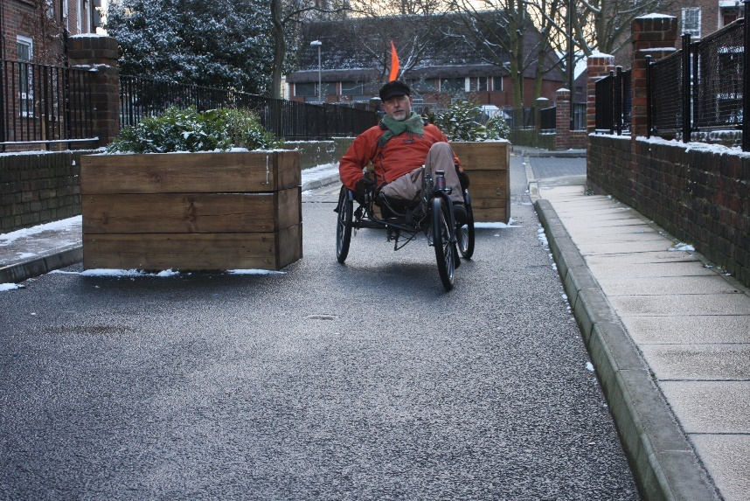

Image (courtesy of John Parkin) depicts a white man who is a lower limb amputee cycling a recumbent foot-peddled tricycle in between two large wooden planters which have been used to close the street to cars.

Decreased Cycling
Just under one third of Disabled cyclists cycled less during the pandemic. Those who decreased the amount they cycled cited a number of reasons. Significant amongst these was the closure of inclusive cycle sessions which meant that cycling was no longer available to them.

Sadly, I had to stop cycling during the COVID-19 lockdown, as Croydon Sports Arena was not open, and this is the only place I know where I can cycle.

Not having access to Ladywell reduces times we can cycle.

Similarly, the closure of other public amenities curtailed some respondents’ ability to cycle.

Even fewer accessible toilets are available making long trips impossible.

For others, some of the cycling and traffic-calming infrastructure presented barriers to cycling.

When the pandemic first started and the first lockdown happened, the roads were much better to use, especially as bus services stopped. But then the council started to put in measures to 'improve' walking and cycling and really did not think it through and many routes I use became no-go areas as I couldn't get through.

The biggest problem has been poor road surfaces and well-intentioned but dangerous speed humps and speed cushions.

Other respondents were shielding, “I don't go out”, or were wary of going out because of crowded public spaces and the lack of distancing and/or mask wearing.

In some ways it was easier because there was less traffic, but as I was close to shielding meant I had difficulty staying away from others.

A lot of our cycle network (traffic free paths) are on old railway lines. They're a fantastic way to get around, usually, but during covid it was impossible to keep a social distance from others on these paths as they are not wide enough. I did end up cycling a lot less, especially once the road traffic started to pick up again.
Initially it was glorious. But I lived someplace where people politicized mask-wearing and it began to be hard to walk or cycle because maskless people were posing a risk to my health.

Negative public attitudes and hostility towards Disabled cyclists both on and off the road also featured among the reasons people cycled less during the pandemic. Some respondents experienced specifically disability-related abuse whilst cycling.

I have been shocked at the aggression of the public towards me using a handcycle during lockdown. Been met with several confrontations over disabled people being CEV [clinically extremely vulnerable] as if we shouldn't be outside.

I’m struggling to go out due to comments and abuse shouted at me even though the traffic was much less during covid. It’s the psychological aspects I’m struggling with, and I hate to struggle with routes and the randomness of routes and barriers. Safe paths that aren’t blocked would help especially away from traffic where people stare at you and pump out pollution.

Other respondents reported an increase in more generalised (e.g. not disability specific) aggression from drivers in between or post lockdowns.

It was great having fewer cars on the road. The ones that were drove much more rapidly and recklessly. Driver behaviour seems worse since return. It's disappointing that not enough has been done to improve cycling infrastructure/road surfaces during lockdown - missed opportunity.

Cycling during first lockdown was amazing with fewer cars on the road. Then the fewer cars started driving crazy fast as the roads were empty. Then the cars came back, more than ever. Particular problem with Ubers, and delivery vehicles randomly stopping, makes the existing infrastructure more hazardous to use.

Finally, for some participants the lack of commuting and the closure of social and/or leisure facilities removed the need for their usual cycle journeys: the broader reduction in the journeys required for day-to-day life during lockdowns corresponded with a reduction in their cycling.

Working from home meant I did not need to commute.

Went out less (work from home, minimise shopping and nowhere else to go) therefore cycled less (was already cycling for leisure, so that didn't change).

Key reasons why Disabled cyclists cycled less during the pandemic were the reduced need for journeys, the closure of essential facilities such as inclusive cycle sessions, distancing and shielding requirements, and public hostility towards cycling in general as well as specific aggression towards Disabled cyclists.
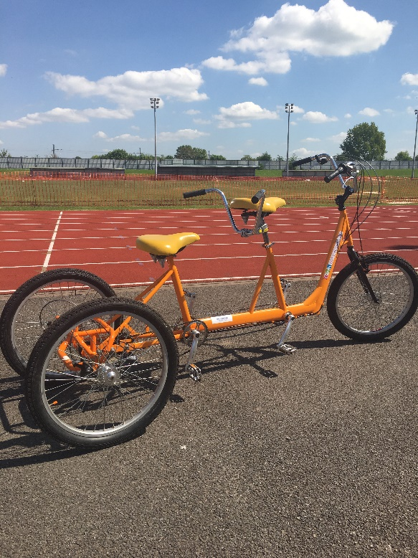

Image depicts an orange tandem tricycle with no riders on an empty athletic track. Inclusive cycling centres closed during lockdowns and many Disabled people had no access to cycling.

Summary
The pandemic has had a mixed impact on the amount that Disabled people cycle. For some, the quiet roads offered a unique opportunity to take-up or increase cycling, as well as providing essential exercise and transport. Well designed, accessible cycle ways and quiet streets enabled many to cycle confidently, whereas poorly designed inaccessible infrastructure prevented some people from cycling at all. Likewise, the closure of cycle sessions and accessible facilities meant that many were unable to cycle. Others were inhibited by the lack of distancing, increased driver recklessness and public hostility. These experiences offer significant insights into the kinds of measures, facilities and social environs that make cycling possible, safe and attractive for Disabled people both during and beyond the pandemic. The reasons why Disabled people cycle, and the barriers and enablers they encounter are further explored in Chapters 2 and 3 of the report.

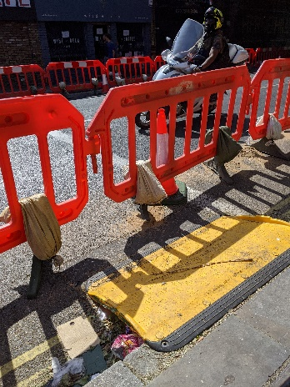

Image depicts an inaccessible pop-up pavement- widening scheme. Barriers have been used to take some of the road space for pedestrians. A temporary ramp has been installed over the kerb, however the space between the ramp and the barrier is too narrow for a wheelchair, mobility scooter or cycle to exit the ramp and turn into the walk way.

CHAPTER 2
Disabled Cyclists’ Journeys and their Impacts
A key aim of the survey is to explore the reasons why Disabled people cycle and the type of journeys Disabled cyclists make. This will provide a greater understanding of not only the barriers to, and enablers for, these journeys (Chapter 3), but also how cycling functions as an essential form of mobility for Disabled people. This chapter draws on questions which focused on cycling as mobility and themes from the free-text responses exploring the mental and physical health impacts of cycling.

Cycling is Easier than Walking
Cycling is often an essential form of mobility for Disabled people who have difficulty walking and/or require mobility equipment. Nearly two thirds of respondents reported that cycling is easier than walking and less than one tenth reported the converse, that walking is easier than cycling.

A consistent theme is that whilst walking is difficult and/or painful, cycling provides efficient, pain-free mobility that allows respondents to travel much further and much more independently than on foot – as well as enjoying the health benefits that come with physical activity.

I have spinal issues and can't walk any real distance. But I cycle on a normal bike without problem. [It] gives me my independence.

I have had MS for 30 years and wish I had realised earlier that I could cycle much better than I could walk! I had always liked cycling but assumed that as my balance had deteriorated that would affect me on a bike. It doesn't! Also, very happy to push it up hills if necessary and difficult junctions as it helps my balance but doesn’t look like a mobility aid. The only time I can really forget MS is when I am on my bike. The feeling of freedom is wonderful, so very good for mental health and doing activities with non-disabled friends.

Cycling also provides a sense of protection for those whose disability renders them visible and vulnerable when on foot.

I have hidden disabilities/long term conditions. I cycle for many reasons. Sometimes my mobility is fine, other times, my knees/hips/feet could be flaring and it's then that my bike becomes my mobility aid. I find there is a freedom in my bicycle, and I feel less vulnerable. I was once mugged on a day when I was flaring so badly I was limping. When I am flaring and walking I definitely feel vulnerable in a way that I don't on my bike.

Cycling provides a safe and efficient means of mobility for many Disabled people who would otherwise face barriers to easy, autonomous movement.

A Mobility Aid
Given that cycling is often easier than walking, it is not surprising that many respondents describe their cycle as a mobility aid – even though it is not currently recognised as such in law.
More than half of respondents described their cycle as their mobility aid. However, the lack of official recognition of cycles in this capacity means that Disabled cyclists are often asked to dismount and walk, even when it is not possible for them to do so.

The most common locations where Disabled cyclists were asked to dismount and walk were pavements or footways and in “cyclists dismount” zones. Other common areas were shopping centres, parks and train stations – all of which are key public infrastructure and often involve significant distances to traverse. Seaside promenades and shared walking and cycle spaces featured strongly as locations for those who had ticked “other”.

Where Were You Told Not to Cycle?

Some of the challenges to Disabled cyclists using their cycle on footways seem to be more about the perception of cycling and cyclists rather than the actual risk posed – this is particularly notable since Disabled cyclists themselves often have to mitigate their own vulnerabilities as they travel and are therefore acutely attuned to the potential risks to other users.

I often get told by members of the public to slow down, or I'm accused of "speeding", when I'm actually limited by my bike's first level of assistance to less than legal pavement speed... and am a much more careful cyclist than many non-disabled people I know (sudden braking can be painful, so I obviously try to avoid it!).

Given that footways are the places where Disabled cyclists are most commonly challenged, it is perhaps not surprising that it is members of the public who present a high proportion of the challenges to Disabled people using their cycle as a mobility aid. Disabled people were most likely to be challenged by members of staff or officials and third and fourth most likely by security guards and police officers in turn. A number of Disabled cyclists were not clear of the role/status of the people who had challenged them, and within the fifteen percent who marked “other”, signs and signage were the most common impediments.

Who Told You Not to Cycle?

Disabled people frequently cycle in a context where their cycling renders them invisible as Disabled people with, for example, limited mobility, and where cycles are not recognised as mobility aids. A change in policy and regulations around cycle use, as well as a shift in public awareness, could have a significant impact for Disabled cyclists, as one respondent noted:
Thank you for this survey. It made me think that perhaps I should get a sign for my electric bike so people don’t glare at me in pedestrianised areas so much.

Reasons for Cycling
The survey findings demonstrate that cycling is often essential for the day to day mobility of Disabled people because it is easier than walking and provides an efficient and accessible means to get around. Regardless of whether or not Disabled cyclists describe it as a mobility aid, they use their cycle for a variety of reasons and to complete a range of journey types.

A multiple-choice question explored the main reasons for respondents’ cycle journeys (participants could select more than one). The top three reasons cited were fun/leisure, exercise and staying fit, and mental health. Cycling for general transport was the fourth most common and commuting for work, fifth. Frequent reasons for cycling given in free-text responses under “other” included everyday mobility, environmental reasons and health.

Why Do You Cycle?

Mental and Physical Health
The mental and physical (e.g. exercise/stay fit) health effects of cycling are particularly significant given the poor mental and physical health outcomes of the Disabled population in general (EHRC, 2017; Inckle, 2020) as well as in terms of their impacts during the pandemic, where Disabled people have been rendered especially vulnerable (Health Foundation, 2021).

The mental and physical health benefits of cycling were often described in tandem, but the physical health dimensions were particularly important for respondents following life-changing health events.

Following a CVA and stroke 5 years ago, cycling has helped my recovery enormously. It has also boosted my confidence.

I have a heart condition which renders me breathless as soon as I do anything. Getting an e-bike has been fantastic. I have been able to return to enjoying cycling after giving up owing to wind and hills. Return to an active life. Great for mental health. I don't really regard myself as Disabled, but it is a hidden disability.

The physical health benefits of cycling were also experienced by those with activity-limiting pain conditions.
Cycling regularly has significantly improved my health and fitness, my energy and supported my mental health during lockdowns, though I do have periods where I have to reduce cycling due to occasional pain and I keep to short distances but regular. Safe infrastructure and smooth cycle lanes would really help.

It is evident from the examples above that respondents experience a close link between mental and physical health and exercise. However, the mental health benefits of cycling are particularly notable for those who face constant barriers to quality of life.

Being a Disabled person who can get out and cycle has been a lifesaver for me, when cycling I feel less disabled, it is the best treatment for my mental health.

My recumbent trike has given me more freedom/motivation to leave my house, even when I am really tired. My mental health is stronger because I don't stay inside.

Respondents also highlighted broader wellbeing impacts of cycling in terms of feeling active, free and confident, as have been reported elsewhere (Inckle, 2019; 2020)

I find it hugely enabling to cycle around for transport and my commute. It keeps me active and mobile, prevents degenerative decline in my muscles and makes me feel good about myself.

Cycling gives me freedom. I have to walk with a stick (sometimes two) or an assistance dog. On a bike I’m free.

Other respondents described alternative aspects of the relationship between mental health and cycling. Here, mental health experiences rendered most transport inaccessible, and in this context cycling is the only accessible form of mobility.

My long-term mental health problems make it extremely difficult for me to drive – I can if absolutely necessary, and still have my licence, but it's a horrible experience, and the practically obligatory nature of car usage in our society is very disabling for me. I also find using taxis etc. very difficult due to past traumatic experiences, and extreme anxiety about climate change. Almost all campaigning and advocacy around disability and transport seems to focus around driving or being driven in cars/taxis. That's fine, and those needs are important, but I wish just a little bit would focus on those of us for whom cars and driving ARE disabling.

A similar theme emerged beyond mental health, where cycling becomes an essential means of everyday transport because other modes are inaccessible.

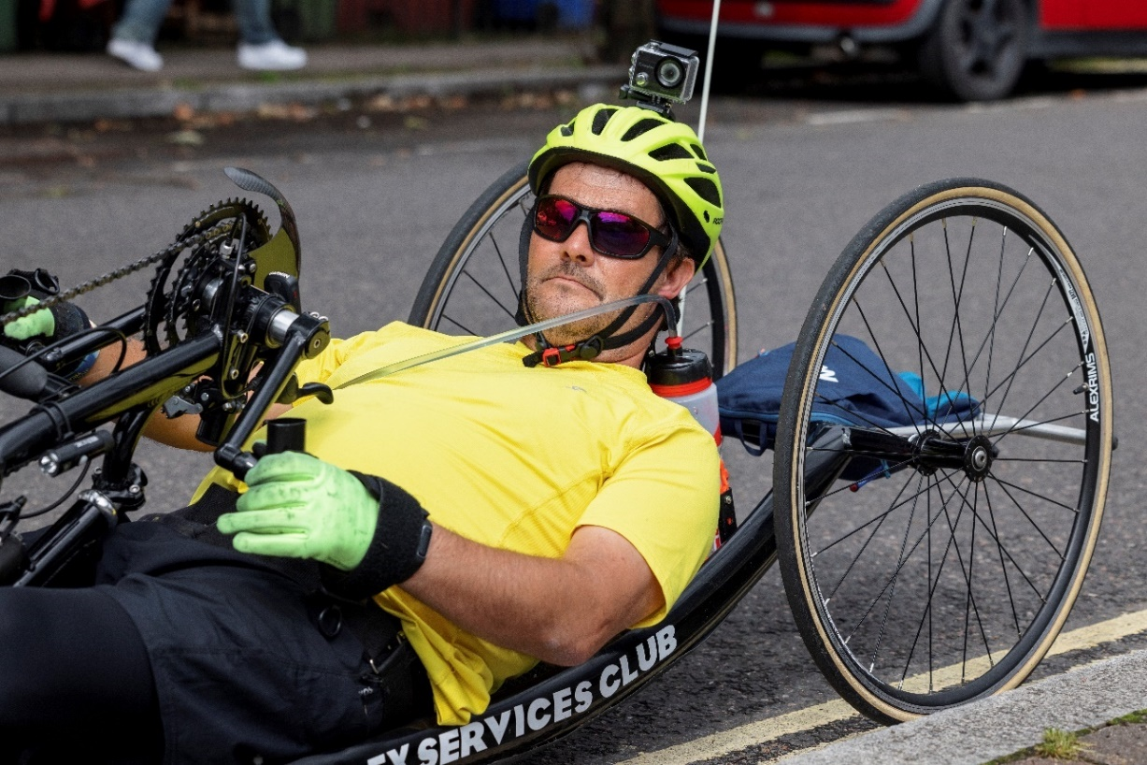

Image depicts a white man wearing a yellow t-shirt and cycling helmet with a camera on top
riding a recumbent hand-peddle tricycle which he has paused by the kerb side.

Everyday Transport
Cycling as everyday transport/mobility was the fourth most common selection for why Disabled people cycle. The general comments highlighted that this was especially important because other forms of transport – both public, and private, such as the car – are not accessible for a wide range of Disabled people. Public transport can pose a range of barriers for Disabled people beyond straightforward physical and sensory accessibility such as ramps, lifts and audio information.

For myself, because my systems can’t cope with busy public transport well, or at all, such as the tube, if I need to travel into London on the whole it needs to be via bike. Without the bike the benefit vs cost in terms of effort, risk of a fall etc. often means that it’s simply not wise.

I have ADHD and I cycle because it is a challenge for me to take public transit. I never read the schedule right, I always get the timing wrong, or I miss my stop, or I can’t figure out a route that works for me. I can’t cope with bus schedules basically. I also don’t like driving a car because the speeds are too fast and the sensory experience of driving a car is overwhelming. I walk sometimes, but I like to bike because I want to get a bit further faster, and I can easily carry groceries in my bike basket.

Cycling also remains an option when a change in circumstances renders driving and private car use impossible.

Cycling was very useful when I was unable to drive due to epilepsy. Strict driving regulations don't apply to cycling so it is an individual decision whether it is safe to do so. As such the main thing that would help are things that make cycling in general safer e.g., segregated infrastructure, less / slower vehicle traffic.

Disabled people use their cycles for a variety of journey types, but common amongst the reasons for cycling is the increased accessibility of cycling compared to other transport modes.

Summary
Cycling provides a wide range of benefits for Disabled people: it is easier than walking, it provides essential mobility and transport, especially given the inaccessibility of other modes, and it brings with it all the health and wellbeing impacts of physical activity. However, cycles are not recognized as mobility aids in regulations, policy or wider social norms. This creates significant barriers to Disabled people’s mobility. Further barriers – and enablers – to Disabled people cycling are explored in the next chapter.
CHAPTER 3
Barriers & Enablers to Cycling
Barriers to cycling are a significant factor in preventing uptake by Disabled people, and year on year common themes emerge in terms of cost, infrastructure and lack of access to cycles through hire and loan schemes or availability of inclusive cycling sessions. Likewise, common enablers emerge, including: high quality cycling infrastructure, access to public transport with cycles and recognizing cycles as mobility aids (see also Chapter 2).

Barriers
The survey asked participants if they had experienced any of the following barriers: cost, abuse/hate crime, lack of inclusive cycling opportunities, lack of parking/storage and hire facilities, infrastructural barriers or none at all. Of these, infrastructure, parking and storage were the most common barriers that Disabled cyclists encountered, followed by cost and the lack of opportunities to hire. Also commonly mentioned were the lack of inclusive cycling opportunities and abuse and hostility directed at Disabled cyclists.

Barriers to Cycling

Cost
Over the years, our surveys have repeatedly highlighted that cost is a significant barrier to cycling for Disabled people, especially for those who require adaptations, non-standard cycles and/or e-assist. This year was no different, and this finding has also been borne out in other recent research (Cycling UK, 2021).

Our son is disabled and having an adapted bike has opened up a whole new world of experience for him and us. We have been unable to afford one until recently, when we were allowed to use his social care budget to purchase one under lockdown. It has been brilliant and really opened up the world for him in a way that wasn’t possible before.

My disabilities, including poor balance, are not obvious. I have bought a secondhand trike and had it refitted for my needs and also bought a [new] trike, both using a specialised trike maker. Both were extremely expensive. Luckily, I’m in a privileged position and could afford to pay; I doubt that many people would be in the same position. I initially bought a recumbent trike, which was also expensive. Before buying each of my first two trikes I needed to test if riding them was possible.

It’s also the equipment; modified pedals that work with splints and calipers can cost £120.00!

The cost barrier is particularly significant, given the disability pay and employment gaps and the close correlation between disability and poverty (EHRC, 2017). Together these create a double barrier, where those who can least afford it face the highest cost barriers to cycling.
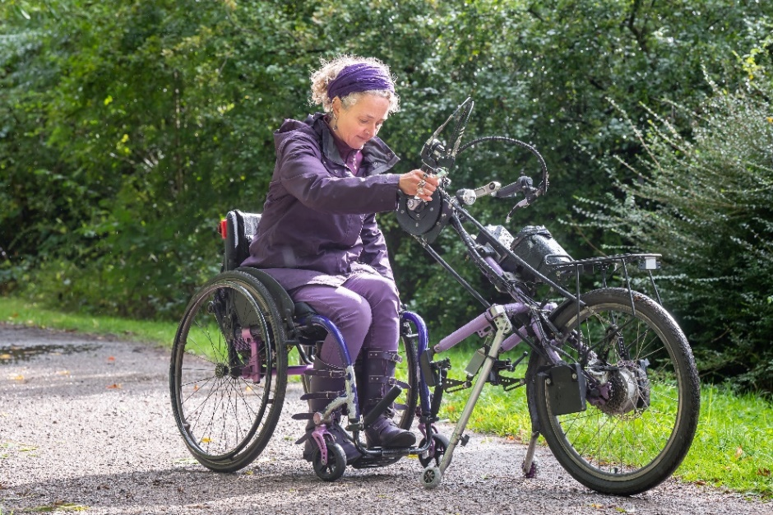

Image (courtesy of Kay Inckle) depicts a white woman detaching an
e-assist clip-on handcycle from her wheelchair. Handcycles such as these
retail in excess of £5,500.
Many respondents expressed their frustration at the cost barriers they encounter.

The absolute biggest barrier to any disabled person who wants to cycle are the extortionate prices of the gear. If that can be tackled by lease/loan/payment schemes or something then, and only then, you will see more disabled people cycling, it's as simple as that. If you can't have a bike, how are you going to cycle?

The biggest barrier is cost. Before being disabled I was a keen cyclist. I could buy a high-quality high-performance bicycle for less than £1000, but an entry level handbike will cost three times that amount – over £3000! It is just another area where disabled people are penalised for having a disability that we neither chose or wanted. WHY ARE ITEMS INTENDED FOR USE BY DISABLED PEOPLE SO MUCH MORE EXPENSIVE? We are being unfairly targeted.

The cost issue is compounded, as one of the respondents above notes, by the lack of opportunities to try out a cycle and ensure it is appropriate before such a costly purchase is made, in addition to key practical issues such as being able to park/store it safely. The lack of nationwide try-out and hire schemes for Disabled cyclists is significant here. And whilst this is an area that WfW and partners are exploring as part of the roll out of the government’s Gear Change policy, in the meantime the lack of opportunities for Disabled people to try cycling remains a barrier.

A lack of cycling opportunities where people can try riding to see if it's right for them and they are physically able to do it is a massive barrier. In my area, it's compounded by the closure of one cycling project that was immensely popular and helpful to the community.

The participant who needed to try out their tricycles before purchase (cited in the section above) was fortunate to find suppliers and organisations that facilitated them doing so.

I was lucky to find a cycle shop in York that ran roadshows for mobility cycles. They kindly stopped close to my home to see if I could get in and out of a recumbent trike and give it a test ride. For my upright trike, I contacted The Tricycle Association and found a local member who allowed me to test ride their own trike, along with vital instructions on how to ride and balance it. The TA have continued to be very helpful.

These crucial opportunities should not be left to chance or goodwill as this can also result in the opposite situation, as illustrated in the next example, where Disabled people cannot access or try the equipment they require.

It will now be a lot more difficult for me to access somewhere to "properly" try out the bikes before buying i.e. for long enough to know which type would suit me and my health. My nearest mobility sales shop that stocks them do not actually have the knowledge among their staff to sell them properly, as they're far more used to providing aids & adaptions for less active people (mostly elderly clients as far as I can tell). They couldn't even measure me for my chair properly.

Being able to try cycles before purchase is an important component of increasing cycling uptake for Disabled people. Cycle hire is one potential opportunity to trial different cycle-types. However, only 16.05% of respondents reported that they sometimes hired a cycle, and the main reasons for not hiring (aside from owning their own cycle) was that either the type of cycle or the adaptations they needed were not available (40.5%).

Why Don’t You Hire a Cycle?
(participants could give more than one reason)

Free-text comments and those given as “other” similarly highlighted the barriers created by the lack of non-standard cycles for hire, and the need for safe, off-road cycling environments, in some cases supported by expert staff.

I didn’t know I could hire a cycle, but even so, I’m not sure the kind of bicycle I need would be available for hire as I have specific needs and can’t use an ordinary bicycle.

I would like to hire a good upright touring tricycle when on holiday. I have never found any trike hire.

Safer to attend sessions, experienced staff.

This suggests that the availability of non-standard cycles for hire across a range of locations and schemes could improve cycling uptake by Disabled people. Wider availability of non-standard cycles might, over time, remediate another cost barrier that Disabled cyclists encounter – that of repair and maintenance. Users of non-standard cycles often struggle to find a mechanic who is willing and able to undertake the work, and it can also prove highly costly.

It is difficult finding accessible places where I can get my cycle repaired or maintained, often cycle shops are not accessible or not familiar with the equipment. Often, I have to travel long distances to find somewhere.

Repair for non-standard cycles and a good secondhand market would also make cycling more accessible/viable for Disabled people who use non-standard cycles.

Addressing the cost barriers and increasing opportunities to try out, hire or lease a cycle are crucial in enabling more Disabled people to cycle.

Infrastructure and Storage
Sub-standard and inaccessible infrastructure is a major barrier for Disabled cyclists. Respondents reported that physical barriers such as gates and A-frames, as well as poor-quality cycleways, were frequent impediments to their journeys. Physical barriers are a common feature of off-road cycleways and pose problems to cyclists using a range of cycle-types.

I'm very frustrated with the accessibility issues locally and I have trouble with the A-frames blocking many routes to someone like me who rides a trike. I need help and can't access these routes unaided.

As a handcycle rider, many routes are not accessible because of gates.

Barriers on cycle routes are sometimes extremely difficult for tandems to pass. The rear handlebars sometimes have to be turned or the whole bike lifted to fit around closely spaced barriers. We got shouted at by a motorist for “being too long” (he was passing in a suburban road).

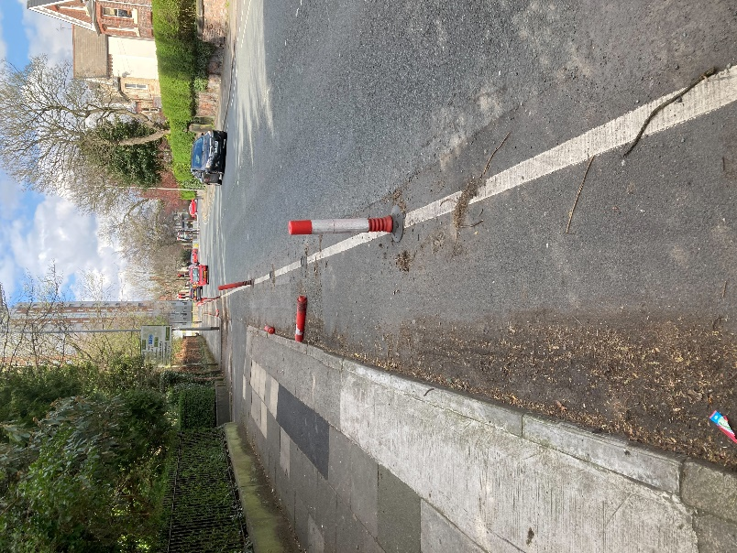

Image depicts a narrow pop-up cycle lane demarcated by a painted white line and bollards. In places nearly half of the width is taken up with mud and debris from trees and two fallen bollards obstruct the path a little further along.

In addition to physical barriers, poor quality surface is a frequent obstruction on off-road, segregated and shared carriageways.

The roads and cycleways are too badly maintained even in major cities for me to safely cycle, as my 3 wheeled clip-on is vulnerable to tip in potholes.

Poor surfaces on cycle paths make handcycling very difficult at times. Stony ground, gravel and sand for example. Camber is also a huge problem as a hand cyclist cannot keep upright if the angle is too much.

In addition to wishing for wider, more numerous, and more interconnected cycleways, there are 2 major bugbears for me as a disabled cyclist: 1) The quality of supposedly “official” surfaces. I frequently follow Sustrans and other routes, and am often forced off-route by the path or road suddenly deteriorating into grassy, rutted, or otherwise inaccessible surfaces. It would be very helpful if there was a facility to search or filter cycle network data to find good paved routes. 2) Barriers. I ride a recumbent trike, and occasionally an upright tandem, and frequently get blocked by gates or wooden/metal barriers that might be navigable with a solo diamond-frame, but are impossible for a wider/longer cycle.

Beyond the journey itself, the lack of safe and accessible parking and storage for cycles at the destination and at home also prevented many Disabled people from cycling as much as they would like to.

I have limited storage space at home and the on-street cycle hangars are too small for my bike; having somewhere secure to store my bicycle would make it easier to cycle more. (And my spouse and housemate both cycle, but can't get a 'spot' in the bike hangars; if they could, it would help them cycle more, as they wouldn't need to carry their bikes around mine to get them outside.)

Parking at work is unsatisfactory so I take my cycle in to my office. If I did not have that option it would put me off cycling.

Safe and secure storage would enable me to also use my trike for travel and transport rather than mainly leisure and exercise. There is none available at all.

The need for high levels of security as well as accessibility in cycle parking was frequently raised by participants because of the high value of (and barriers to obtaining) non-standard cycles. High quality security equipment, such as locks, are often unusable by Disabled cyclists.

There needs to be more secure locking places for non-standard cycles, also guards to prevent theft.

Non-standard cycles are expensive and bike security is a great concern. I find it difficult to lift and operate a gold/platinum standard lock on my own

The design and quality of cycle infrastructure and parking and storage facilities present significant barriers to Disabled people cycling. The implementation of LTN/120 and Active Travel England should offer some redress. However, there is still much work to be done in terms of the design and delivery of infrastructure, parking and storage. Some Disabled cyclists reported additional barriers such as not being able to find helmets and/or clothing that was suitable for those with cochlear implants or with autism-related sensitivities.

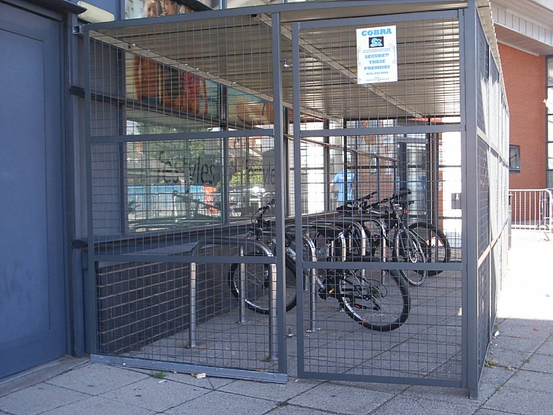

Image depicts a row of Sheffield stands which have been surrounded by a metal cage, making the cycle parking inaccessible to Disabled cyclists.
Attitudinal Barriers
A common underpinning feature of many of the barriers that Disabled cyclists encounter is the belief/attitude that Disabled people cannot or should not cycle.

As with everything else in my life, my cycling is controlled by people who don't have a disability. Until such time as people with disabilities gain positions of power (to influence infrastructure, financial support, etc), this will never change.

The public’s response to my non-standard cycle is appalling.

These attitudes are often expressed in hostility towards Disabled cyclists by drivers (see below on re-education).

For me, safety is the main factor that creates a barrier to cycling. The recent lowering of COVID restrictions led to a substantial increase in motorised traffic and, at the same time, verbal abuse from motorists (the first I had encountered in over two years).

Sometimes it is other (non-disabled) cyclists and pedestrians who express hostile attitudes towards Disabled cyclists.

Cycling with my disability is hard. Balance is difficult. Leg strength is weak. I am more frightened of militant cyclists in Lycra than cars. Most cars seem understanding but the militant cyclists scare me a lot. I feel judged and vulnerable. Although it is good having cars move more slowly, I live on a residential A road and traffic here is much more than it was due to a local LTN. I also think that parks should aspire to separate cycle lanes, as cyclists in parks are very dangerous if they go fast.

I find shared spaces very dangerous, pedestrians walk in the cycle lane and they become abusive if mentioned to them they are in the cycle lane. There should be much more signage telling people not to walk in cycle lanes. If I have to share a pavement I tend to ride on the road rather than being abused.

Attitudes shape behaviour, and Disabled cyclists encounter a range of barriers, including abusive behavior as a result of prejudice and misperceptions about Disabled people and/or Disabled cyclists.

Benefit Qualification Criteria
Another aspect of attitudinal barriers is found in the perceptions of disability that underpin state policies. This is particularly true in regards to the Department for Work & Pensions’ (DWP) disability benefits, which are assessed on the basis of a deficit model of disability. Here, any apparent ability is judged to counter the claimant’s disability status and therefore reduce their entitlement to benefits. This creates a context in which many Disabled cyclists are afraid to use their cycle, and/or of the consequences of admitting that they can cycle. Although only a small proportion of respondents had had their benefits directly stopped because they cycled/were deemed too active, a large number reported significant concerns. Just over one third of respondents were not in receipt of any disability-related benefits.

Have You Had Benefits Reduced or Withdrawn Because You Cycle
or Are Physically Active?

Less than two percent of respondents (1.24%) reported that they had had benefits stopped because they cycled. However, more than a quarter (25.32%) lived in fear of benefit penalties if they were discovered cycling, and some did not apply for benefits for this reason. PIP (Personal Independence Payment) and ESA (Employment Support Allowance) were the benefits that participants most commonly feared losing.

ESA and PIP, because I believe that if the DWP found out I was cycling they'd determine that I wasn't disabled.

PIP – I can’t walk very far and qualify for the mobility element. Given the inexperience of PIP assessors I would be worried about disclosing that I cycle, even with an e-assist, because I can do miles on my trike. I’d be worried they’d see this as “evidence” against me.

It concerns me greatly that, even though I now have to take 3,300mg of Gabapentin (for pain management) and ride electrically assisted bikes, this will be seen as a sign that I am somehow no longer disabled. The price of the bikes I need is astronomical, my War Disablement Pension and PIP help me to pay for my bikes.

My biggest worry about cycling is the DWP.

It was not just cyclists with physical disabilities who were concerned that their cycling activities might be used to discount their disability status. Some respondents with mental health issues were equally concerned that, for example, the influx of policies that focus on physical activity, including cycling, to improve mental health might become a rationale to discount the disabling impacts of their distress.

I get benefits (ESA Support Group) because of my mental health issues, which are serious and longstanding. I get very worried that given all this push to save mental health by physical activity (including cycling) that folks won’t understand how I can be suffering from mental ill health and still go cycling.

Fear of benefit sanction is a significant barrier to Disabled people taking up cycling. This occurs in a context where both public health (DHSC) and DfT policies promote active travel for Disabled people, including cycling on prescription and an imminent pilot of active travel on prescription. If Disabled people are to be able to take up these opportunities, then there must be consistency across government departments and between health, transport and benefits (DWP) policies.

Enablers to Cycling
The barriers to Disabled people cycling have been clearly identified. Thus, the key enablers to cycling address the cost, infrastructure and attitudinal barriers that Disabled cyclists encounter and expanding the variety of hire and loan schemes, including increased access to cycle sessions.

The survey asked participants to rank eight policy interventions in order, according to which they felt would have the most positive impact for Disabled cyclists.

Enabling Policy Interventions
(participants ranked in order of preference)

Accessible infrastructure was ranked as most important intervention for Disabled cyclists, with subsidies for non-standard cycles in second place. Reduced traffic speed and quantity was in joint third place along with official recognition of cycles as mobility aids. Another cost-related enabler – access to cycles on the Motability scheme – was ranked fourth, followed closely by access to inclusive cycling sessions. Awareness raising was rated sixth most important, and access to cycle hire was ranked last. Whilst this reiterates that infrastructure and cost are huge barriers, it is also important to note that the majority of our respondents already own a cycle, and therefore hire and inclusive sessions would be less of a priority for this demographic.

Additional enablers to cycling that emerged in the free-text comments included Disabled people being able to access public transport with a range of mobility aids, including cycles, and safe and supportive cycling environments.

Public Transport
Survey participants frequently reported that being able to bring cycles on public transport, especially trains, was crucial in enabling them to cycle more frequently. Likewise, recognizing cycles as mobility aids (see Chapter 2), which can be used in stations and other “no cycling/no-bike” zones, would enable Disabled people to increase their cycle journeys and to make multi-modal trips on a regular basis.

Being able to take my cycle on trains and tubes more easily, and cycle-friendly step-free access in more stations, would be very helpful.

Full access to rail is urgently required. Solves a range of issues

It would be nice to have more opportunities to [ride] and also the ability to transport my handcycle to those rides.

Access to public transport and public spaces is essential if Disabled cyclists are to cycle with the same freedom and variety of choices as non-disabled people. The role of public transport in facilitating cycle journeys by Disabled people highlights the ways in which key enablers to cycling involve a wide range of public services and infrastructure, not just cycleways.

Safe and Supportive Cycling Environments
Another enabler to Disabled people cycling is a safe cycling environment. This includes specialist off-road sessions for Disabled people, segregated and low traffic cycling environments and improvements in driver behaviour where cyclists and motorists share the carriageway.

Access to cycling sessions – both in terms of their availability nationwide and their easy accessibility – is essential for many Disabled cyclists for whom this provides their only opportunity to cycle:

Need more inclusive cycling opportunities.

Walking distance/proximity to sessions is important.

Inclusive cycling organisations also play an important role in facilitating cycling beyond the specialist sessions themselves. Many participants learn to cycle and/or find a cycle that is suitable for them at a specialist session, which then enables them to go on and cycle independently.

Having a facility like WfW has renewed my confidence in my ability to cycle, so if more schemes like this were available it would be a fantastic boost to people who have mobility issues in day to day life.

I ride an electric-assist folding tandem with my husband, generally on cycle paths and trails. It is great to take part in mass events, such as SkyRide etc, as it makes me feel part of the whole cycling community. I got into it through Wheels 4 Fun here in Leeds; without them I would not have got back on a bike again. Groups such as Wheels 4 Fun are essential in promoting cycling to people with disabilities.

Inclusive cycle sessions are essential in allowing a range of Disabled people to cycle, some of whom will go on to cycle independently and others who will always rely on specialist services. For those who go on to independent cycling, the behaviour of other road/infrastructure users can be a key factor in whether or not they continue to cycle.

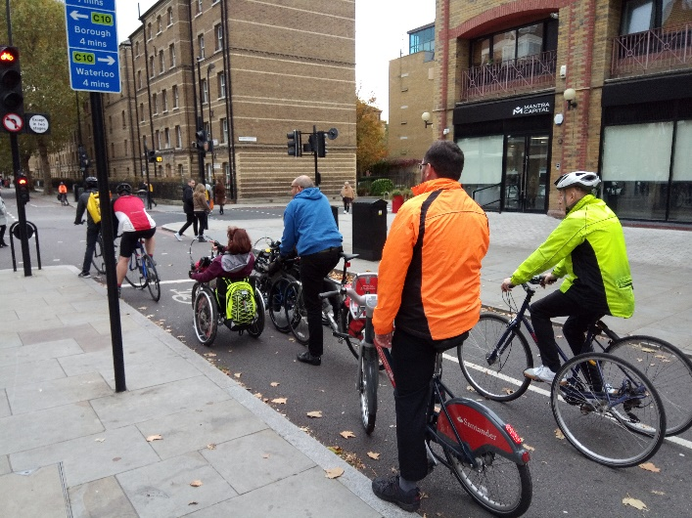

Image (courtesy of Sustrans) depicts a back-view of a number of cyclists waiting at a
road junction, including four bicycles, two handcycles and an upright tricycle.

Many respondents described the re-education of other road-users as a key enabler of safe cycling environments because, “Cars are a constant danger”. A common experience was close passes and inconsiderate/potentially dangerous behaviour from drivers – the new Highway Code has attempted to address some of these issues. A number of Disabled cyclists also noted the role of the media in fuelling unsafe attitudes.

Drivers need re-training. Many pass too close.

Urgent retraining of drivers is needed – e.g. to give enough space to people on cycles.

I cycle every day with my son, who is 23 and learning disabled. We ride for just 15 mins because it helps him get his day started and he really benefits from routine. We live in a mainly rural area and would cycle a lot more if motorists were required to drive slower and recognize the risks and impact of close passing as well as other dangerous driving that happens regularly. I drive a car a fair amount too. It's really not hard to treat cyclists as vulnerable road users, give them space and be nice. It also takes only a negligible amount of time. It would help a lot if certain sections of media just recognized that every life matters and stopped pitching one group of road users against another.

Danger from traffic, close passes and hostile attitudes can be particularly inhibiting for those using non-standard cycles that take up more road width, and/or have lower sight lines: “I feel unsafe on the recumbent in the roads in my city due to the traffic”. Consequently, for some Disabled cyclists, LTNs have been vital in providing a safe cycling environment (although it is worth remembering that some LTNs, especially those provided on a pop-up/emergency basis during the pandemic, have created barriers to Disabled people’s mobility – see Chapter 1).

I could only cycle my trike because the low traffic neighbourhood made it safe enough to get to the park. Ealing Council has ripped out the LTN and now I hardly cycle because I don't feel safe on my trike in the traffic.

Other respondents highlighted the dangers for those who are adversely impacted by traffic fumes and pollution.

More focus needs to be given to cyclists who have disabilities that are affected by air pollution (for example those with heart conditions). This means much more focus should be put on the importance of cyclists not being left on the road behind polluting (particularly) diesel, and petrol motor vehicles. As well as protected cycle lanes, there is a strong merit in advance stop lanes (cycle boxes) for people with heart conditions. Incorrect stereotypes – disabled people only drive and use taxis – keep being presented in the media, with the tropes unchallenged.

Safe and supportive cycling environments are essential in enabling Disabled people to cycle. These range from off-road inclusive cycle sessions, low and no-traffic cycle infrastructure to a significant shift in attitudes and behaviour where cyclists and motor vehicles share a carriageway.

Summary
Each year our survey highlights key barriers and enablers to cycling, including impediments such as cost, infrastructure, attitudes and driver behaviour alongside the need for improved access to public transport and a range of safe and supportive cycling opportunities. Some of these are already being addressed in government policy and schemes, such as the LTN1/20 cycle infrastructure design standards, and pilot hire and active travel social prescribing schemes via Gear Change. However, a much broader, joined-up approach is needed to address the full spectrum of barriers that Disabled cyclists encounter, including culture-wide attitudinal changes, accessible public infrastructure, improved funding and consistency of approach between government departments.

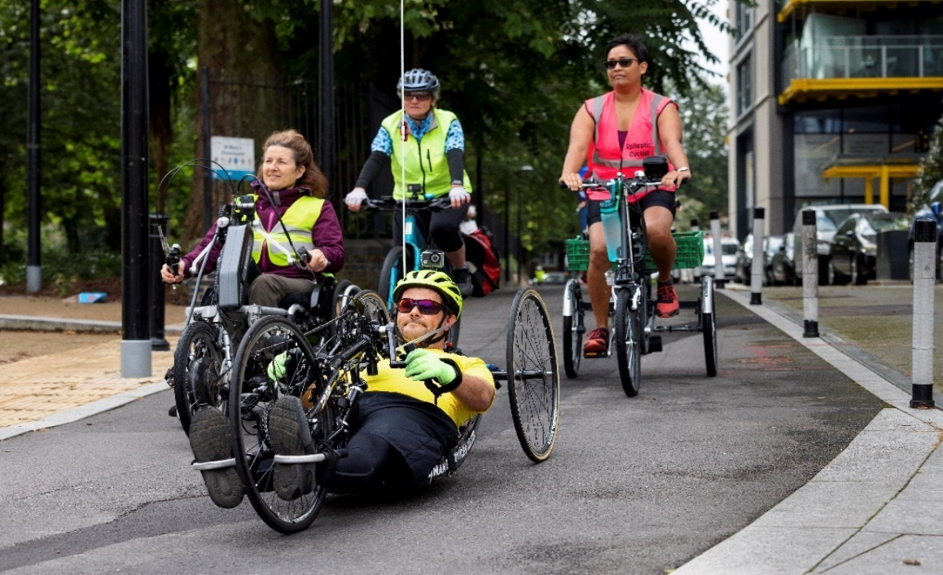

Image depicts a group of four cyclists on a wide cycle path. A white man rides a
recumbent handcycle, a white woman rides an upright clip-on handcycle, a woman of
colour rides an upright tricycle and a white woman rides a standard bicycle.
Conclusions & Recommendations
The 2021 survey echoed a number of key findings from previous years, including that cycling is easier than walking for many Disabled people and that it is a vital form of mobility, independence and support for mental and physical health. The findings confirm that many barriers remain consistent year on year: inaccessible infrastructure (including cycle storage and parking), cost, and the lack of inclusive cycle hire and inclusive cycle sessions – which was felt particularly keenly during periods of lockdown. Difficulty in accessing public spaces and public transport with cycles was also a barrier for many, and Disabled cyclists all too often encountered hostility or abuse whilst cycling. All of these findings will continue to shape our work over the coming year – as a Disabled cyclist-led organization, our mission to amplify the voices and experiences of Disabled cyclists remains stronger than ever.

2022 will witness the launch of Active Travel England (ATE), whose role will include inspecting cycle infrastructure and active travel schemes to ensure they are fully accessible and LTN1/20 compliant. WfW have been working with the Department for Transport (DfT) to support the establishment of ATE and will work with ATE across a spectrum of activities to ensure fully accessible cycle schemes that address the key barriers to cycling.

Findings specific to the 2021 survey were predominantly pandemic-related. COVID-19 had a devastating impact, with Disabled people accounting for 60% of deaths in England. Pop-up walking/cycling infrastructure around the country was of varying quality; that which was fully accessible had positive impacts for Disabled people, allowing many to increase their cycle journeys or take up cycling for the first time. However, inaccessible, poorly designed temporary infrastructure had the opposite impact, preventing Disabled people from cycling and impeding their wider mobility and social connectedness. The experiences of Disabled people during the pandemic re-emphasise how crucial fully accessible, high quality infrastructure is, and this remains a campaigns and policy priority for us.

The pandemic also highlighted the stark physical and mental health inequalities that Disabled people endure and how crucial cycling is for Disabled people’s mental and physical health, exercise and mobility – themes that were reflected in data from across the survey. This is increasingly recognized through active travel policies, such as social prescribing for active travel, and we will continue to work with DfT to ensure they are rolled out in fully accessible and inclusive ways. We will also keep pushing for better links between the different government departments, as this is crucial to ensuring full participation in Disabled cycling. Schemes recognizing cycles as mobility aids will begin to be developed in a selected number of local authorities in 2022 and, again, we look forward to inputting into the design and rollout of these vital initiatives.

Cycling is not just important for the mental and physical health of Disabled people but also for the wider community and planet as a whole. Access to cycles has never been more important, and WfW are working with a number of micro-mobility organisations to ensure that new share and hire schemes are accessible to all. We are also providing training and consultation to designers and developers to enable them to produce cycle parking and storage that is fully accessible for Disabled cyclists in new housing, commercial and public developments.

2021 saw the establishment of the Expert Panel on Inclusive Cycling, made up of manufacturers of cycles for Disabled people and providers of inclusive cycling opportunities. The panel incorporates the four nations and all regions of the UK and pan-disability organisations. Amongst its many functions, we are looking forward to the panel working with us to develop future surveys that are even more representative of the diversity of Disabled cyclists and that deepen our exploration of their experiences in the rapidly changing policy and infrastructure context.

Recommendations
- Universal rollout of fully accessible cycle infrastructure, including parking and storage.
- Rapid development of policies/initiatives that will make cycles affordable for Disabled people.
- An increased range of safe and supportive inclusive cycling environments, including specialist sessions, accessible, segregated and off-road cycle ways, quiet streets and driver re-education (building on the recent changes to the Highway Code).
- Formal recognition of cycles as mobility aids, to permit cycle-use by Disabled people throughout public infrastructure, including public transport, and eliminating the risk of benefit penalties for Disabled cyclists.
- Action to tackle prejudice, hostility and hate crime towards Disabled people.

References
Cycling UK (2021) Adaptive Bike Share Survey Results 2021. Guildford: Cycling UK.
Department for Transport (2020) Gear Change: A Bold Vision for Walking and Cycling. London: TSO.
Department for Transport (2021) Gear Change: One Year On. London: TSO.
EHRC (2017) Being Disabled in Britain: A Journey Less Equal. London: EHRC.
HM Government (2020) Local Transport Note (LTN) 1/20. London: TSO.
Health Foundation (2021) Unequal Pandemic, Fairer Recovery. London: The Health Foundation.
Inckle, Kay (2020) Disability, Cycling and Health: Impacts and (Missed) Opportunities in Public Health. Scandinavian Journal of Disability Research, 22(1): 417–427.
Inckle, Kay (2019) Disabled Cyclists and the Deficit Model of Disability. Disability Studies Quarterly, 39(4).
Wheels for Wellbeing (2020) Guide to Inclusive Cycling. London: WfW
Wheels for Wellbeing (2020) Experiences of Disabled Cyclists 2019. London: WfW
Wheels for Wellbeing (2018) Experiences of Disabled Cyclists 2018. London: WfW
Wheels for Wellbeing (2017) Experiences of Disabled Cyclists 2017. London: WfW

Acknowledgements
Heartfelt thanks to all the Disabled cyclists and their supporters who took the time to complete our survey and provide insight into their cycling experiences. Thanks also to our volunteers, allies, supporters, campaigners and staff who work tirelessly to make fully inclusive cycling for everyone more of a reality each day.

Published: May 2022 by Wheels for Wellbeing, 336 Brixton Road, London
© Wheels for Wellbeing. Images may not be reused.

