Recruitment Pack

SENIOR ADMINISTRATOR

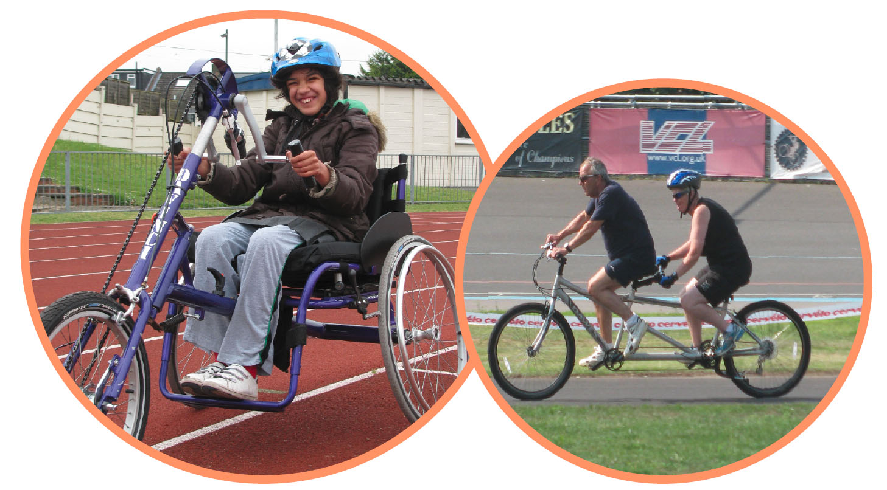

AUGUST 2021

336 Brixton Road
London
SW9 7AA
Tel: 020 7346 8482
info@wheelsforwellbeing.org.uk
www.wheelsforwellbeing.org.uk

18 August 21

Dear Applicant,

Thank you for your interest in the post of Senior Administrator at Wheels for Wellbeing. Our current post holder is moving on after four years in the role.

We would love to hear from you if you:
- Love organizing others
- Enjoy taking responsibilities and juggling endlessly varied tasks
- Are a great communicator and able to explain things clearly without ever patronizing people
- Are confident across the Microsoft Office suite and you pick up other IT systems quickly and explain them to others

I attach some background information, the job description and person specification. Please note that this post involves some work with adults at risk and is not protected under the Rehabilitation of Offenders Act 1974. Applicants invited to interview will therefore be asked to disclose criminal convictions, no matter when they occurred. Information will be treated confidentially and only considered if relevant to the post.

Wheels for Wellbeing promotes opportunities for Disabled people in all aspects of our work. Our offices are based within an inclusive community hub, fully accessible by wheelchair and home to several Disability-led organisations. Please tell us if there is anything else we can do to make sure the recruitment process is accessible to you. We are planning to hold interviews in person at our offices unless restrictions are reintroduced in the meantime.

To apply, please email your CV to info@wheelsforwellbeing.org.uk with a cover letter (no more than two pages) outlining why you would like to be considered for this post, the skills and experience you’d bring (ensuring you address the points in the person specification).

The closing date for this role is 5pm on Monday 6th September 2021. Applications received after this will not be considered. Interviews will take place on Friday 17th September 2021.

Yours sincerely

Isabelle Clement

Isabelle Clement MBE, Director

Background
Wheels for Wellbeing is a small charity with unique impact, run by and for Disabled people. Our campaigning voice is shaped by Disabled trustees, staff, participants and allies.

Our grassroots work takes place in leisure facilities, community centres, schools, hospitals and on streets in south London, using our large fleet of bikes, trikes, handcycles, recumbents, tandems and side-by-sides. Our participants are aged 2-102 and live with a range of impairments, health conditions, mental health issues and/or neurodiversity. They all have one thing in common: they had all experienced barriers to cycling prior to finding out about the cycling opportunities and advocacy we provide.

We prove daily that anyone can cycle, as long as they have the right equipment, infrastructure, support and encouragement. Our expertise is sought widely, and we are regularly referred to as thought-leaders and experts on inclusive active travel. It is our mission to challenge the barriers that prevent Disabled people from enjoying active and independent travel, by:
- Helping 1000+ Disabled people a year experience cycling from our ‘hubs’ in Herne Hill, Croydon and Lewisham.
- Coordinating the 'Beyond the Bicycle' Coalition, which aligns Disabled cyclists’ needs with those of allies who use larger or wider cycles: parents of small children; cargo bike delivery companies etc.
- Providing training and advice regarding accessibility and inclusion to organisations such as TfL, Sustrans, Department for Transport, local authorities across the UK, developers and designers.
- Creating a movement and voice for Disabled people's rights to active travel.
- Changing attitudes to cycling, and attitudes to Disability.
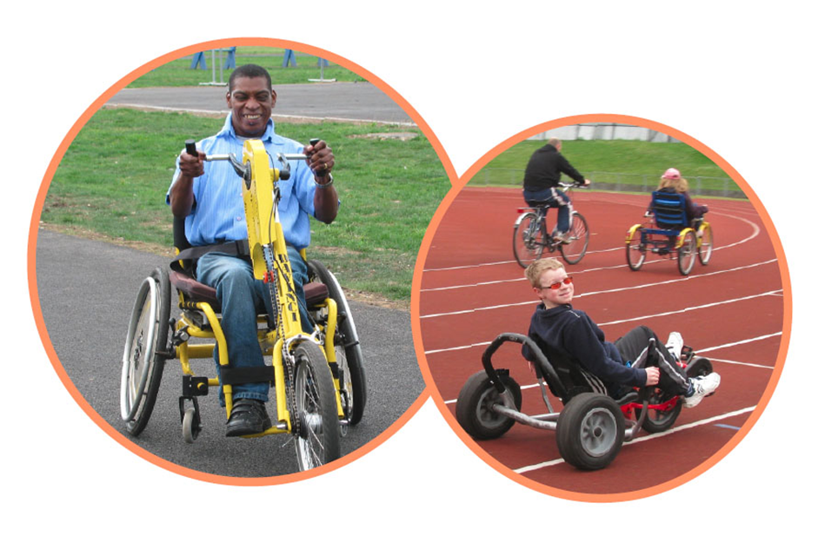

See www.wheelsforwellbeing.org.uk

Wheels for Wellbeing staff structure (August 2021):

Senior Administrator

Responsible to: Director & Operations Manager
Accountability for: Office Volunteers / Office Interns
Hours: 25 per week over 5 days (exact work pattern to be agreed with appointee)
Duration: Permanent
Salary: £25,000 to £28,000 pro rata (incl. London Weighting) depending on experience
Place of work: Office based at 336 Brixton Road, SW9, London

Job Purpose
Sadly, our current Senior Administrator is moving on at the end of August. We are now looking for an experienced and talented person to fill this position. This job is full-on as well as varied and fun! If you love people and systems in equal measures, you will love working for us.

You will work closely with our Operations Manager and Session Managers, providing administrative support to all aspects of cycling sessions (monthly staff and volunteer rotas, staff timesheets, venue bookings), ensure that the quality of our session records (on our online database) enables us to provide quality data to our funders. You will also provide support across the organisation, helping the senior management team by providing HR administration, liaising with our IT support provider, assisting with finance administration, producing regular monitoring and evaluation data reports, managing our contacts database, disseminating Marketing, Communications and Fundraising materials, being the first point of contact for any enquires and session bookings, and generally ensuring the smooth running of our office.

Probationary Period
The appointment of every new employee is subject to a probation period of six months.

Pension
Wheels for Wellbeing provides 5% contribution towards your pension.

Annual leave
Annual leave entitlement is 20 days in addition to the 8 English Public Holidays (pro rata), plus a few days between Christmas and New Year when the building is generally closed.

Job Description

- Cycling Sessions Administration
- Draw up and update monthly rota of Inclusive Cycling Instructors & Volunteers
- Check session staff monthly timesheets with the rota, and prepare payroll calculations
- Be responsible for dedicated bookings inbox, accept participants’ booking requests for various sessions, send confirmation emails and keep booking spreadsheets up-to-date
- Create the session data in the online database, monitor its quality, add any paper- or email-based data (e.g. registration forms) to the database. Promptly bring up any issues relating to session data to the Director.
- Assist Session Managers in delivery of sessions by liaising with venues, partner organisations, etc.; managing session supplies; booking vans for outreach sessions etc.
- Regularly review and update session documentation
- Be actively involved in our annual participants survey and other feedback mechanisms
- Adhere to appropriate standards of confidentiality at all times

- Office Administration
- Manage incoming and outgoing correspondence and respond to phone and email enquiries
- Manage office supplies ensuring adequate stocks; maintain office furniture and furnishings to a good standard and organise repairs and purchases
- Maintain WfW’s monitoring and evaluation systems, collate monitoring and evaluation information from projects and events for Board of Trustees and funders
- Maintain general office systems and ensure electronic files are organised and accessible, adhering to data protection principles when processing personal data

- Human Resources Administration
- Assist in the management of the recruitment process for staff and volunteer vacancies
- Support the induction of new starters, including office furniture and IT requirements, training in the use of our systems etc.
- Prepare all relevant paperwork, including recruitment pack, draft advert, offer letter, contract, including ensuring they are in accessible formats
- Ensure systems are in place for recording employees work time and monitoring absences (including sickness and annual leave)
- Administer training, DBS checks & conference bookings for staff and volunteers (and arrange travel where needed)

- Finance and accounts
- Issue invoices using our online accounting system Xero and support the Director with preparation of ‘month-end’ and ‘year-end’ tasks
- Monitor and chase aged debtors where required
- Count session petty cash and pay it in, along with cheques, to the organisation’s bank account
- Manage any contracts/relationships with suppliers.

- Health and Safety:
- Monitor and review the Health & Safety Policy in relation to the office environment
- Take responsibility for the annual office risk assessment, and to keep it under review, drawing to the Director’s attention any gaps with regards to relevant HR, health and safety, insurance and any other obligations

- Support to Staff and Board of Trustees
- Provide any general administrative support, including taking minutes of meetings
- Provide administrative/organisational support to outreach and/or fundraising events
- Assist with the preparation of Board papers, annual report, evaluation reports and other related administration
- Provide trouble-shooting support for staff
- Support Wheels4Me cycle hire Coordinator in admin-related tasks
- Where needed, support our admin volunteers to enable them to gain valuable experience with us, whilst ensuring that they are contributing to our objectives

- Communications & IT
- Manage the maintenance and appropriateness of telecommunications and IT equipment
- Manage the dissemination of updates / newsletters to participants & supporters, assist in updating the website and social media
- Help introduce new online database and booking system (to replace existing database during Autumn 2021), train all staff members and volunteers to use the online system
- Create user accounts on the online database for relevant staff members and volunteers
- Centralise colleagues’ feedback on IT issues and liaise with external IT Support to resolve them
- With IT Support, ensure regular tasks (including network maintenance, server back-ups, etc.) are performed and that any issues are brought to the attention of the Director.

- Other:
- Contribute to the ongoing development of Wheels for Wellbeing, team meetings and organisational priorities
- Be proactive in keeping up to date with developments affecting the role
- Abide by and promote organisational policies and practices, and charity’s values
- Support diversity and equality of opportunity in the workplace
- Occasionally, with notice, work evenings / weekends
- Work at least once a quarter in an appropriate role at a Wheels for Wellbeing session

This job description is not exhaustive, but assists the post holder to understand their main duties. It may be amended from time to time without change to the levels of responsibility appropriate to the grade of the post and in discussion with the post holder.
Person Specification

QUALIFICATIONS AND TRAINING | Essential | Desirable
Educated to degree level (or equivalent)
Business administration, finance or other relevant subject qualification

KNOWLEDGE AND EXPERIENCE | Essential | Desirable
Experience in a similar role, with a minimum of two years’ experience
Practical experience of dealing with human resource systems
Advanced user of MS Office, especially Word and Excel; confident user of databases (especially for data reporting)
Knowledge and understanding of office based health and safety issues
Experience of managing office supplies and systems
Knowledge of data-protection legislation
Experience of managing staff and volunteers, including (where appropriate) supervision, annual appraisal and performance management
Experience (paid or unpaid) of working with disabled adults and children

SKILLS: | Essential | Desirable
Excellent communication (verbal & written)
Strong problem-solving skills
An organised and efficient person, able to function on own initiative with limited supervision; excellent attention to detail
Proven ability to liaise competently with IT support suppliers over IT problems
Proven planning and organisational skills, including under pressure
Excellent interpersonal and communication skills with people from all backgrounds
Excellent timekeeping and reliability

ATTITUDES AND BEHAVIOURS | Essential | Desirable
A positive, energetic and enthusiastic outlook with a ‘can do’ approach
Professional manner and friendly disposition
A commitment to working to empower and further the rights of disabled people and to working within the Social Model of Disability
An ability to relate positively to people of different cultures, backgrounds and experiences
Friendly, approachable & helpful to anyone requiring information (participants, their supporters, volunteers, colleagues, etc.)
Respectful of others and with a total belief in the equal value of people, regardless of race, religion, culture, gender, age, disability or sexuality

