Survey 2021

Wheels for Wellbeing: We are a charity which supports Disabled people of all ages to enjoy cycling.

Looking at the needs and experiences of Disabled cyclists.

- Questions about using your data

Data: this means personal information that you give us in this survey.
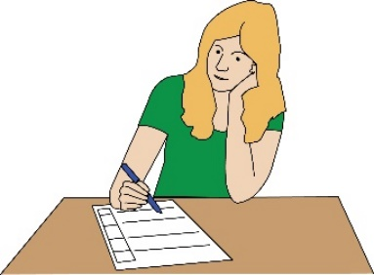 |  | Wheels for Wellbeing will use data from this survey to support and work on our policies in the future.
Policies: this means decisions or rules made by our organisation.
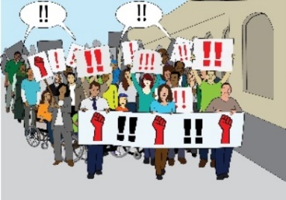 |  | We will also use data from this survey to help us with our campaigning work in the future.
 |  | We will make sure that your data is anonymous.
Anonymous: this means the information won’t have your name on it.
 |  | We will only keep your personal data for as long as we need it. We will only keep it if it is useful for us. We will meet Data Protection guidelines.
Data protection guidelines: this means rules around looking after any personal information that our members give to us. As an organisation, we must look after your data and meet our responsibilities by law.
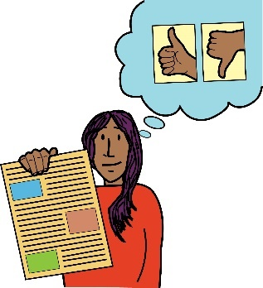  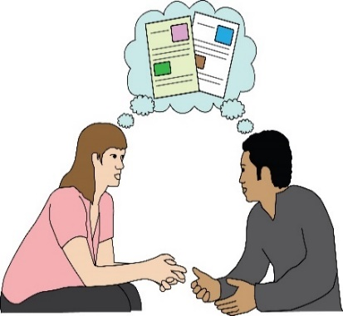 |  | Question 1 – Is it ok if we use your data for the reasons we have talked about above?  Please tick one of these answers:  ☐ Yes, this is fine.  ☐ No, I don’t want you to use my data. This means I won’t take part in this survey.
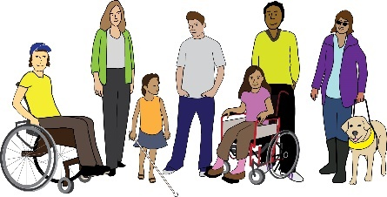 |  | Question 2 - Do you think of yourself as a Disabled person? Or do you think of yourself as having a long-term health condition or a hidden disability?
Hidden Disability: this means that you have a disability or health condition that can’t be seen such as autism or anxiety.
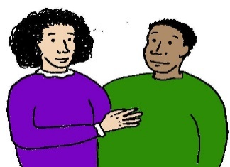  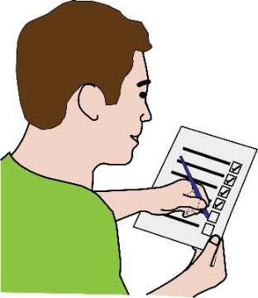 |  | Please tick one of these answers:  ☐ Yes  ☐ No  ☐ No, but I am writing these answers for someone who is. I am a parent, carer or guardian.
- Some basic questions about cycling

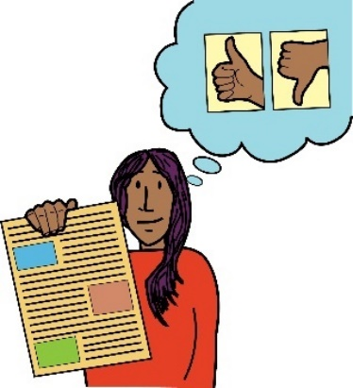  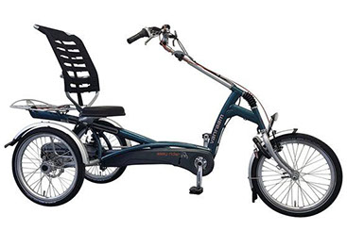 |  |  | Question 3 - Do you think of yourself as a person who cycles?  You can say yes even if you don’t cycle very often.  Please tick one of these answers:  ☐ Yes  ☐ No
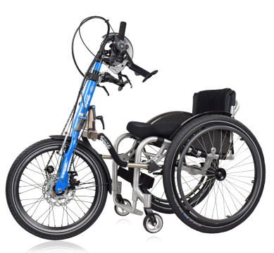  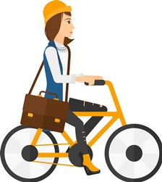  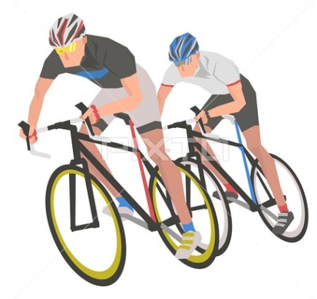  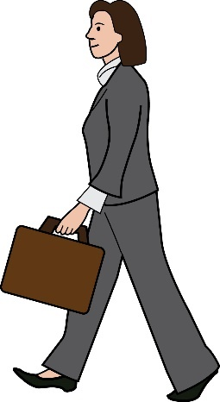 |  |  | Question 4 - Why do you cycle?  Please tick as many reasons as you want to.  ☐ To relax or for fun  ☐ To go to and from work or to use during work  ☐ To get around  ☐ For sport or to race against other cyclists  ☐ For exercise or to get fitter  ☐ For my mental health  ☐ For another reason. Please tell us more about this:  …………………………………….
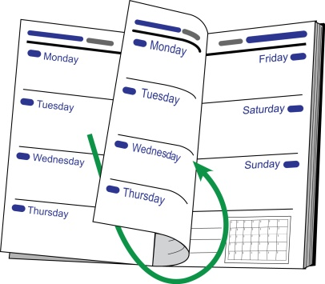  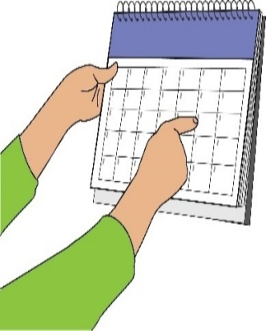 |  |  | Question 5 - How often do you cycle?  Please only tick on one:  ☐ Less than once a month  ☐ One or two times a month  ☐ Once a week  ☐ Every day
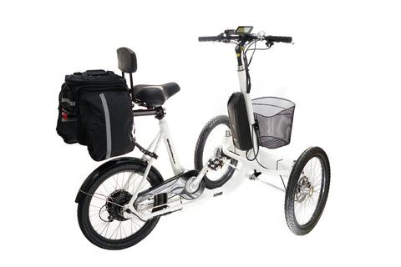 |  |  | Question 6 - Which of these activities do you find easier?  Please only tick one answer:  ☐ Cycling  ☐ Walking  ☐ I find both as easy or as hard as each other
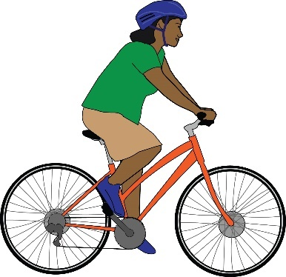 |  |  | Question 7 - Do you own your own bike?  ☐ Yes  ☐ No
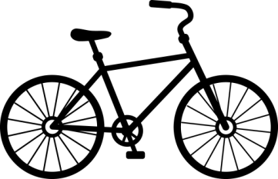  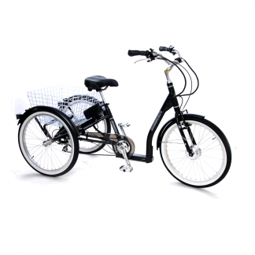  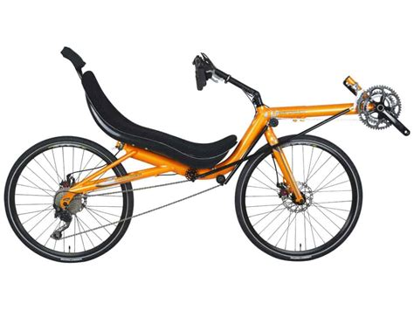  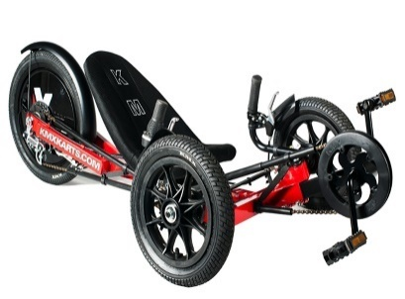  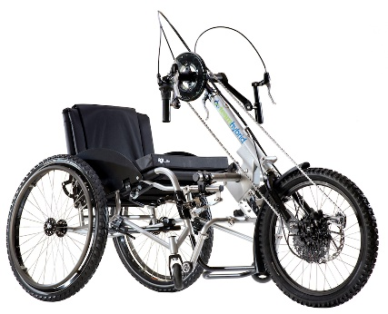  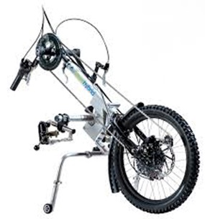  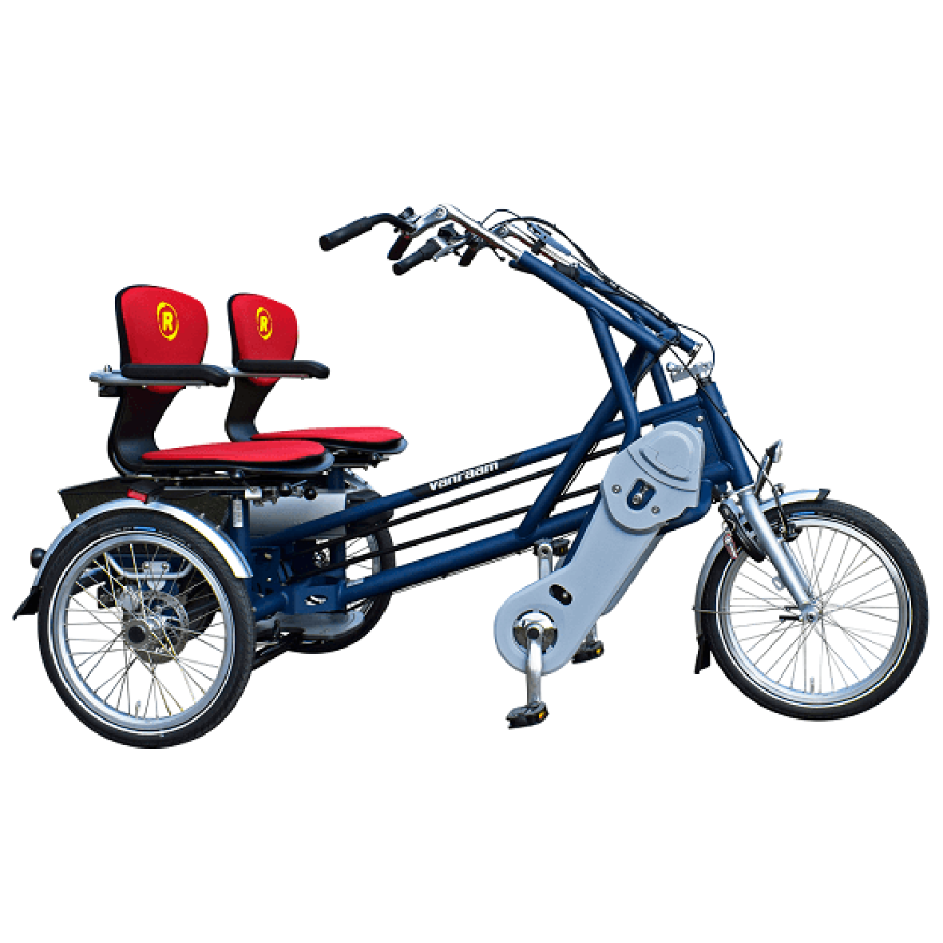  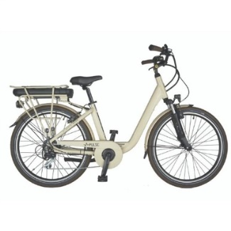  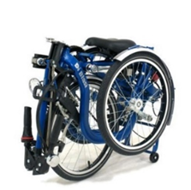 |  |  | Question 8 – If you do own a bike, which kind of bike do you own? Tick all the bikes that you own. You can look at the pictures to help you see what kind of bike you own:  ☐ A standard two-wheeled bike. This can be with or without adaptions. Adaptations mean when changes are made to your bike to make it more accessible for you.  ☐ Trike, this is a bike with three wheels.  ☐ Recumbent bike with two wheels. This is a bike with a wider and lower seat.  ☐ Recumbent bike with three wheels.  ☐ Handcycle, one piece. This is a bike that you cycle using your arms instead of your legs.  ☐ Clip-on handcycle. These are attachments that fit onto your wheelchair so you can use it as a handcycle.  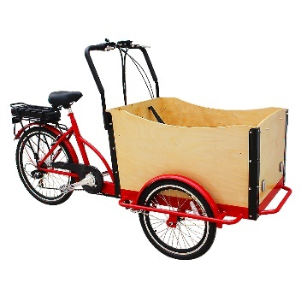  ☐ Tandem. This is a bike for two people. You might have a tandem where the seats are next to each other. You might have a tandem that carries wheelchairs.  ☐ Cargo or family cycle. This is a bike which is made to carry heavy loads.  ☐ My bike has electric-assist. This means the bike can be powered by cycling and by electricity.  ☐ My bike can be folded  ☐ Other. Please tell us more about this:  …………………………………….
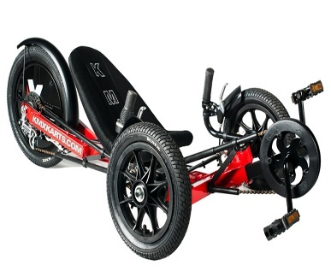  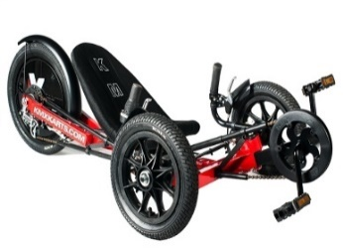  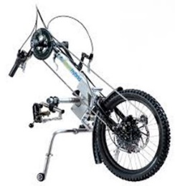  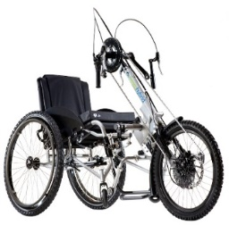 |  |  | Question 9 – Which kind of bike do you use most often? Please only tick one:  ☐ A standard two-wheeled bike. This can be or without adaptions.  ☐ Trike  ☐ Recumbent, with two wheels  ☐ Recumbent, a trike  ☐ Handcycle, one piece  ☐ Clip-on handcycle.  ☐ Tandem  ☐ Cargo or family cycle  ☐ Other. Please tell us more about this:
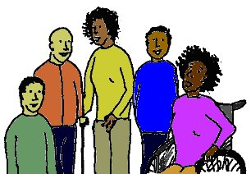 |  |  | Question 10 - If you don't own a bike, how do you access cycling?  Please tick any of the options that are true for you:  I go to:  ☐ An inclusive cycling group  ☐ A club for cyclists of all different levels or  ☐ A Wheels for All centre
Wheels for All: this is a programme that supports children and adults with disabilities and different needs to take part in cycling across the UK.
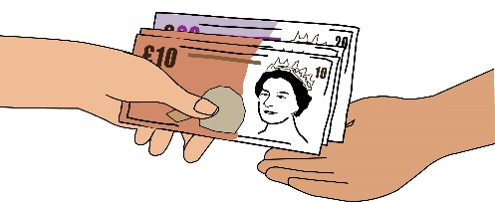 |  |  | ☐ I hire a bike when I need one  ☐ I borrow a bike from a cycling group or another person  ☐ Other. Please tell us more about this:  ………………………………………
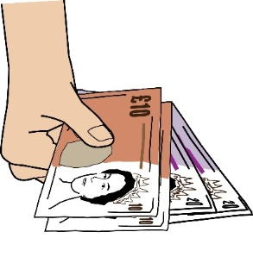 |  |  | Question 11 - Do you sometimes hire a bike?  ☐ Yes ☐ No
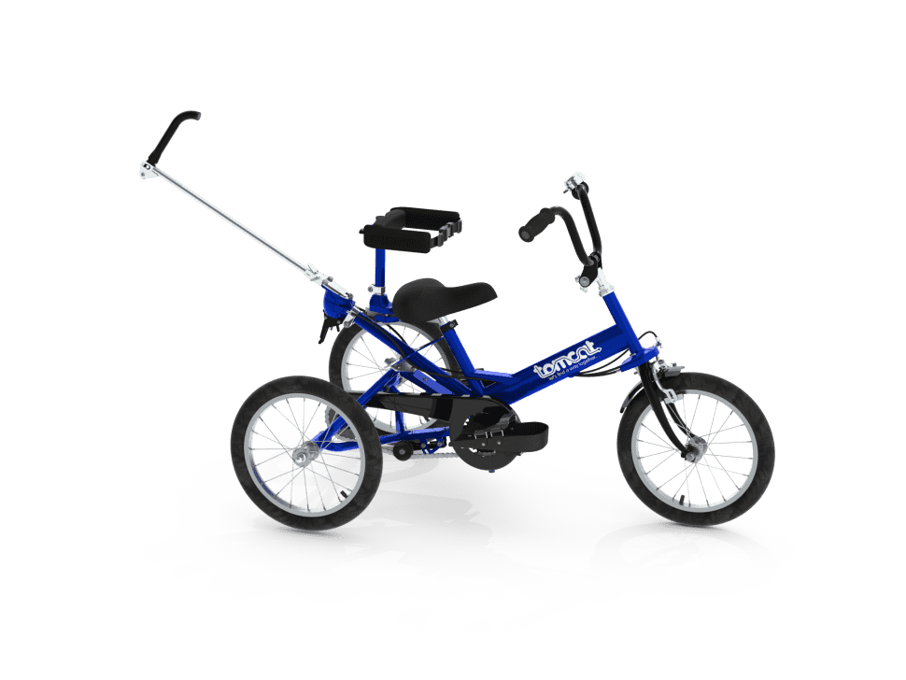 |  |  | Question 12 - If you said no, why don’t you hire a bike?  Please tick any of the options that are true for you:  ☐ I don’t need to because I have my own bike  ☐ I can only use my own bike because it has special adaptations or equipment  ☐ The type of bike or adaptation that I need can’t be hired  ☐ I can’t access a bike to hire  ☐ Other. Please tell us more about this:  ……………………………………..
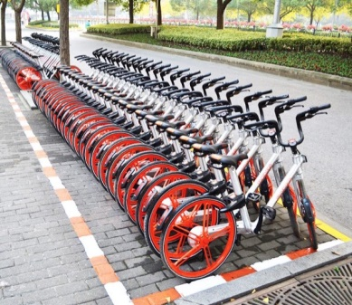  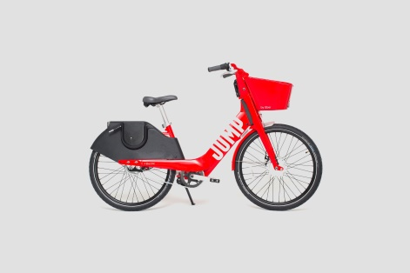  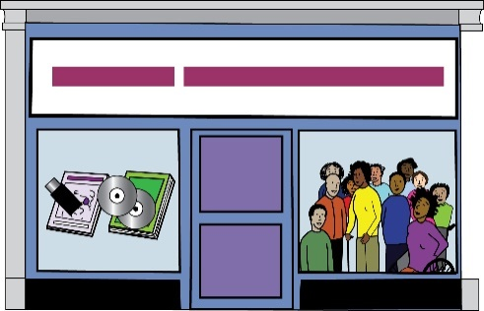  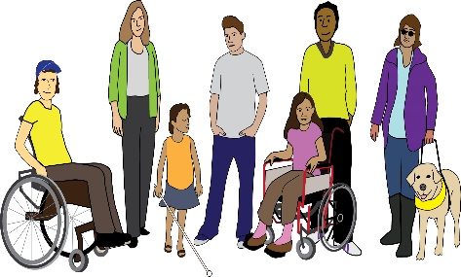 |  |  | Question 13 - If ‘yes’, who do you hire the bike from? Please tick any of the options that are true for you:  ☐ Docking stations around my town or city. These are bike racks where you must leave and pick up bikes. For example, Santander cycles in London, or Just Eat Cycles in Edinburgh  ☐ Dockless bikes. These are bikes that can be parked or picked up anywhere. For example, Jump, Lime, Beryl or Freebike.  ☐ A bike shop or cycle hire company  ☐ A special Disability cycling organisation. For example, Wheels for Wellbeing in London or Sheffield Cycling for All  ☐ Other. Please tell us more about this:  ………………………………
Question 14 – Do you hire your bike for part of your journey then use public transport or a car for the rest of the journey?

☐ Yes. Please tell us about the other types of transport that you use
……………………………
☐ No

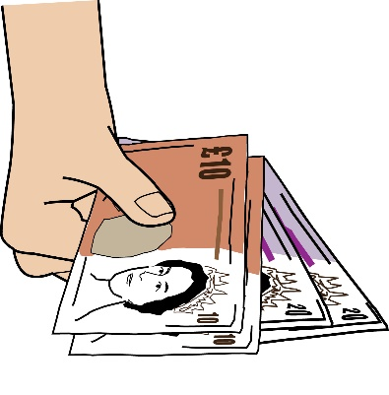 |  |  | Question 15 - Would you like to hire a bike more often if this was possible?  ☐ Yes  ☐ No
- Tell us more about your experiences of being a Disabled person who cycles:

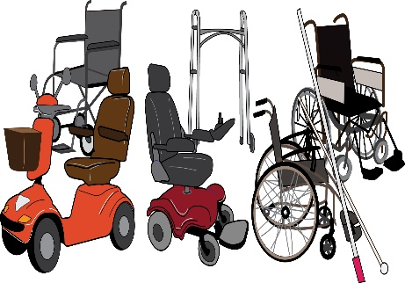 |  |  | Question 16 - Do you use your bike as a mobility aid?  For example, do you use it because you can’t walk far or because the route is too hard without a bike?  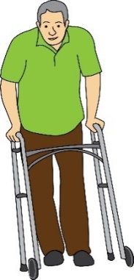  Do you use your bike because cycling takes away the pain you feel when walking?  ☐ Yes ☐ No
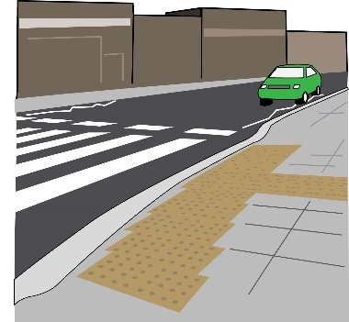  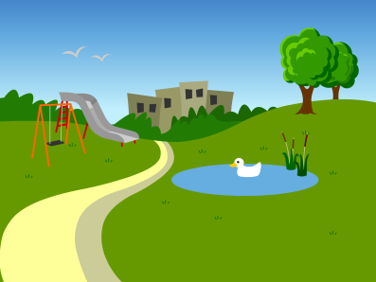 |  |  | Question 17 - If you answered yes, have you ever been asked to get off your bike and walk when you were using it as a mobility aid?  Has this happened in any of the following places?  Please tick any of the places that this has happened:  ☐ On the pavement  ☐ In a park  ☐ In a cyclist dismount zone - an area where you should get off your bike and walk with it.  ☐ In a shopping centre  ☐ On a train platform, station or track  ☐ Any other places. Please tell us more about this:  …………………………………….
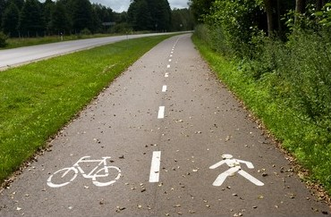 |  |  | Question 18 - If you have been told that you should get off your bike, were you allowed to carry on after you told them that you can’t get off and walk?  ☐ Yes ☐ No
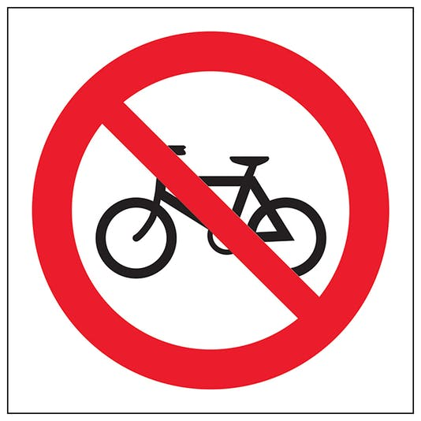  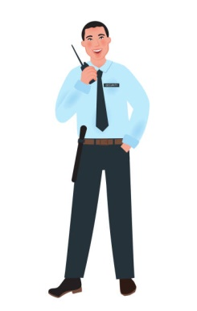  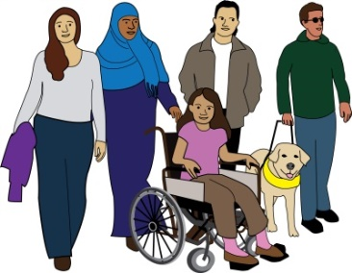 |  |  | Question 19 - If you have been told that you should get off your bike, who told you this?  Please tick any of the people that told you this:  ☐ A Police Officer  ☐ A security guard  ☐ A member of the public  ☐ I don’t know  ☐ Other, please tell us more  ……………………………………..
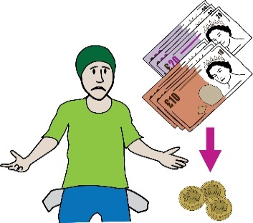  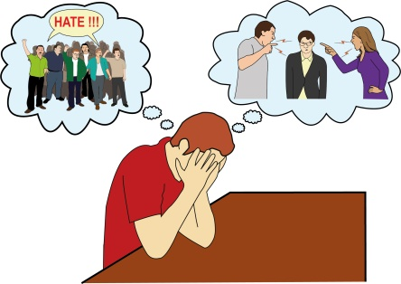 |  |  | Question 20 - Have you faced any of these barriers as a Disabled cyclist?  Please tick any of the barriers you have faced:  ☐ I couldn’t buy a bike that meets my needs because the one I wanted was too expensive  ☐ I faced abuse or disability hate crime while cycling
Abuse: this means being violent or causing pain to somebody else. This can be physical actions such as hitting somebody. It can also be something that a person says to you or the way that a person treats you.
Disability hate crime: this means when somebody commits a crime against a Disabled person because of their impairment.
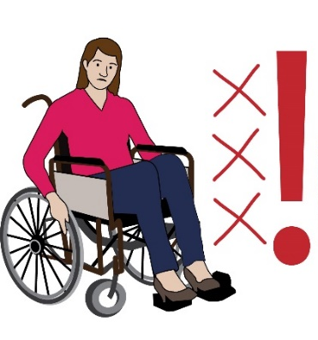  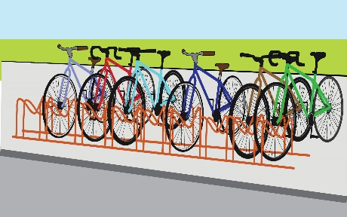  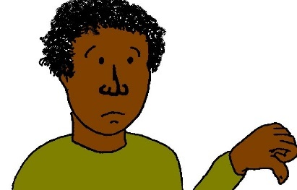 |  |  | ☐ I couldn't find any cycling opportunities in my area. I couldn’t find anything that I could take part in as a Disabled cyclist  ☐ I couldn’t park or keep my bike somewhere because the equipment wasn’t good enough  ☐ I couldn’t find somewhere that hires the type of bike I need  ☐ I couldn’t finish a cycling journey because the journey was not accessible. For example, there were barriers like gates or turnstiles  ☐ None of these
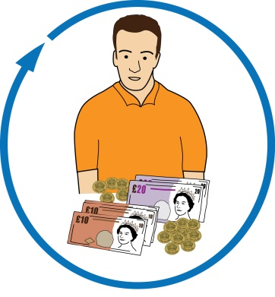 |  |  | Question 21 - As a Disabled cyclist, have you ever worried about having any of your benefits taken away because you are physically active?  This means you are moving or doing exercise.  Please only tick one answer:  ☐ Yes, and this has made me worried about cycling. It has made me cycle less or give up cycling  ☐ Yes – but my worries have not affected my cycling  ☐ No  ☐ No - I’m not getting any benefits
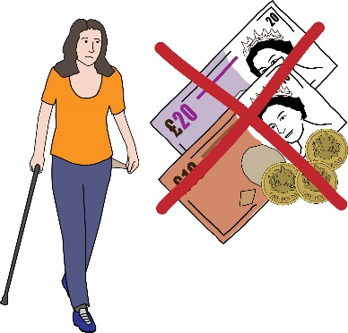  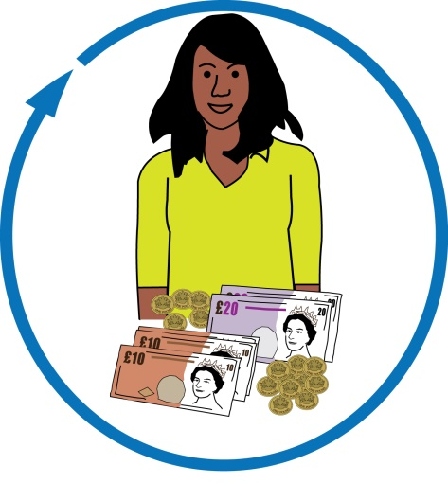 |  |  | Question 23 – Have you ever had your benefits taken away or been given less benefits because you are physically active?  ☐ No  ☐ No - I’m not getting any benefits  ☐ Yes. Please tell us about the type of benefits you were getting and why these were taken away.  ………………………………………
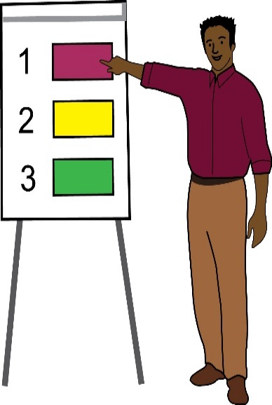 |  |  | Question 22 -Which of these options do you think would get more Disabled people to cycle?  Please put these options in order from 1 to 10. Number 1 would be the best way to get more Disabled people to cycle and number 10 would be the worst way. Please write the number in the box next to the option.  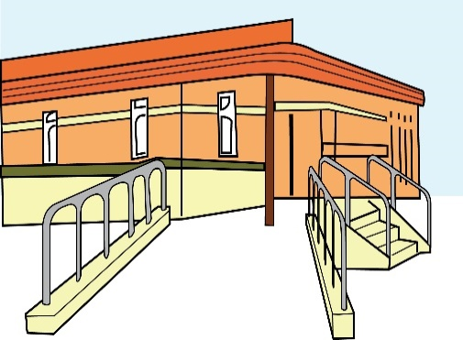  Making sure Disabled people can access cycling. Changes must be made to meet people’s needs. For example, step-free access and wide cycle lanes.  Making sure there are less cars in areas where people live. Putting speed limits in place so that cars can’t drive so fast in areas where people live.  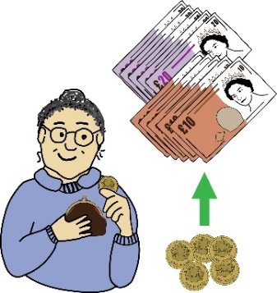  Giving subsidies to Disabled people so they can afford bikes that meet their needs. This means paying for some of a Disabled person’s bike so that they can afford it.  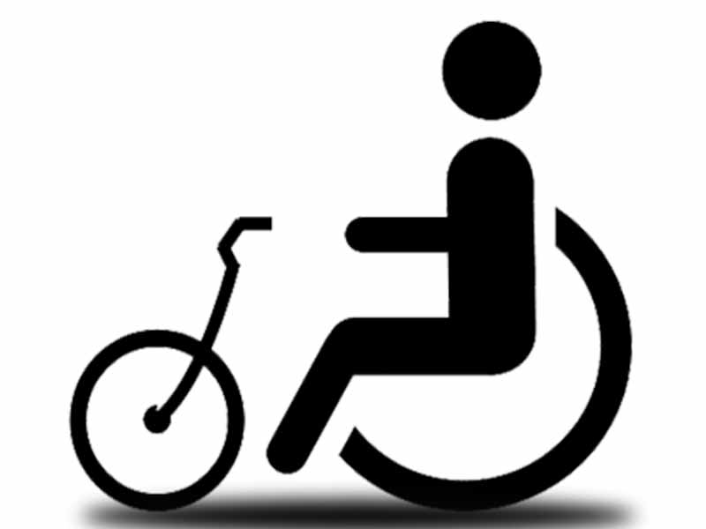  Making it official that bikes can be used as mobility aids for Disabled people. Bikes should be seen as the same as wheelchairs and mobility scooters.  Making it easier to hire and borrow bikes that meet your needs.  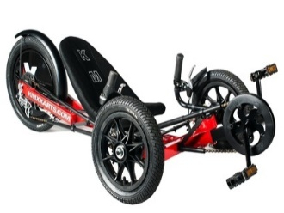  Motability offering bikes that meet your needs, as part of their Mobility scheme.
Motability Scheme: this is a programme where Disabled people, their families and their carers can rent a new car, mobility scooter or powered wheelchair, using their disability benefit.
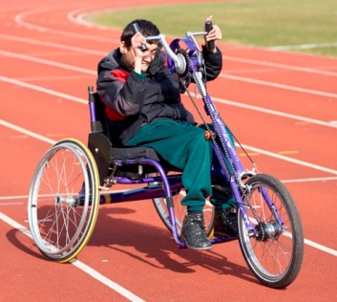  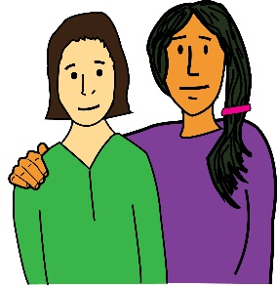 |  |  | Having more places where Disabled people are supported to try out and practice cycling  Starting a campaign to spread the word that lots of Disabled people can cycle
D. Cycling and Covid-19

Coronavirus or Covid-19: this is the virus that has spread all over the world in 2020 and 2021. It has changed the way that people live and work. It has affected Disabled people a lot because often, they are in danger of getting very ill if they catch the virus.
Pandemic: this is when a virus spreads all over the world.
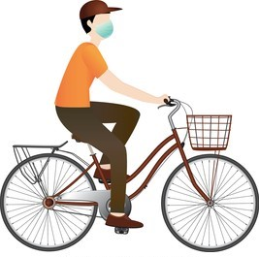 |  |  |  | Question 23 – How has the COVID-19 pandemic affected how often you cycle?  ☐ I didn’t cycle before COVID-19, but I started to cycle during the pandemic  ☐ I cycled before COVID-19, and cycled more often during the pandemic  ☐ I cycled before COVID-19, but cycled less during the pandemic  ☐ The pandemic didn’t affect how often I cycled. I cycled just as much or just as little as before.
E. Tell us a bit about you. Only fill in this section if you want to.

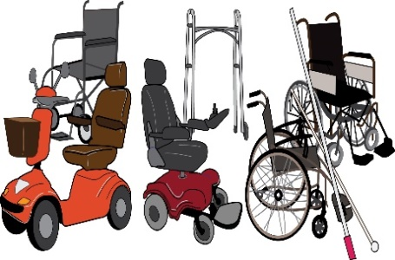  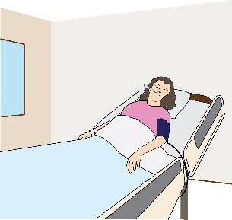  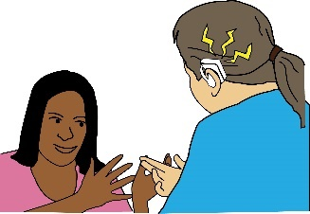  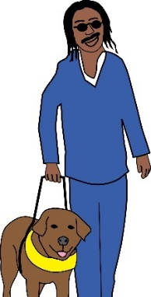  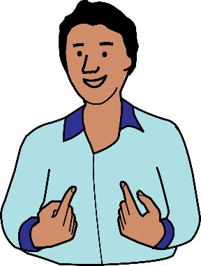  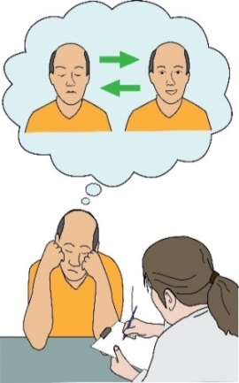  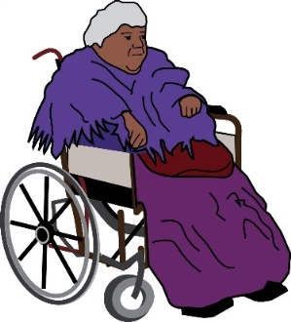 |  |  |  | Question 24- Please tell us about your impairment, health condition or hidden disability.  If you are filling in this survey for somebody else, please tell us about them.  Which of these options describes your impairment? Tick as many as you want to:  ☐ I have a physical Impairment. This means any impairment that affects the way you move your body  ☐ I have a Long-Term Health Condition  ☐ I am getting better from an operation or illness  ☐ I am deaf or losing my hearing  ☐ I am blind or losing my sight  ☐ I have ADHD  ☐ I am on the Autism Spectrum  ☐ I have Learning Disabilities or a Learning Difficulty  ☐ I have Down’s Syndrome  ☐ I have Mental Health Issues  ☐ I have a physical impairment, that has happened because I am getting old  ☐ I have Dementia  ☐ Other. Please tell us more about this:  ……………………………………
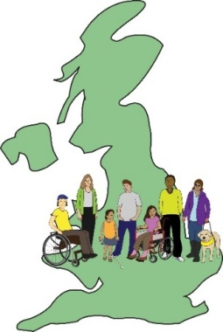 |  |  | Question 25 - Are you based in the UK?  ☐ Yes ☐ No
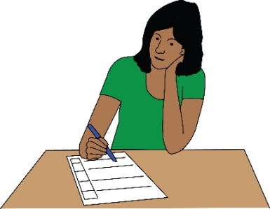 |  |  | Question 26 - Please choose your age group.  If you are filling this form in for somebody else, please tell us that person’s age group.
15-24  25-34  35-44 | 45-54  55-64  65-74 |  |  |  | 75-84  85-89  90+
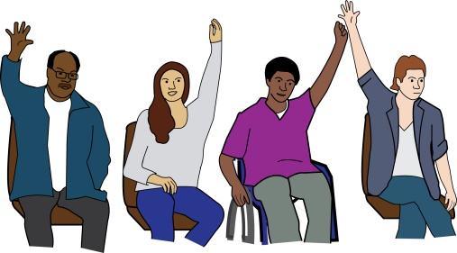 |  |  | Question 27 - What gender do you see yourself as?  ☐ Male  ☐ Female  ☐ I see my gender as:  ....................................................  ☐ I don’t want to say
F. Keeping in touch

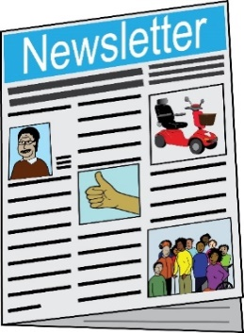 |  |  |  | Question 28- Would you like to sign up to Wheels for Wellbeing's online newsletter and get updates about our work?  ☐ Yes ☐ No  Our online newsletter is free and you can stop getting it at any time.  Would you like to get the results of this survey?  ☐ Yes ☐ No  If yes, please write your email address here:  ……………………………………..
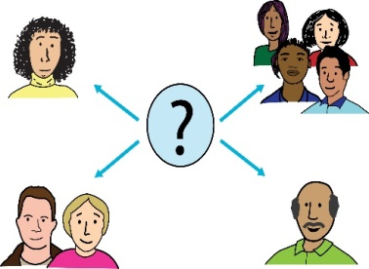 |  |  | Question 29 - Would you be happy for us to get in touch with you to take part in research in the future?  ☐ Yes ☐ No  If yes, please write your email address here:  ………………………………………..

