Recruitment Pack

Inclusive Cycling Operations Manager

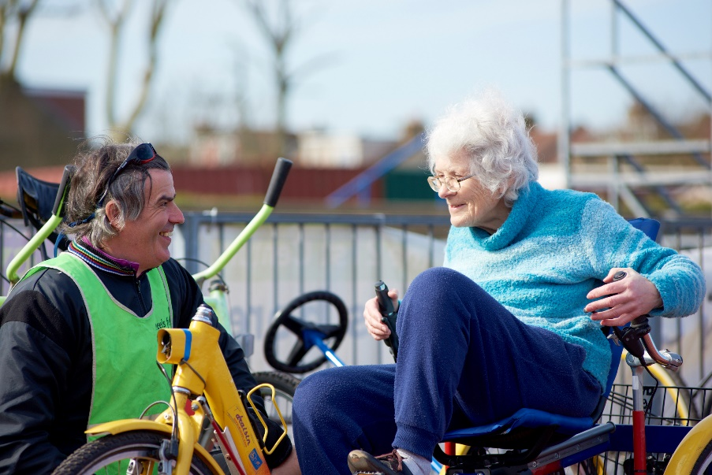

April 2021

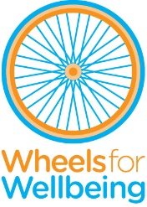

336 Brixton Road
London
SW9 7AA
Tel: 020 7346 8482
info@wheelsforwellbeing.org.uk
www.wheelsforwellbeing.org.uk
13 April 2021

Dear Applicant,

Thank you for your interest in this new (initially 12 months) post of Inclusive Cycling Operations Manager at Wheels for Wellbeing. We’re very excited to be growing our team to help enhance our reach and impact, supporting more Disabled people to access the benefits of cycling and influencing attitudes and accessibility.
We’d love to hear from you if you are:
- An experienced manager and shaper of services, 100% focused on the needs of end users.
- A team builder who excels at leading motivated and happy teams of staff and volunteers.
- A skilled champion of all things Safeguarding, Health and Safety and financial systems (to support safe and sustainable services).
- A partnership builder with the skills and energy to influence change.
A good understanding of Disability and/or Cycle Training sectors would be an advantage.

I attach some background information, the job description and person specification. Please note that this post involves work with adults at risk and is not protected under the Rehabilitation of Offenders Act 1974. Applicants invited to interview will therefore be asked to disclose criminal convictions, no matter when they occurred. Information will be treated confidentially and only considered if relevant to the post. If appointed, you will need to undertake an Enhanced DBS check.

Wheels for Wellbeing promotes opportunities for Disabled people in all aspects of our work. Our offices are based within a wheelchair accessible inclusive community hub, which is home to many other disability-led organisations. Interviews will be held at our offices or online. Please tell us if there is anything else we can do to make sure the recruitment process is accessible to you.

To apply, please email your CV to info@wheelsforwellbeing.org.uk with a cover letter (no more than two pages) outlining why you want to be considered for this post, the skills and experience you’d bring, and how you’d ensure that Wheels for Wellbeing services are safe, responsive to end users’ needs and sustainable in equal measures (ensuring you address the points in the person specification). Closing date for this role is 12noon on Tuesday 4th May 2021 and we hope to carry out interviews on Monday 10th May 2021.

If you’d like to discuss any aspect of the role or the process please don’t hesitate to contact me. I look forward to hearing from you.

Yours faithfully
Isabelle
Isabelle Clement MBE, Director (isabelle@wheelsforwellbeing.org.uk)

Background
Wheels for Wellbeing is a small charity with unique impact, run by and for Disabled people. Our inclusive cycling opportunities and campaigning voice are shaped by Disabled trustees, staff, participants and allies.

Our grass-roots inclusive cycling work takes place in leisure facilities, community centres, schools, hospitals and on streets in South London, using our large fleet of bikes, trikes, handcycles, recumbents, tandems and side-by-sides. Our participants are aged 2-102 and live with a range of impairments, health conditions, mental health issues and/or neurodiversity. All experienced barriers to cycling prior to finding out about the cycling opportunities and advocacy we provide.

Wheels for Wellbeing proves daily that anyone can cycle, with the right equipment, infrastructure, support and encouragement. Our expertise is sought widely. We are made up of individuals who bring their own experience to create a unique blend of passionate individuals, intent on challenging and removing the barriers which prevent Disabled people from enjoying all the benefits that cycling brings. We do this by:
- Supporting 1000+ Disabled people a year to experience cycling from our “hubs” in Herne Hill, Croydon and Lewisham, on led rides, training and leisure sessions.
- Coordinating the 'Beyond the Bicycle' Coalition which aligns Disabled cyclists’ needs with those of allies who use larger or wider cycles: parents of small children; cargo bike delivery companies.
- Providing training and advice regarding accessibility and inclusion to organisations such as TfL, Sustrans, DfT, local authorities, developers and designers.
- Creating a movement and voice for Disabled people's rights to active travel.
- Changing attitudes to cycling, and attitudes to disability.
Though we have supported many Disabled people to continue cycling locally over most of the pandemic (through cycle loans; reopening sessions at the Herne Hill Velodrome last July; developing led-rides and recently restarting at the Croydon Arena), we are not yet back at full capacity. Accessible and affordable options to be physically active and to travel actively will be critical to help many rebuild independence, physical and emotional wellbeing after months of COVID-19 related shielding/self-isolation. Our cycling services must return to full strength and also “build back better” from all that we learnt during the pandemic.

Plans for the next 12 months for our operations include:
- Restarting our full pre-Covid19 schedule of cycling and building the business case for new projects in line with our participants’ requests.
- Operationalising Wheels4Me, a new bespoke accessible cycle hire scheme for London (currently in pilot phase).
- Reviewing our impact and our costings model to inform our fundraising strategy.
- Strengthening the way our fleet of cycles is managed/maintained/deployed to best effect.
- Expanding the roles of and support structures for volunteers across our services.

Wheels for Wellbeing staff structure:
We are now in a position to be able to grow the team (April 2021) and appoint two new posts, an Inclusive Cycling Operations Manager (this role) and a Campaigns and Policy Manager.

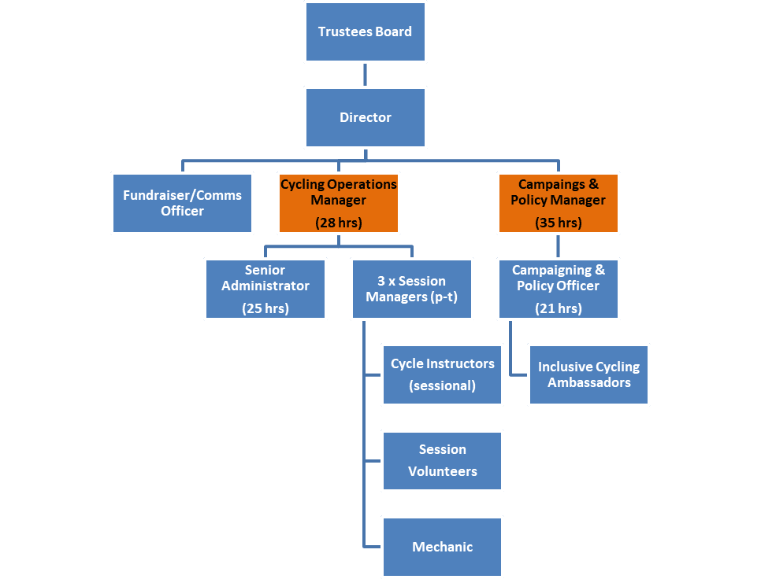

Inclusive Cycling Operations Manager (12-months contract)

Summary
Purpose of the role:

This is a new senior management role as the organisation grows. You will provide leadership to our great operational team, and with them constantly improve and take a strategic approach to developing Wheels for Wellbeing’s customer focused inclusive cycling services. You will operationalise a new cycle hire service (currently being piloted). Other key priorities for this post are: Safeguarding of adults at risk and children and the Health and Safety of all involved; improved data handling and impact evidencing; excellent budget management of our services.

Responsible to: Wheels for Wellbeing’s Director

Responsible for: Three part-time Session Managers, a part-time Senior Administrator

Hours: 28 hours per week

Salary: £30,000 to £35,000 incl. London Weighting (dependent on experience) - pro-rata for 28 hours per week

Annual leave: 20 days + 8 Public Holidays + 3 days between Christmas & New Year

Place of work: Our office at 336 Brixton Road is based within a diverse and dynamic hub of organisations which provide vital services to disabled and older people and carers. This post requires living in or close to London in order to be based at our office (Covid-19 restrictions allowing) and frequently visiting our three hubs in South London.

Temporary contract: This new post is currently funded for 12 months. We hope to secure further funding during the year to make the role permanent.

Job Description - Inclusive Cycling Operations Manager
This job description is not exhaustive, but is provided to assist the postholder to understand their main duties. It may be amended from time to time without change to the levels of responsibility appropriate to the grade of the post and in discussion with the post holder.

- You will support and oversee the safe re-opening of all our cycling services post-lockdown and the planning of new projects/services including:
  - Develop excellent relationships with our three venue partners and firm up with them post-lockdown agreements/protocols/hire rates etc.
  - Lead the continuing development and operationalisation of our ambitious new inclusive cycle hire scheme (“Wheels4Me”).
  - With our Session Managers: review our operational manuals, risk assessments, Safeguarding and Health and Safety handbooks; support the team to continue delivering safe services at all times; plan for restarting sessions where this has not yet happened.
  - Review our fleet management/maintenance/logistics, and present options to our Director/Board for improving our systems, including costing models for different options.
  - Oversee the redesign of our main data handling system (our “portal”) with our Senior Administrator and our external software developers and lead on the implementation of any new protocols/training needed to make best use of the new portal.
  - Lead on a post-lockdown survey of current and former participants to inform the planning of future services/projects and to provide evidence for our Fundraiser to use in bids.

- You will lead and be a part of a happy and motivated team
  - Providing team leadership, supervision, performance and development reviews of the staff you line-manage; ensuring Session Managers are supported in the line-management of their own teams.
  - Occasionally working/providing cover for other staff at front-line services.
  - Coordinating staff recruitment & induction processes for our cycling operations.
  - With the support of our Senior Administrator, ensuring smooth administration of staff rotas and monthly payroll calculations for our sessional staff.
  - Reviewing the role of volunteers and how they are supported

- You will promote excellent partnerships between Wheels for Wellbeing and stakeholders by:
  - Representing WfW at partnership meetings with other Inclusive Cycling providers, forums, conferences, etc.
  - Attending WfW and external events as needed, liaising with public figures/senior staff from outside agencies and the media, as required.
  - As necessary, developing and delivering presentations and talks to increasing the understanding of inclusive cycling and fostering new partnerships.

- You will participate positively in the running and development of Wheels for Wellbeing by:

  - Being part of the new Senior Management Team (with the Director and the new Operations Manager) and deputising for the Director when appropriate.
  - Modelling the organisation’s core values, including user-led working practices and the Social Model of Disability
  - Occasionally working evenings/weekends as necessary
  - Being proactive in keeping up to date with developments affecting the role
  - Carrying out other associated duties as may arise in line with the broad remit of the post
  - Supporting diversity and equality of opportunity in the workplace
  - Promoting improvement and innovation in working practices across the organisation, and seeking to deliver all work to the highest quality.
Person Specification - Inclusive Cycling Operations Manager
- EXPERIENCE (gained in a paid or unpaid capacity)
 | Essential | Desirable
2 years’ minimum experience of delivering projects & services in a relevant sector or context: Disability / cycle training / sports & physical activity / community health / Education | √
Managing teams | √
Drafting, managing and reporting on budgets | √
Developing and managing relationships with a variety of stakeholders | √

- KNOWLEDGE (or ability to rapidly acquire knowledge) of:

 | Essential | Desirable
Codes of practice, policies and guidance documents relating to Equality & Diversity; Safeguarding Children and Adults; Health and Safety and Data Protection | √
The voluntary, community and statutory sectors as relevant to disabled children, disabled adults and older people |  | √
An understanding of the wide range of specialist cycles and adaptations that exist on the market and/or that can be tailored to individuals' needs |  | √
Awareness of the main national, regional and local cycling organisations, services and training programmes |  | √

- SKILLS IN

 | Essential | Desirable
Influencing others, and engaging positively with others from different backgrounds, cultures, and experiences | √
Solving problems, both strategic and operational | √
Writing and implementing operational policies and procedures | √
Monitoring and evaluating service performance | √
Time management and prioritisation skills | √
Financial literacy for costing proposals, monitoring accounts and interpreting data and statistics | √
Confident in the use of the Microsoft Office suite and happy to learn to use other software | √

- ATTITUDES & BEHAVIOURS

 | Essential | Desirable
Thrives on receiving excellent customer feedback and on fostering happy, motivated staff/volunteer teams | √
Relates to Disabled/older people as equals and acknowledge them as the expert in how physical and societal barriers affect them. We can help you develop disability confidence but you must be committed to this. | √
Some experience of cycling, however occasionally and on whatever cycle, or willingness to have a go. | √

