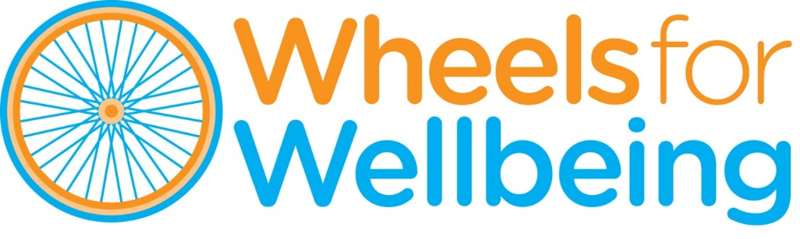

Recruitment Pack

Campaigns & Policy Manager

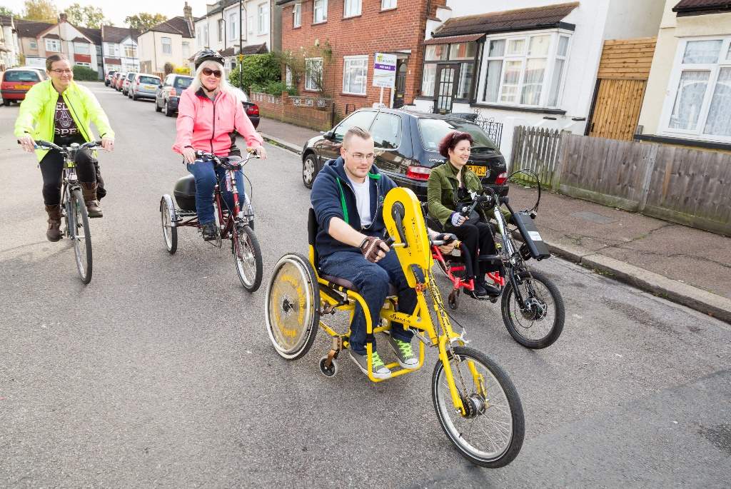

April 2021

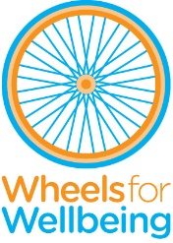

336 Brixton Road
London, SW9 7AA
Tel: 020 7346 8482
info@wheelsforwellbeing.org.uk
www.wheelsforwellbeing.org.uk
13 April 2021

Dear Applicant,

Thank you for your interest in the post of Campaigns & Policy Manager at Wheels for Wellbeing. We are very excited to be growing our team to help enhance our reach and impact, amplifying the voice of Disabled people to influence attitudes and accessibility.

We would love to hear from you if you are:
- A politically astute big-picture thinker.
- Keen to remove systemic barriers to mobility and enable Active Travel for Disabled people.
- A Campaigns/Policy professional with experience of managing people and projects.
- A partnership builder with the skills and energy to influence change.

I attach some background information, the job description and person specification. Please note that this post involves some work with adults at risk and is not protected under the Rehabilitation of Offenders Act 1974. Applicants invited to interview will therefore be asked to disclose criminal convictions, no matter when they occurred. Information will be treated confidentially and only considered if relevant to the post.

Wheels for Wellbeing promotes opportunities for Disabled people in all aspects of our work. Our offices are based within an inclusive community hub, fully accessible by wheelchair and home to several Disability-led organisations. Interviews will be held at our offices or online. Please tell us if there is anything else we can do to make sure the recruitment process is accessible to you.

To apply, please email your CV to info@wheelsforwellbeing.org.uk with a cover letter (no more than two pages) outlining why you would like to be considered for this post, the skills and experience you’d bring, and how you’d ensure that a wide range of experiences inform Wheels for Wellbeing’s lobbying work (ensuring you address the points in the person specification). The closing date for this role is Tuesday 4th May 2021, and we hope to carry out interviews on Friday 14th May 2021.

If you’d like to discuss any aspect of the role or the application process, then please don’t hesitate to contact me. I look forward to hearing from you.

Yours faithfully

Isabelle

Isabelle Clement MBE, Director
isabelle@wheelsforwellbeing.org.uk

Background
Wheels for Wellbeing is a small charity with unique impact, run by and for Disabled people. Our campaigning voice is shaped by Disabled trustees, staff, participants and allies.

Our grassroots work takes place in leisure facilities, community centres, schools, hospitals and on streets in south London, using our large fleet of bikes, trikes, handcycles, recumbents, tandems and side-by-sides. Our participants are aged 2-102 and live with a range of impairments, health conditions, mental health issues and/or neurodiversity. They all have one thing in common: they had all experienced barriers to cycling prior to finding out about the cycling opportunities and advocacy we provide.

We prove daily that anyone can cycle, as long as they have the right equipment, infrastructure, support and encouragement. Our expertise is sought widely, and we are regularly referred to as thought-leaders and experts on inclusive active travel. It is our mission to challenge the barriers that prevent Disabled people from enjoying active and independent travel, by:
- Helping 1000+ Disabled people a year experience cycling from our ‘hubs’ in Herne Hill, Croydon and Lewisham.
- Coordinating the 'Beyond the Bicycle' Coalition, which aligns Disabled cyclists’ needs with those of allies who use larger or wider cycles: parents of small children; cargo bike delivery companies etc.
- Providing training and advice regarding accessibility and inclusion to organisations such as TfL, Sustrans, DfT, local authorities across the UK, developers and designers.
- Creating a movement and voice for Disabled people's rights to active travel.
- Changing attitudes to cycling, and attitudes to Disability.
We are keen to accelerate the growth, recognition and impact of our work at an urgent time for Disabled people and the planet. Giving everyone the choice of realistic, practical and affordable options to travel actively will be critical in helping many rebuild independence and physical and emotional wellbeing after months of shielding/self-isolation due to COVID-19, and to help cities build back better with healthier, more inclusive accessible environments with better air quality and reduced car dependence.

Plans for the coming year include work to:
- Build new alliances with other Disabled People’s User Led Organisations (DPULOs) to change the narrative and build consensus around how to best tackle barriers to active travel for people with sensory, mobility or intellectual impairments.
- Develop and support a network of Disabled active travel advocates who can influence more widely in this area – all while building self-confidence through the value of their own lived experience(s).
- Pilot and learn from our new London-wide inclusive cycle hire scheme.

- Continue to create strategic partnerships and co-design projects with cycling campaign groups/active travel organisations/local and national Government.
- Share Wheels for Wellbeing’s “Guide to Inclusive Cycling” far and wide to influence inclusive streetscapes, reduce reliance on motor vehicles and improve air quality.
- Energise and empower an international network of Disabled people and allies for change.
- Grow our ability to meet the demand for consultancy services from the public and private sector.

Wheels for Wellbeing staff structure:
We are now in a position to be able to grow the team (April 2021) and appoint two new posts, a Campaigns and Policy Manager (this role) and an Operations Manager.

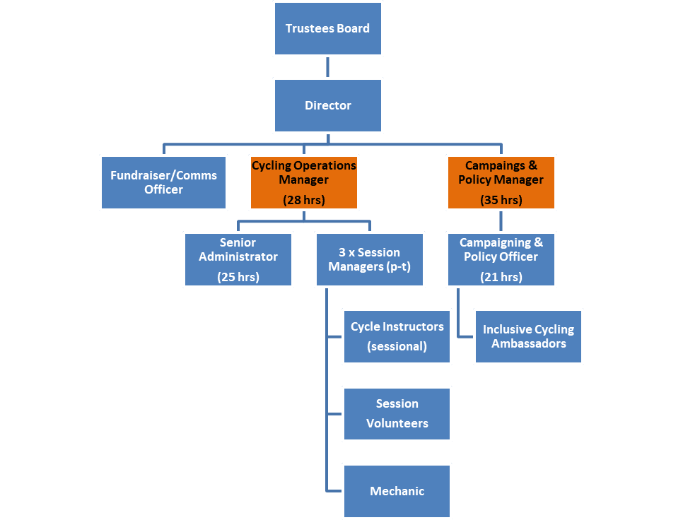

Campaigns and Policy Manager (12-months contract)

Summary
Purpose of the role:

This is a new senior role to lead Wheels for Wellbeing’s policy and campaigns brief, working closely with our Director, Campaigns & Policy Officer, trustees and ambassadors to make the most of opportunities to make lasting change in the UK for Disabled people. You will ensure that the voice of Disabled people who wheel and cycle is heard loud and clear, in particular by the Department for Transport’s Active Travel team and the new Active Travel England as they implement the Gear Change plan.

Reports to: Wheels for Wellbeing’s Director

Line manages: Campaigns & Policy Officer (p-t)

Hours: 35 hours per week (possibility of part-time/ flexible)

Salary: £30,000-£35,000 depending on experience

Annual leave: 20 days + 8 Public Holidays + 3 days between Christmas & New Year

Place of work: Our office at 336 Brixton Road is based within a diverse and dynamic hub of organisations that provide vital services to Disabled and older people and carers. We welcome applicants based anywhere in the UK and/or wishing to work from home. It will occasionally be necessary to attend events in London and other UK locations in person.

Temporary contract: This new post is currently funded for 12 months by the Department for Transport. We hope to secure further funding during the year to make the role permanent.

Job Description, Campaigns and Policy Manager
This job description is not exhaustive but is provided to assist the postholder to understand their main duties. It may be amended from time to time without change to the levels of responsibility appropriate to the grade of the post and in discussion with the post holder.

Main duties are:

- Lead the campaigning work of Wheels for Wellbeing to ensure the systemic barriers to Disabled people accessing cycling are understood and addressed at the national level:
  - Working closely with national strategic organisations such as new Active Travel England (ATE) to ensure their leadership and operational teams alike recognise the needs of Disabled people who wheel or cycle.
  - Developing and presenting policy briefings for law makers & decision makers to grow understanding and commitment to removing barriers to Active Travel for Disabled people.
  - Leading the creation of a Strategic Commission for Accessible Active Travel, with the aim of tackling systemic causes of barriers to walking/cycling faced by Disabled people.

- Increase co-operation and partnerships across the expert inclusive/accessible cycling sector to grow capacity for lobbying, consultation and engagement.
  - Identifying and liaising with key players in the inclusive/accessible cycling sector to co-create an Inclusive/Accessible Cycling expert panel.
  - Coordinating the development of the panel and its engagement with the Department for Transport, developing an action plan to tackle priorities.
  - Supporting Disabled people who wheel and cycle to engage with and influence the work of inclusive cycling providers/manufacturers/retailers etc.

- Ensure the dissemination of WfW’s existing expert knowledge so that the Department for Transport’s Gear Change investment fully benefits Disabled people:
  - Developing training for local authorities and others on improving engagement with Disabled people & representative groups (in partnership with other Disability organisations e.g. Transport for All)
  - Developing training for planners/designers/developers on understanding how to meet the accessibility requirements of LTN1/20 National Cycle Design Guidance. This will include improving the usability our own Guide to Inclusive Cycling.
  - Continuing the development of tools to rate accessibility of walking/cycling schemes, for dissemination to designers/engineers (e.g. Southwark Score).
  - Developing guidance on the accessibility of bikeshare/mobility hubs/e-bike schemes.
  - Leading WfW’s ongoing close partnership with Sustrans and supporting their infrastructure and behaviour change programmes.

- Ensure WfW supports increasing numbers of Disabled people and Disability organisations to positively influence Active Travel by leading on:
  - Driving our annual survey of Disabled people who cycle and increasing the dissemination of findings and strategic implications.
  - Developing new ways for Disabled Active Travel campaigners to connect and support each other.
  - Supporting Disability organisations to better understand and engage in Active Travel issues through our emerging “Safe and Accessible Streets Charter”.
  - Delivering opportunities for cycling campaigners and Disability campaigners to gain a better understanding of each other’s needs and priorities and begin to co-develop shared goals with regard to street space design.

- Participate positively in the running and development of Wheels for Wellbeing by:
  - Being part of the new Senior Management Team (alongside the Director and new Operations Manager) and deputising for the Director when appropriate.
  - Modelling the organisation’s core values, including user-led working practices and the Social Model of Disability.
  - Occasionally working evenings/weekends as necessary.
  - Being proactive in keeping up to date with developments affecting the role.
  - Carrying out other associated duties as may arise in line with the broad remit of the post.
  - Abiding by and promoting organisational policies and practices, and the Charity’s values.
  - Supporting diversity and equality of opportunity in the workplace.
  - Promoting improvement and innovation in working practices across the organisation and seeking to deliver all work to the highest quality.
Person Specification, Campaigns and Policy Manager
- EXPERIENCE (gained in a paid or unpaid capacity)
 | Essential | Desirable
2 years’ minimum experience in a Policy and or Campaigning role | √
Personal experience of disability AND/OR experience of working in the Disability sector | √
Managing the work of others | √
Writing for a range of audiences, from in-depth policy briefings to web pages and social media posts | √
Experience of influencing national government |  | √

- KNOWLEDGE (or ability to rapidly acquire knowledge) of:

 | Essential | Desirable
Walking & cycling policy and infrastructure as they relate to pedestrians & cyclists with a variety of impairments | √
The barriers to active travel (and to transport and mobility in general) experienced by Disabled people | √
The Social Model of Disability |  | √
Main Active Travel and disability organisations and campaigns |  | √

- SKILLS IN

 | Essential | Desirable
Influencing others, and engaging positively with others from different backgrounds, cultures, and experiences | √
Solving problems, building consensus | √
Communicating clearly (verbally and in writing) - the ability to explain policy in meaningful language | √
Being politically astute | √
Time management and prioritisation skills | √
Confident in the use of MSOffice | √

- ATTITUDES & BEHAVIOURS

Friendly and approachable; always respectful of others | √
Totally committed to the principles of user-led organisations | √
Relates to Disabled/older people as equals and acknowledge them as the expert in how physical and societal barriers affect them. We can help you develop disability confidence, but you must be committed to this. | √
Value working cooperatively in teams | √
Give attention to detail | √
Some experience of cycling, however occasionally and on whatever cycle, or willingness to have a go. | √

