Recruitment Pack

SENIOR ADMINISTRATOR

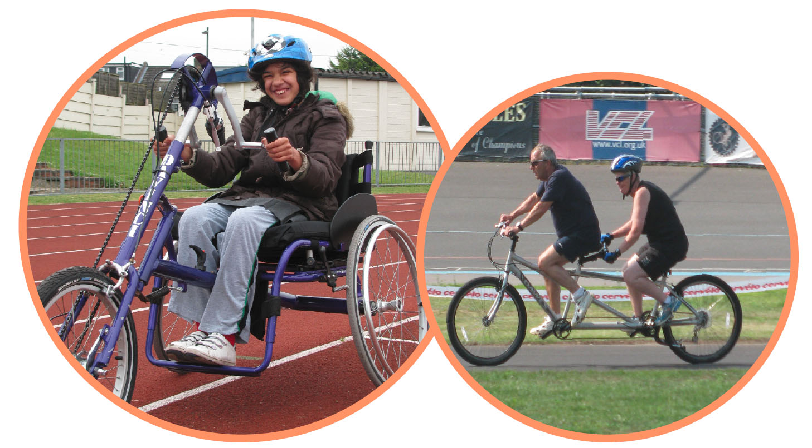

Contents

Cover Letter …………………………………………………...………..…………………………………………………………………………………………….……….3
Wheels for Wellbeing: A dynamic, award winning cycling charity 6
Wheels for Wellbeing staff structure (July 2017): 8
Senior Administrator 9
Information for disabled candidates 15
Equal Opportunities Statement 16

336 Brixton Road
London
SW9 7AA
Tel: 020 7346 8482
info@wheelsforwellbeing.org.uk
www.wheelsforwellbeing.org.uk
28 June 17

Dear Applicant,

Thank you for requesting information about the Senior Administrator post at Wheels for Wellbeing. This job pack contains the following:

- Cover Letter
- Background to Wheels for Wellbeing
- Senior Administrator Job Description and Person Specification
- Notes for disabled candidates
- Equal Opportunities Statement

Please note, this post involves work with vulnerable adults, so it is not protected under the Rehabilitation of Offenders Act 1974. Applicants invited to interview will be asked to disclose criminal convictions, no matter when they occurred. Information will be treated confidentially and only taken into account if relevant to the post. DBS checks will be carried out before a confirmed offer of employment.

The Application Form can be downloaded from our website (www.wheelsforwellbeing.org.uk). Please email / post applications forms to the details above, ensuring you include the Equal Opportunities Form and DBS Declaration. Please do not send CVs as they won’t be considered.

The closing date is midday on Friday, 14th July 2017. Applications received after this will not be considered. Interviews will take place on Wednesday 26th July, 2017.

Yours sincerely

Isabelle Clement

Isabelle Clement
Director

Wheels for Wellbeing: A dynamic, award winning cycling charity

Wheels for Wellbeing exists to enable anyone who thinks they can’t cycle to discover the joy of cycling. This is to ensure disabled people of all ages share in all the benefits of cycling, including better physical fitness and mental health, increased freedom and independence, connection to our communities, access to cheap transport and smaller carbon footprint.

How do we do this?

We do this by owning and making available a wide variety of cycles (bicycles, tricycles, 4 wheelers, handcycles, tandems, etc.), by employing experienced cycling instructors, and by running regular cycling sessions at off-road venues in South London. We also provide one-to-one cycle training and work to raise awareness of the fact that cycling is for everyone and we campaign nationally on behalf of disabled people who cycle.
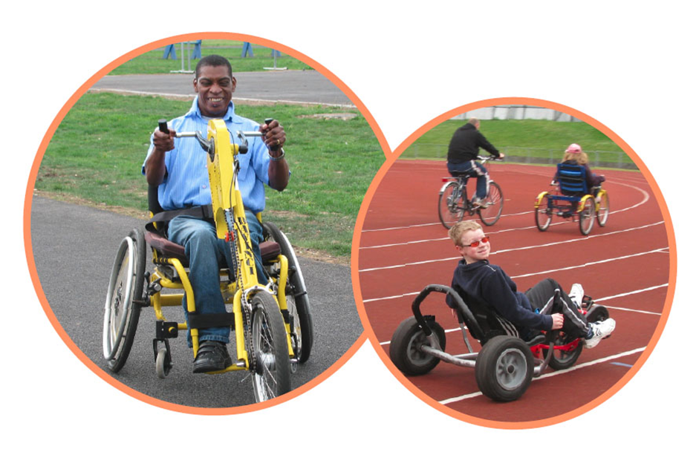

Who do we help?

Our beneficiaries are people who experience barriers to cycling. In the main, this means disabled children and adults, including older people; people with physical impairments as well as learning disabilities or mental health issues; people who have always been disabled as well as people with acquired impairments and health conditions; their carers and the organisations that work with them (we are helping care providers, special schools etc to offer stimulating and meaningful activities for their clients / pupils).

See www.wheelsforwellbeing.org.uk

Wheels for Wellbeing staff structure (July 2017):

Senior Administrator

Responsible to: Director
Accountability for: Office Volunteers / Office Interns
Hours: 25 per week over 5 days (exact work pattern to be agreed with appointee)
Duration: Permanent
Salary: £27,905 pro rata (incl. London Weighting)

Job Purpose
Sadly our current Senior Administrator is moving on at the end of July. We are looking for an equally experienced and talented person for this position. This job is full on as well as and varied and fun! If you love people and systems in equal measures, you will love working for us:
You will work closely with our Cycling Session Managers, providing administrative support to all aspects of cycling session staffing (monthly casual staff and volunteer rotas, timesheets), ensure the quality of our session records (on our online database) enabling us to provide quality data to our funders. You will also provide support across the organisation, supporting the management team by providing HR administration, liaising with our IT support provider, assisting with finance administration, producing regular monitoring and evaluation data reports, managing our contacts database, disseminating Marketing, Communications and Fundraising materials and generally ensuring the smooth running of our office.

Probationary Period
The appointment of every new employee is subject to a probation period of six months.

Pension
Wheels for Wellbeing provides a generous 5% contribution towards your pension.

Annual leave
Annual leave entitlement is 20 days in addition to the 8 English Public Holidays (pro rata), plus a few days between Christmas and New Year when the building is generally closed.

Job Description

- Cycling Sessions Administration
- Draw up and update monthly rota of Cycling Instructors & Volunteers
- Reconcile session staff timesheets with the rota, ready for Session Managers’ authorisation
- Monitor the quality of session data entry (and ensure any paper-based data is promptly entered on the online portal). Promptly bring up any issues relating to session data to the Director.
- Assist Session Managers in delivery of sessions by liaising with venues, partner organisations, etc.; managing session supplies; booking vans for outreach sessions, registering new drivers, etc.
- With Session Managers, regularly review and update session documentation
- Be actively involved in our annual participants survey and other feedback mechanisms
- Adhere to appropriate standards of confidentiality at all times

- Office Administration
- Manage WfW’s incoming and outgoing correspondence and respond to enquiries
- Manage office supplies ensuring adequate stocks; maintain office furniture and furnishings to a good standard and organise repairs and purchases
- Maintain WfW’s monitoring and evaluation systems, collate monitoring and evaluation information from projects and events for Board and funders
- Maintain general office systems and ensure electronic files are organised and accessible, adhering to data protection principles when processing personal data

- Human Resources Administration
- Assist in the management of the recruitment process for staff and volunteer vacancies
- Organise induction for new starters, including office furniture and IT requirements
- Prepare all relevant paperwork, including recruitment pack, draft advert, offer letter, contract, including ensuring they are in accessible formats
- Ensure systems are in place for recording and monitoring absences (including sickness and annual leave)
- Administer training & conference bookings for staff and volunteers (& arrange travel where needed)

- Finance and accounts
- Manage and monitor office supplies , furniture, IT and repairs.
- Support the Director with preparation of invoices, ‘month-end’ and ‘year-end’ tasks
- Enter payments and money received on to the online accounting system Xero
- Count session petty cash and pay it in, along with cheques, to the organisation’s bank account
- Manage any contracts/relationships with suppliers including chasing payments when needed
- Update the assets register & keep it updated (including office equipment and cycles)

- Health and Safety:
- Monitor and review the Health & Safety Policy in relation to the office environment
- Take responsibility for the annual office risk assessment, and to keep it under review, drawing to the Director’s attention any gaps with regards to relevant HR, health and safety, insurance and any other obligations

- Support to Staff and Board
- Provide any general administrative support, including taking minutes of meetings
- Provide administrative/organisational support to outreach and/or fundraising events
- Assist with the preparation of board papers, annual report, evaluation reports and other related administration
- Develop and maintain a range of internal information and knowledge resources including, resource library of relevant news, statistics, research and policy
- Provide trouble-shooting support for staff
- Support our admin volunteers to enable them to gain valuable experience with us, whilst ensuring that they are contributing to our objectives

- Communications & IT
- Manage the maintenance and appropriateness of telecommunications and IT equipment
- Manage the dissemination of updates / newsletters to staff & volunteers, participants & supporters
- assist in updating the website and social media
- Centralise colleagues’ feedback on IT issues and liaise with external IT Support to resolve them
- With IT Support, ensure regular tasks (including network maintenance, the server, back-ups, etc.) are performed and that any issues are brought to the attention of the Director

- Other:
- Contribute to the ongoing development of Wheels for Wellbeing, team meetings and organisational priorities
- Be proactive in keeping up to date with developments affecting the role
- Abide by and promote organisational policies and practices, and WfW’s values
- Support diversity and equality of opportunity in the workplace
- Occasionally, with notice, work evenings / weekends
- Work at least once a month in an appropriate role at a Wheels for Wellbeing session

This job description is not exhaustive, but assists the post holder to understand their main duties. It may be amended from time to time without change to the levels of responsibility appropriate to the grade of the post and in discussion with the post holder.
Person Specification

QUALIFICATIONS AND TRAINING | Essential | Desirable
a business administration finance or other relevant subject qualification,

KNOWLEDGE AND EXPERIENCE | Essential | Desirable
Experience in a similar role, with a minimum of two years’ experience
Practical experience of dealing with human resource systems
Advanced user of MS Office, especially Word and Excel; confident user of databases (especially for data reporting)
Knowledge and understanding of office based health and safety issues
Experience of managing office supplies and systems
Knowledge of data-protection legislation
Experience of managing staff and volunteers, including (where appropriate) supervision, annual appraisal and performance management
Experience (paid or unpaid) of working with disabled adults and children
Knowledge and experience of book-keeping

SKILLS: | Essential | Desirable
Effective communication (verbal & written) and interpersonal skills
Strong problem-solving skills
An organised and efficient person, able to function on own initiative with limited supervision; excellent attention to detail
Proven ability to liaise competently with IT support suppliers over IT problems
Proven planning and organisational skills, including under pressure
Excellent interpersonal and communication skills with people from all backgrounds
Excellent timekeeping and reliability
An ability to work flexibly according to the needs of the organisation,
including occasionally attending meetings / events outside office hours

ATTITUDES AND BEHAVIOURS | Essential | Desirable
A positive, energetic and enthusiastic outlook with a ‘can do’ approach
Professional manner and friendly disposition
A commitment to working to empower and further the rights of disabled people and to working within the Social Model of Disability
Must be enthusiastic, motivated and have an overall desire to help individuals to benefit from cycling
An ability to relate positively to people of different cultures, backgrounds and experiences
Friendly, approachable & helpful to anyone requiring information (volunteers, colleagues, etc.)
Respectful of others and with a total belief in the equal value of people, regardless of race, religion, culture, gender, age, disability or sexuality

Information for disabled candidates

It is the intention of Wheels for Wellbeing to give every possible opportunity to disabled candidates who have the skills and experience we seek, as it is fundamentally important to the success of the project to involve disabled people in as many ways as we can. If you wish to clarify any aspects of the job, do not hesitate to contact our Director, Isabelle Clement, on the number below.

If you consider yourself to be disabled, is there anything we need to know in order to offer you a fair interview? The interview will be held in a fully wheelchair accessible venue with available car parking on-site. Please tell us if there is anything else we can do to make sure the recruitment process is accessible to you.

If you have any specific requirements, please outline them below and return this form with your application. Alternatively, contact Isabelle Clement on 020 7346 8482 to discuss.

Post applied: Senior Administrator
Name:

This is what I need Wheels for Wellbeing to take into account / provide to make the interview process accessible to me:

Signature:

Date:

Equal Opportunities Statement

Wheels for Wellbeing will treat all people who use our services or who work for us with respect, and will value their contributions.

Wheels for Wellbeing recognises that many people covered by this statement face discrimination for a variety of reasons. They are likely to experience prejudice in their personal lives and unequal access to services. Disabled people face additional discrimination caused by physical barriers within the environment, inadequate transport, a lack of accessible information, and other factors.

Wheels for Wellbeing is actively opposed to all forms of discrimination and breaches of human rights on the grounds of disability or health status, including physical and sensory impairments, serious and long-term illnesses, learning difficulties, mental health problems, age, class, gender or transgender status, sexual orientation, ethnic origin, nationality or immigration status, responsibilities for dependents, religious or political beliefs (including trade union activities), marital status, and unrelated criminal convictions

Wheels for Wellbeing will comply fully with the requirements of the Equal Pay Acts 1970 and 1984, the Rehabilitation of Offenders Act 1974, the Sex Discrimination Acts 1975 and 1986, the Race Relations Act 1976, the Race Relations Act 1976 (Amendment) Regulations 2003, the Employment Equality (Age) Regulations 2006, the Equality Act 2010 and other relevant legislation.

We will introduce measures to combat all direct or indirect discrimination in our own employment practices and service delivery.

If you would like a copy of our Equal Opportunities Policy then please ask. If you feel that we are not meeting our aims, please contact the Director or ask for a copy of the Complaints Procedure.

